IRCHESTER PARISH COUNCIL

Minutes of the Ordinary Meeting of the Parish Council held on Wednesday 28th September 2022 at the Village Hall, School Road at 7.15p.m.

Members Present:
P Armstrong – In the Chair

Councillors
P Smith L Brown JP Carr M May S East V Wilkinson K Clarke

The meeting started at 7.15pm after a minute silence for the Queen. There were 3 members of the public present. The Chair welcomed the new Clerk Miss S Tweddell to the meeting.

Apologies - Agreed and Accepted from Cllrs J Dunkley, D Shroll, C Ashford, S Bridge, T Maguire, & K Watts.

22/44 Public Questions, Police Report from PCSO Fenner and colleague (left at 19.35pm) and NNC Update.

NNC executive committee have elected to charge for green waste collection £40 per year. Highways are due to visit the village in the autumn to discuss highways issues. Update given on Knuston Hall it was requested by councillors that a letter to be sent to the executive committee for more information on the agreement by the NNC executive committee that it was better to put the hall on the open market for sale due to the cost of repair.

22/45 Notification of Any Interests

V Wilkinson declared other interest reference London Road planning application (22/52). M May declared other interest reference Village Voice (22/55).

22/46 Minutes

The minutes from 31st August 2022 were agreed as a true record to be signed by the Chair.

22/47 Financial Matters

- Payments – Resolved: That the payments for September £10,818.85 were approved.
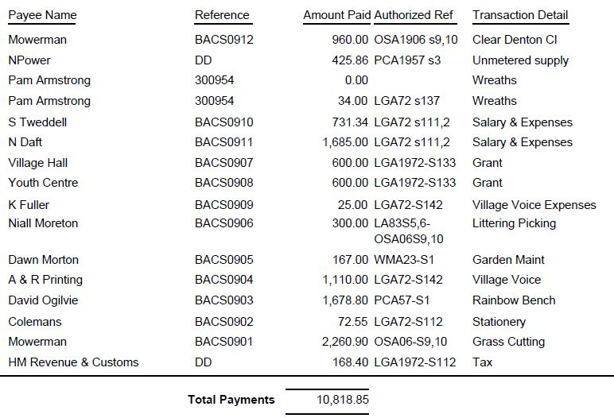

- The Current financial statement after the payments being £240,188.98
- RESOLVED that Cllrs P Armstrong and L Brown to authorise the bacs payments for September 2022
- Discussion took place regarding a possible drug dog operation in the village that would cost £400. It was agreed this would be a good idea for the village but the cost was too excessive per operation.

22/48 Cemetery/War Memorial

- There had been a several interments within the cemetery. Details for the levelling of graves to be given to the contractor.
- Discussion took place regarding the quotation to repaint the railings at Little Irchester War Memorial. It was RESOLVED to accept the quotation for £150 plus materials.

22/49 Highways

- Report raised on removing of the vegetation along Gypsy Lane from Country Park entrance to roundabout.
- Discussion took place regarding the re varnishing of the bus shelter next to the Recreation Ground in Wollaston Road. It was RESOLVED to accept the quotation for £100 plus cost of materials.

22/50 Play Areas

- Working party had met and were looking at places to visit for ideas to improve.

22/51 Community Projects

- Orchard – Request was made from the parish council in order to have some raised flower beds for the orchard. After discussion it was agreed to obtain new trees and obtain official quotation for wood for flowerbed. Cllr Smith requested his voted of abstention to be recorded.
- A request had been received from the Bowls Club asking if the pc would re-install parking bays in the car park. Other users of the car park had been notified and requests for contributions sent out. RESOLVED quotation for lines to be accepted.
- Library – The lease was signed with the solicitor. Several volunteers have been trained and the library due to be opened from 19th October. A discussion took place regarding quote to remove vegetation at the front of the library. It was RESOLVED - JP Carr has abstained from voting.
- Remembrance Day Service – The road closure for the service had been applied for and working party meeting arranged.

.22/52 Planning

The following planning applications were discussed:

- NW/22/00598/FUL – Single storey front porch, 1st floor side ext above garage plus grey pvc windows – 3 Prospect Avenue – No comment.
- NW/22/00619/VAR – Removal of condition 3 on planning permission reference WP/2002/0367/F - which restricts 'The annexe accommodation hereby approved shall always remain ancillary to the main residential unit on the site and shall not be subdivided from it so as to create its own planning unit'. Location: 130C High Street Irchester Wellingborough NN29 7AB – No comment.
- NW/22/00620/FUL - Demolition of an existing garage and a single storey pitched roof side extension. Location: 6 Redwood Close Irchester – No comment.
- NW/22/00646/FUL – 188 Station Road, Single Storey rear extension – No comment.
- NW/22/00640/FUL – Proposed Liquefied Natural Gas (LNG) road tanker storage and Liquefied Petroleum Gas (LPG) retail centre. The western half of the site will comprise: 3x6 cylinder stack storage area, forklift manoeuvre area x2, LPG cylinder unloading bay, forklift storage area, overnight parking areas for up to 4LNG road tankers and 4x lighting columns. The eastern half of site will comprise: 2 storey office/reception building, customer/staff parking bays, 4additional parking bays, 7m hinged gate entrance / exit, 3x lighting columns, provision for incoming services and septic tank, pedestrian gates (internal and emergency), 2 x 5m traffic barriers and concrete safety wall. Location: Land Rear 60 London Road Little Irchester – Irchester Parish Council currently object to the planning application due to a lack of detail. In particular there concerns are as follows:
  - Lack of details on Highways issues - this has also been highlighted by the Highways Authority who are requesting more details. We welcome an opportunity to comment once Highways have commented.
  - Lack of details on Security issues.
  - The impact on the development on the Environment - in particular the projected noise and planned floodlight of the site and its positioning within the Nene Valley and the SPA/SSSI.
  - There is little detail in the application about visual impact, in particular the view from the Nene Valley and the public footpaths which run alongside the River Nene.
  - There is also concern about the Safety aspect of the site not only with the movement of vehicles into/out of the site, but also within it. In addition the impact it may have from a safety perspective to the nearby village of Little Irchester, its residents and amenities. It is right next door to a sub station and next to a main sewer pipe for the community.

22/53 Exclusive to Public and Press

RESOLVED: That pursuant to the Public Bodies (Admission to Meetings) Act 1960, the public and press is excluded from the meeting for the item of business on the grounds that publicity would be prejudicial to the public interest by reason of the confidential nature of the business to be discussed.

22/54 Clerk

Discussion took place regarding the purchasing of a council mobile phone for the Clerks use - this was agreed. Further discussion to pay for SLCC membership and ordering new Local Council Administration Book – this was agreed.

22/55 Village Voice

Village Voice policy has been adopted. Cllr P Smith abstained from the vote, Cllr P Smith asked for his vote to be recorded.

Meeting closed at 9.25 pm

Chair

