IRCHESTER PARISH COUNCIL

Minutes of the Ordinary Meeting of the Parish Council held on Wednesday 26th February 2025 at the Village Hall, School Road at 7.15p.m.

Members Present:
K Watts – In the Chair

Councillors
A Hurley J-P Carr P Smith D Schroll G Brotherston I MacDonald
M May B Leeson A Howden J Dunkley

The meeting started at 7.15pm. There was 1 member of the public present.

Apologies - received and noted from Cllr P Armstrong.

- Notification of any Interests

None declared.

- Public Questions, Police Report and NNC Update
Public – No comments from attending public, a question was received from a member of the public given to Cllr Schroll regarding to the planning application at the gas works in Lt Irchester, Cllr Carr check the NNC portal for the application and confirmed this was approved.

Police – Report received and sent to Cllrs prior to the meeting. Query to be sent regarding to the crime stats for Irchester country park and Chester House.

NNC Update – Leader’s report sent to councillors.

- Minutes
  - RESOLVED - The minutes from 29th January 2025 meeting was agreed as a true record and signed by the Chair.

- Date of council meeting 2024/25
  - Confirmed a change of date for the Annual meeting of the Parish Council to the 21st May 2025.

- Financial/Policies
  - Payments – RESOLVED to agree the payments for February 2025 as listed below,

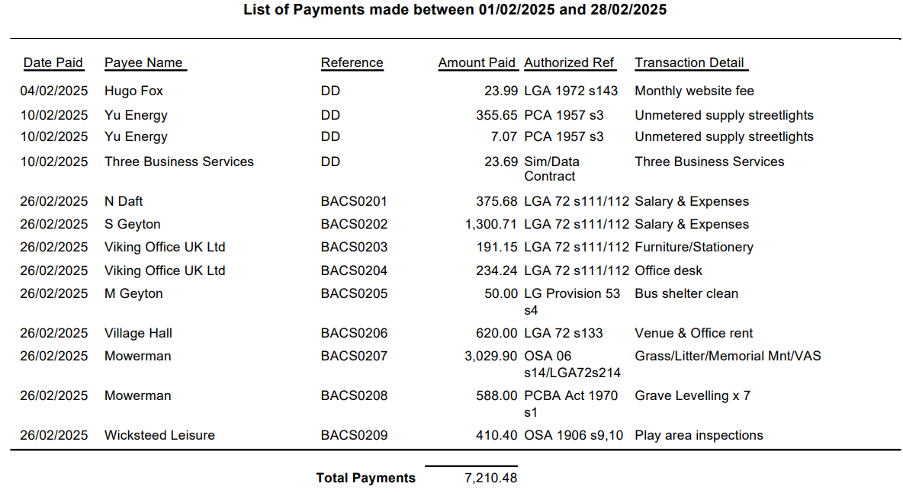
  - The Current financial statement before the February payments £215,981.71.
  - RESOLVED that Cllrs JP Carr & P Smith to authorise the bacs payments for February 2025.
  - RESOLVED to delegate powers to the Clerk and Chair to obtain more prices for materials for bus shelter repairs and action accordingly.

- Recreation Grounds
  - Play inspection report notes from Cllr Dunkley. Clerk to obtain pricing for the required repairs and bring back to full council.

- Highways
  - No issues raised.
  - RESOLVED to approve the costs for a new bench at Farndish Road.

- Cemetery/War Memorial
  - Report sent from the Cemetery Officer – Working party meeting to be arranged to discuss ongoing issues with headstones and report back to full council.
- Planning
  - To note the below comments for the following planning applications received by NNC

NW/25/00033/FUL - Proposed erection of a two-storey office & welfare building.
Location: Victoria Mills, London Road, Little Irchester, Wellingborough, NN8 2DT.

No comment from the council.

  - No decisions to note from NNC.

- Correspondence
  - No new correspondence to report.

- Exclusive to public and press

RESOLVED: That pursuant to the Public Bodies (Admission to Meetings) Act 1960, the public and press is excluded from the meeting for the item of business on the grounds that publicity would be prejudicial to the public interest by reason of the confidential nature of the business to be discussed.

- Staff
  - RESOLVED to approve the additional hours worked and unused holiday leave to be paid. RESOLVED to approve temporary cover for the cemetery officer for a period of a 3 month from 1st March.

Meeting closed at 9.08pm

Chair 26th March 2025

These minutes are draft until agreed at the next full council meeting

