IRCHESTER PARISH COUNCIL

Minutes of the Virtual Ordinary Meeting of the Parish Council held on Wednesday 27th January 2021 via Zoom at 7.15p.m.

Members Present:
P Armstrong – In the Chair

Councillors
P Smith D May JP Carr A May L Brown R Elliott
A Drage V Wilkinson

The meeting started at 7.15pm. There were no members of the public present.

At the start of the meeting, the Chair reported on the sad death of Cllr Lesley Ellis-Day in December after a long illness. Councillors stood and observed a minutes silence in her memory

The Chair also reported that the Parish Clerk is also currently ill and that Cllr Carr will be taking the notes for the meeting. Councillors expressed to the Chair how sorry they were to hear of the Clerk being poorly and send their best wishes to her

Apologies - Agreed and Accepted from Cllr J Dunkley, K Watt, D Shroll, M May and T Maguire

20/62 Public participation/Police Report/NCC Update

No members of the public present. No reports received. It was noted that the County Councillor, Cllr M Griffiths is currently poorly.

20/63 Declaration of Interest

- There were no declarations of interests from Councillors

20/64 Minutes

- The minutes from 25th November 2020 were agreed as a true record to be signed by the Chair asap

20/65 Financial Matters

- Payments – Resolved: That the payments of £8317.52 for December 2020 be approved

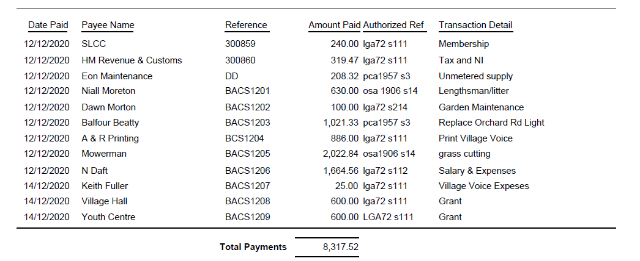

Payment – Resolved That the payments of £5197.80 for January 2021 be approved

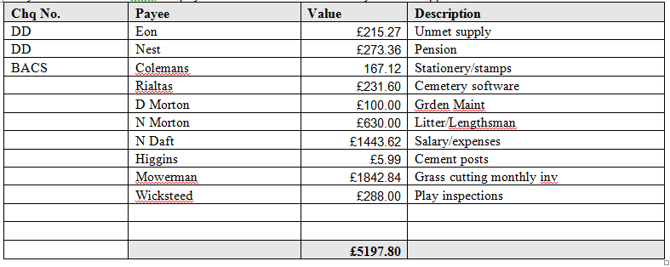
- The Current financial statement was not available due to the Parish Clerk being ill. This was noted by Councillors.
- RESOLVED that Cllrs JP Carr & P Armstrong to authorise the bacs payments for January 2020 when possible. It was also agreed by all Councillors that Cllr Carr and Cllr Armstrong to sign cheques as necessary with the Parish Clerk.

20/66 Village/Cemetery/War Memorial
- Two graves at the cemetery had recently had kerbstones erected on them that do not meet the current regulations of the cemetery as they stand above the ground. The Clerk had written to the two owners and had a returned letter from one (Gent) and had no reply from the other (Cruden). Images were shown to Councillors.
All agreed that the kerbstones should be removed as they do not meet the current cemetery regulations and to ask the Clerk to instruct contractors to undertake there removal.
- It was decided by all Councillors to order the WW2 bench that has the red poppies on and 1939-1945 and request that the Clerk order the bench for instalment at a later date. Cllr Carr stated that instead of a tree being planted for his Mayoral Year that £200 would be coming from the Borough Council to the Parish Council towards payment for the bench. Councillors gratefully accepted this offer towards the Bench

20/67 Planning
- WP/20/00863/FUL – Erection of side porch rear extension and loft conversion – 121 Bradshaw Way
  - No Objection
- WP/20/00856/FUL – New detached dwelling – High Farm 400 Station Road
  - No Objection - This house will actually provide accommodation for a rural worker at his place of work
- WP/20/00851/FUL – Installation of 6 dormer windows, rear conservatory and 1 first floor window – Lower Farm 130 High Street
  - No Objection (see further comment below)
- WP/20/00852/LBC – Listed consent for the above application – Lower Farm 130 High Street
  - No Objection - however Councillors expressed disappointed that this is a retrospective planning application but realise the Borough Councils Conservation Officer has no objections on these two applications that were first started in 2006.

20/68 Highways
- Councillors decided to defer the decision until the next meeting on the planters outside the old Post Office and Indian Takeaway to the next meeting. The Chair suggested that Councillors go and view the locations along with the images and information the Clerk has provided to guide them on a decision. It was noted that the planter outside the Old Post Office would have to be moveable to allow utility companies to access the site as this area had been dug up in the past by utility suppliers.
- Information was not available due to the Clerks absent regarding the Section 136 grants funding from NCC for grass verge cutting for 2021-22. However all agreed in principle to accept the intended grant and authorised the Clerk to accept on behalf of the Council.
- It was proposed by Cllr Wilkinson and seconded by Cllr Brown to replace the burnt out bin in Daniels Road Little Irchester with a metal bin. All Agreed. Cllr Armstrong proposed and Cllr Wilkinson seconded to authorise the Clerk (in her absence) to spend up to £1000 to purchase and install the bin. Councillors all agreed.

.20/69 Play Areas
- The Chair brought relevant papers to the Councillors attention that had been provided by the Clerk. Discussion took place and it was decided by Councillors to defer decisions until the next meeting. This would allow Councillors to visit the Recreation Ground and come back to Council with suggestions on which one piece of equipment they felt would be appropriate for installation based on current council funds.

20/70 Community Information
- It was decided to defer the positioning and planting of Woodlands trees to the next meeting. The Chair suggested Councillors look around the Parish for suitable locations.
- All Councillors agreed to officially appoint the Parish Clerk as the Police Liaison Representative to act as a single point of contact with Northamptonshire Police as agreed with the Police and NCALC

20/71 Correspondence
- The Chair gave a verbal update on various matters.
- It was stated that the bus shelter at Knuston had been demolished in an accident. The Chair had obtained the crime number and was awaiting further information before consultation with insurers and its removal
- The wooden panels had been inserted into the bus stop next to the Recreation Ground replacing the damaged Perspex areas.
- The replacement bus shelter will hopefully be installed shortly in Gipsy Lane
- That Gritting of the Highways is the responsibility of NCC and subject to temperature as advised by NCC gritting procedure the Parish Council contractor will grit the paved area around the old Post Office. This was agreed by the Parish Council a number of years ago.
- The tree on the Recreation Ground will be dealt with shortly by a contractor
- It was agreed that the following would also go on the next Agenda
  - Discuss possible Community Orchard
  - Update on May Local Government Elections and Unitary

20/72 Exclusive to Public and Press
RESOLVED: That pursuant to the Public Bodies (Admission to Meetings) Act 1960, the public and press is excluded from the meeting for the item of business on the grounds that publicity would be prejudicial to the public interest by reason of the confidential nature of the business to be discussed.

- A report had previously been shared on the Library and all Councillors noted its content:
Library– Following the last PC Meeting the Management Group and the Parish Clerk considered all the latest reports and received from NCC relating to the building fabric and the Service Level Agreement (SLA).
The Clerk wrote to NCC before Christmas with points regarding the SLA and the building fabric report. Issues raised included a blocked outside drain, building alarm insurance details, fire alarm and smoke detector report, issues to still be addressed from the Mechanical and Electrical Inspection Report (including copies of the Boiler Certificate and PAT testing Certificate that had been completed in the Autumn ), Electronic Door Report, Fire Risk Assessment Issues that need to be addressed (including some electrical issues and door seals), The email to NCC also asked if volunteer training could be undertaken by Zoom.
A response was received on the 12th January 2021. Most of the SLA enquiries have been dealt with, the work to aspects of the building fabric are still ongoing by NCC. Training cannot be undertaken by Zoom and needs to be undertaken in person which is difficult at the moment due to the Pandemic. Now we are in a Lockdown situation we await to hear on next steps from NCC. The lease will not be signed until aspects of the building fabric are sorted as it may cause ongoing problems and invalidate things like insurances e.g. Building, Content and Public Lability Insurances. No Parish Council monies have currently been transferred to the Library Management Committee.

.Meeting closed at 8.27 pm Chair

Please not that these minutes remain as drafts until agreed and signed at the next full council meeting

