IRCHESTER PARISH COUNCIL

Minutes of the Ordinary Meeting of the Parish Council held on Wednesday 27th April 2022 at the Village Hall, School Road at 7.15p.m.

Members Present:
P Armstrong – In the Chair

Councillors
P Smith K Watts D Shroll V Wilkinson L Brown JP Carr

M May T Maguire K Clarke

The Chair suggested One minutes silence for the late ex councillors Mr J King and N Greenhalf.

The meeting started at 7.15pm. there was 1 member of the public present Cllr T Partridge-Underwood

Apologies - Agreed and Accepted from Cllr J Dunkley and Cllr N Gibbons

21/106 Public participation/Police Report/North Northants Council

NNC – 12 months from formation of Unitary Council. Ukraine update and information regarding support is on the NNC website. £23k has been donated to this cause. Queens Green canopy - 4374 trees have been planted in the county. Green issues being investigated and £1m has been earmarked for this. Electric points in place in Swansgate and a couple of roads in Wellingborough. Helpline set up 0800 1381625 called The Hate Line. Green waste consultation now closed but no further news is available. Norse now in house. Scam about re door knockers and telephone regarding energy bill rebate which is to be paid by NNC only.

21/107 Declaration of Interest

None declared

21/108 Minutes

- The minutes from 30th March 2022 were agreed as a true record to be signed by the Chair.

21/109 Financial Matters

- Payments – Resolved: That the payments of £30,907.84 for April were approved
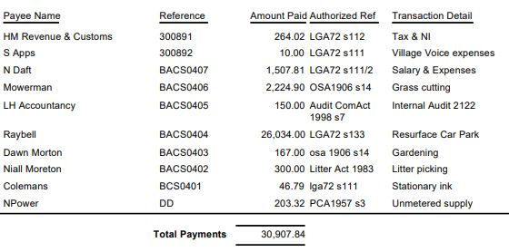

- The Current financial statement after the payments being £149,753.83
- RESOLVED that Cllrs JP Carr & V Wilkinson to authorise the bacs payments for April 2022
- The end of year account details were sent to councillors
- The internal report had been received and noted
- RESOLVED Section 1 of the AGAR was agreed
- RESOLVED Section 2 of the AGAR was agreed

21/110 Cemetery/War Memorial
- There were no issues with the cemetery. The spoil around the fence line had been removed and edging placed at the gates and railings.

21/111 Highways

It was stated that there were still pot holes needing repairing. Still awaiting to have the yellow lines up to East Street carried out.

.21/112 Play Areas

No problems recorded – however the graffiti on the skatepark was proving difficult to remove.

21/113 Community Projects

- Orchard – The trees were all in blossom. The wild flowers had started coming through the grass and the ivy around the fence line had been removed. A report was being written to be sent to the Solar Farm company who may contribute towards planters and a seat for the area.
- Library – Further repairs were still needed to be carried out in the building.
- A further meeting of the jubilee steering group had taken place.
- A request had been received from the allotments for a grant towards the removal of asbestos from the site. RESOLVED not to provide a grant as the organisation funds in their account above the Councils criteria.

21/114 Exclusive to Public and Press

RESOLVED: That pursuant to the Public Bodies (Admission to Meetings) Act 1960, the public and press is excluded from the meeting for the item of business on the grounds that publicity would be prejudicial to the public interest by reason of the confidential nature of the business to be discussed.

21/115 OLB

RESOLVED to accept the working party recommendations and allocate a budget of £500.00

Meeting closed at 8.15 pm

Chair

