
The Parish Council of Irchester
Clerk  Nikki Daft MILCM  45 Park Road  Irthlingborough  Northants  NN9 5PW |  | Telephone 01933 384180  Parishclerk123@gmail.com

Dear Councillor 20th October 2015

You are hereby summoned to attend the Ordinary meeting of Irchester Parish Council to be held at Village Hall, Irchester on Wednesday 28th October 2015 at 7.15p.m.

Yours faithfully
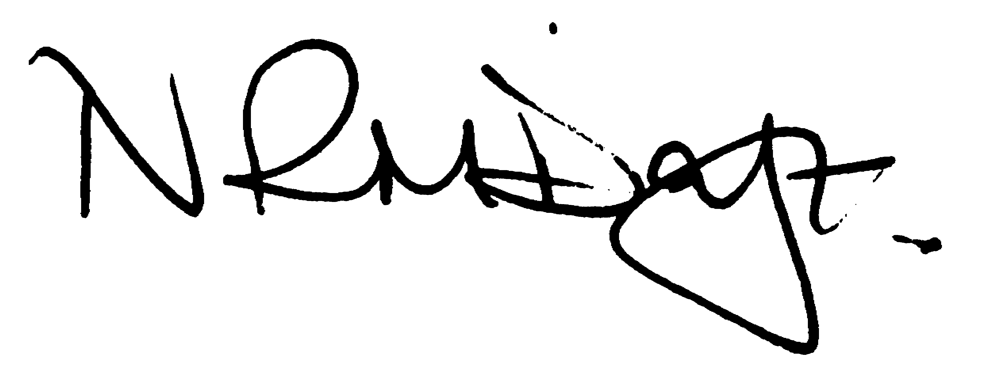

Nikki Daft – Parish Clerk

AGENDA

APOLOGIES AND ACCEPTANCE OF APOLOGIES

15/60 NOTIFICATION OF ANY DISCLOSABLE PECUNIARY INTERESTS OR OTHER INTERESTS
Only in respect of matters which are to be considered by members below. (Disclosures previously declared and registered need not be repeated).
• To receive written requests for dispensations for disclosable pecuniary interests (if any)
• To consider any requests for dispensations as appropriate

15/61 MINUTES

a) To approve the minutes of the meetings held on 30th September 2015 as true records

15/62 PUBLIC QUESTIONS, POLICE REPORT AND NCC UPDATE

Public participation may continue until for 15 minutes after which the public must not take part at any other time during the meeting. Please note that the meeting maybe recorded. All audible sounds to be switched to silent unless otherwise agreed at the start of the meeting. A report only can also be given by the Police and NCC representatives

15/63 RESOLUTIONS AND ACTIONS - MATTERS FROM PREVIOUS MINUTES
Agenda | Task | By | Completed/comments
90/101/13 | Quotes re land registry | Clerk | Ongoing
Sept | Paths Newtown Rd | Clerk | Report St Dr 755207
 | Village voice printing | Clerk | Contact Printer re lateness
 | Drains Newtown Rd | Clerk | To investigate
 | London Road 30mph | Police | To investigate
 | Rota for park inspections | Clerk | Completed
 | Letter re conifer trees | Clerk | sent

15/64 FINANCIAL/POLICIES

- To Approve Payments for October 2015 (Clerk)
- To receive information regarding the current financial statement (Clerk)
- To agree the authorisation of the bacs payments
- To consider adopting the following policies
Data Protection
Equal Opportunities
Contingency Plan
Grants Policy
Memorial Testing

15/65 RECREATION GROUNDS

- To receive and agree the reports/repairs/damage to the recreation grounds
- Discuss the Cost to repair the wet pore in the basket ball court
- Discuss the damage to the exercise equipment and decide to replace or remove equipment
- To discuss the copings of the skatepark.
- To receive an update regarding the problem with litter in Austin Close

15/66 HIGHWAYS

Street Doctor updates :
752547 – Footpath from Railway bridge to Knuston – Work instructed 1st September
752576 – Footpath Chester Road – Work instructed 1st
755207 – Footpath condition Newtown Road – Work instructed will be completed by Jan 2016
755595 – Weed spraying of gutters – being undertaken

- To receive a quotation to cut back the alleyway in Alfred Street to Bakers Crescent

15/67 LITTLE IRCHESTER/KNUSTON

a) To agree the Highway Warden report. Matters arising will be added to the next agenda

15/68 PLANNING

To receive an update on planning matters

WP/15/00566/FUL – Garage conversion and 1st floor extension – 49 Arkwright Road
WP/15/00601/FUL – Single storey side extension – 59 Bradshaw Way

15/69 NEIGHBOURHOOD PLAN

- To receive an update on the NH Plan

15/70 CEMETERY/WAR MEMORIAL

- Registrar report – previously circulated – matters for next agenda
IMPORTANT ITEM

- To discuss the problems of the path in the cemetery which has been highlighted as a potential trip hazard and the cost of repair.
IMPORTANT ITEM

- War Memorial – to discuss the removing of the other spikes on the War Memorial fencing

15/71 ORGANISATION REPORTS/SUGGESTIONS

- To receive an update regarding the Remembrance Day Service

15/72 CORRESPONDENCE

To consider information received from incoming correspondence and decide on agenda items for the next meeting.

- WBC Council Tax Support Scheme – details on which option the pc would prefer.

