
The Parish Council of Irchester
Clerk  Nikki Daft PSLCC  45 Park Road  Irthlingborough  Northants  NN9 5PW |  | Telephone 07525909528  irchesterpc@gmail.com  www.hugofox.com/community/irchester-parish-council-13388/about-us

Dear Councillor 20th June 2022

You are hereby summoned to attend the ordinary meeting of Irchester Parish on Wednesday 29th June 2022 at 7.15p.m.at the Village Hall, School Road, Irchester

Yours faithfully
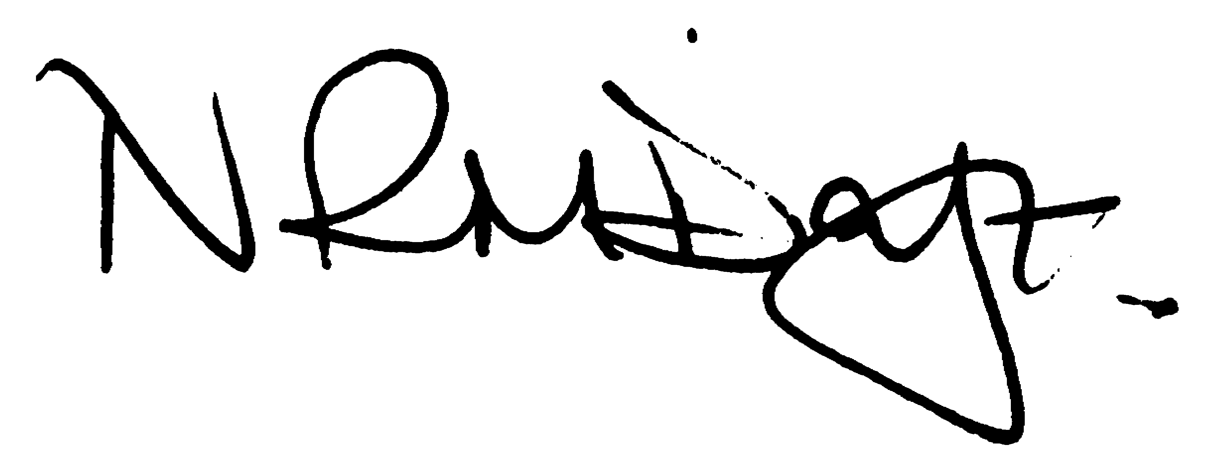

Nikki Daft – Parish Clerk

AGENDA

APOLOGIES AND ACCEPTANCE OF APOLOGIES – AND DISPENSATION REQUEST

22/17 PUBLIC QUESTIONS, POLICE REPORT AND NNC UPDATE

Public to send questions to council prior to the meeting due to time constraints

22/18 CO-OPTION OF COUNCILLOR

To agree the co-option of a new councillor

22/19 NOTIFICATION OF ANY DISCLOSABLE PECUNIARY INTERESTS OR OTHER INTERESTS
Only in respect of matters which are to be considered by members below. (Disclosures previously declared and registered need not be repeated).

- To receive declarations of interest
- Councillors to declare any personal interest in any items on the agenda
- Councillors to declare any personal and/or prejudicial interest in any items on the agenda and to inform the Chairman if they wish to speak on the matter during public participation

22/20 MINUTES

a) To approve the minutes of the meeting held on 25th May 2022 as a true record.

22/21 FINANCIAL/POLICIES

- To Approve Payments for June 2022 (Clerk)
- To receive information regarding the current financial statement (Clerk)
- To agree the authorisation of the bacs payments
- To discuss and update the key holders for the notice boards

22/22 CEMETERY/WAR MEMORIAL

- To receive an update on cemetery matters
- To discuss the replacement of the Tommy for Little Irchester or equivalent memorial
- To discuss the quotation to reduce the tree on Irchester War Memorial
- To discuss the request to donate a tree from WI for either the War Memorial or land opposite Parsons Hall.

22/23 HIGHWAYS

- To receive an update on Highways matters
- To discuss a request to ask highways to look into reducing the speed limit through Knuston
- To discuss the quotation to repair the broken light in Austin Close

22/24 PLAY AREAS

- To receive an update regarding the play areas

22/25 COMMUNITY
- To receive an update on the community orchard.
- To receive an update on the Library and to receive a request for the start up grant
- To discuss the organising of the Remembrance Day Service

22/26 PLANNING

- NW/22/00353/FUL Proposal: Construction and operation of a solar farm comprising ground mounted solar photovoltaic (PV) arrays together with associated infrastructure, including DNO substations, customer substations, customer switchgear, access, fencing, CCTV cameras and landscaping. Location: Land To The South Of The Gipsy Lane (B570) Irchester
- NW/22/00383/FUL Proposal: Demolition of a rear conservatory and construction of a single storey rear extension. The raising of the roof and addition of a roof above an existing garage to enable habitable accommodation to the provided in the first floor and the addition of 5 dormer windows in the front elevation and a balcony and full height windows on the rear elevation. Location: 89 Gipsy Lane Irchester
- NW/22/00415/FUL Demolition of brick built out-building and erection of single storey rear extension Location: 7 Alfred Street Irchester

22/27 EXCLUSIVE TO PUBLIC AND PRESS

22/28 FUTURE IMPROVEMENTS TO IRCHESTER CEMETERY

To discuss future improvements to the cemetery

