
The Parish Council of Irchester
Clerk  Nikki Daft MILCM  45 Park Road  Irthlingborough  Northants  NN9 5PW |  | Telephone 01933384180  Parishclerk123@gmail.com

Dear Councillor 12th May 2015

You are hereby summoned to attend the Annual meeting of Irchester Parish Council followed by the ordinary meeting of the Parish Council to be held at Village Hall, School Lane, Irchester on Wednesday 20th May 2015 at 7.15p.m.

Yours faithfully
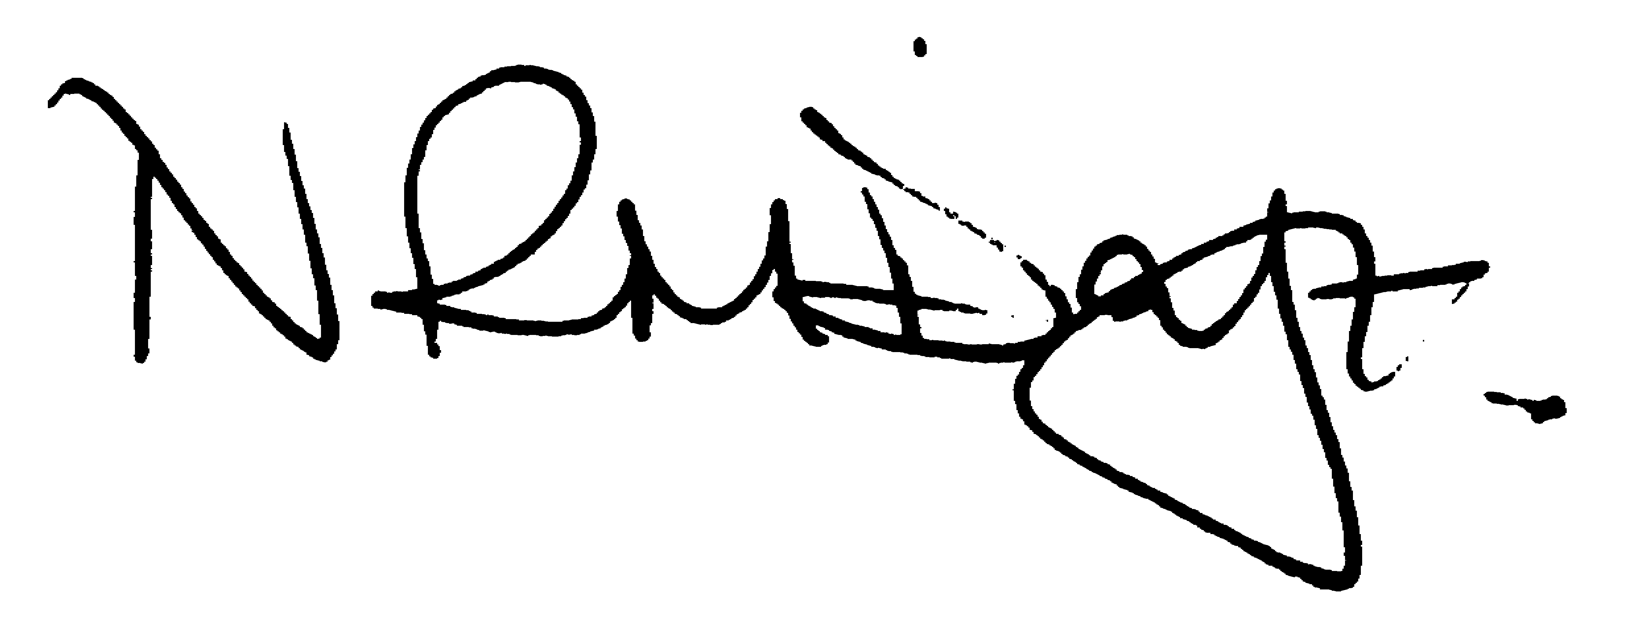

Nikki Daft – Parish Clerk

AGENDA

APOLOGIES AND ACCEPTANCE OF APOLOGIES

15/1 COUNCILLORS, CHAIRMAN ELECTION AND ACCEPTANCE OF OFFICE

- To receive nominations and elect a Chair for the Parish Council for the ensuing year. Declaration of acceptance of office to be completed.
- Councillors to complete declarations of office

15/2 CO-OPTION OF COUNCILLORS FOR LITTLE IRCHESTER WARD

To review the candidates for the co-option of councillors for Little Irchester Ward

15/3 NOTIFICATION OF ANY DISCLOSABLE PECUNIARY INTERESTS OR OTHER INTERESTS
only in respect of matters which are to be considered by members below. (Disclosures previously declared and registered need not be repeated).

- Declaration forms need to be completed and returned to the Monitoring Officer at Wellingborough Council and also a copy sent to the Clerk for the website

15/4 APPOINTMENTS OF MEMBERS to the following specific areas of interest:

a) Vice Chair b) Internal Accounts Controller and Digital Overseer
c) Footpaths d) Highway Warden Irchester
e) Highway Warden Little Irchester and Knuston

15/5 APPOINTMENT OF ADVISORY GROUPS

- Public lighting
- Finance
- Recreation
- Cemetery
- Planning
- Village Voice
g) Emergency planning/flooding

15/6 APPOINTMENT OF REPRESENTATIVES ON OUTSIDE BODIES

To appoint representatives on Outside Bodies for the following:

a) Irchester Sports Association (2) b) Village Hall Committee
c) Youth Centre Management Committee d) Allotment Association
e) Bowling Club Committee

15/7 DATES OF COUNCIL MEETINGS 2015/16

To approve the dates and venues for meetings throughout 2015/16

24th June 2015 27th January 2016
26th August 2015 24th February 2016
30th September 2015 (HH) 30th March 2016 (HH)
28th October 2015 27th April 2016
25th November 2015 18th May 2016 Annual Meeting

15/8 GENERAL POWER OF COMPETENCE

To determine if the council wish to use the General Power of Competence

To commence the Ordinary Meeting of Irchester Parish Council

15/9 MINUTES

a) To approve the minutes of the meeting held on 29th April 2015 as a true record

15/10 PUBLIC QUESTIONS, POLICE REPORT AND NCC UPDATE

Public participation may continue until for 15 minutes after which the public must not take part at any other time during the meeting. Request should be made to the Chair if any member of the public wishes to make a recording of any part of the meeting. All audible sounds to be switched to silent unless otherwise agreed at the start of the meeting. A report only can also be given by the Police and NCC representatives

15/11 RESOLUTIONS AND ACTIONS - MATTERS FROM PREVIOUS MINUTES
Agenda | Task | By | Completed/comments
90/101/13 | Quotes re land registry | Clerk | Ongoing
8797//13 | Dog Fouling | Cllrs | Monitor
106/13 | Sign fly posting | Cllrs | To monitor
14/112 | Unmetered suppliers | Clerk | On going
14/122 | Get well card NHW | Clerk | Sent
 | Bins on road and road sweeper letter | Clerk | Sent
 | Townwell Road report to St Dr | Clerk | Reported
 | NCC road closure query | Clerk | Requested
14/125 | Cost of gate Austin Close
14/128 | Ask Lark Solar re contribution to unmetered supply | Clerk | Letter sent
14/130 | Cemetery rules | Cllrs | June meeting
14/131 | Parsons Ind Est lead water pipes | Clerk | Letters sent to occupiers

15/12 FINANCIAL/POLICIES

- To Approve Payments for May 2015 (Clerk)
- To receive information regarding the current financial statement (Clerk)
- To agree the authorisation of the bacs payments
- To agree the signatories for the bank account
- To arrange a finance meeting to discuss the Auto Enrolment options and updating of policies
- To review the Standing Orders, Financial Regulations, Risk Assessment and Internal Audit Controls
- To discuss the quotations received regarding the safety surface at the village hall for the pre school children and to decide if the pc can make a grant towards this and what budget heading this would be taken from

15/13 RECREATION GROUNDS

- To receive and agree the reports/repairs/damage to the recreation grounds (JD)
- To discuss the request from King West in respect of the Parish Council selling a parcel of land at Austin Close for the purpose of providing an adoptable standard vehicular success to adjoining land.

15/14 HIGHWAYS

a) To agree the Highway Warden report, previously circulated. Matters arising will be added to the next agenda

15/15 LITTLE IRCHESTER/KNUSTON

a) To agree the Highway Warden report, previously circulated. Matters arising will be added to the next agenda
b) Update regarding the problems with the grass verge along A509

15/16 PLANNING

- To receive an update on the Neighbourhood Plan
- WP/15/00273/LBC Conversion of existing barn into 2 No dwellings together with raising of roof line to smaller barn. New car port. New chimney stack The Tithe Barn, 75A High Street, Irchester
- WP/15/00272/FUL Conversion of existing barn into 2 No dwellings together with raising of roof line to smaller barn. New car port. New chimney stack The Tithe Barn, 75A High Street, Irchester
- WP/15/00240/FUL – 6 foot fence Amended plans 69 High Street Irchester

15/17 CORRESPONDENCE
To consider information received from incoming correspondence and decide on agenda items for the next meeting.

