
The Parish Council of Irchester
Clerk  Nikki Daft MILCM  45 Park Road  Irthlingborough  Northants  NN9 5PW |  | Telephone 01933 384180  Parishclerk123@gmail.com

Dear Councillor 21st September 2015

You are hereby summoned to attend the Ordinary meeting of Irchester Parish Council to be held at Hilton Hall Little Irchester on Wednesday 30th September 2015 at 7.15p.m.

Yours faithfully
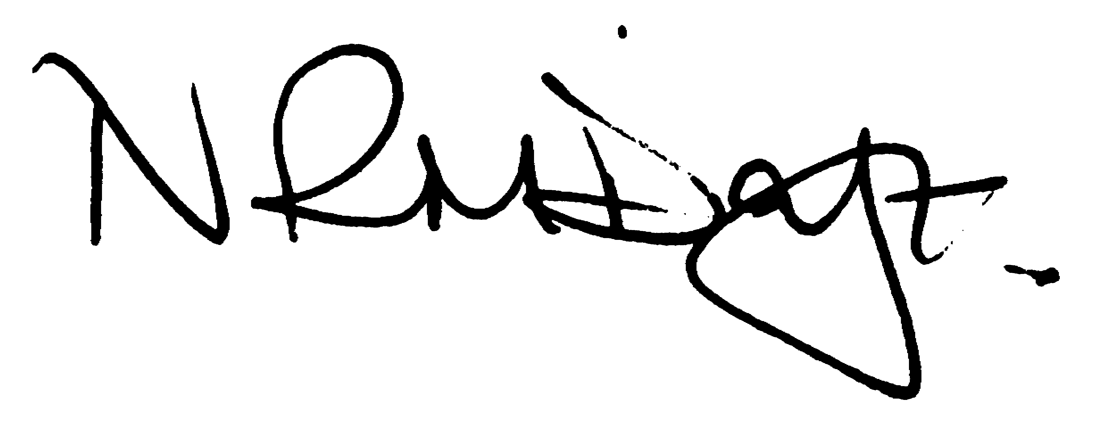

Nikki Daft – Parish Clerk

AGENDA

APOLOGIES AND ACCEPTANCE OF APOLOGIES

15/45 NOTIFICATION OF ANY DISCLOSABLE PECUNIARY INTERESTS OR OTHER INTERESTS
Only in respect of matters which are to be considered by members below. (Disclosures previously declared and registered need not be repeated).
• To receive written requests for dispensations for disclosable pecuniary interests (if any)
• To consider any requests for dispensations as appropriate

15/46 MINUTES

a) To approve the minutes of the meetings held on 26th August 2015 as true records

15/47 PUBLIC QUESTIONS, POLICE REPORT AND NCC UPDATE

Public participation may continue until for 15 minutes after which the public must not take part at any other time during the meeting. Please note that the meeting maybe recorded. All audible sounds to be switched to silent unless otherwise agreed at the start of the meeting. A report only can also be given by the Police and NCC representatives

15/48 RESOLUTIONS AND ACTIONS - MATTERS FROM PREVIOUS MINUTES
Agenda | Task | By | Completed/comments
90/101/13 | Quotes re land registry | Clerk | Ongoing
 | Quote cans only bin | Clerk | Agenda item
15/36 | Facebook/social media policy | Clerk | Draft completed
15/37 | Skatepark surface | Clerk | Awaiting manu report

15/49 FINANCIAL/POLICIES

- To Approve Payments for September 2015 (Clerk)
- To receive information regarding the current financial statement (Clerk)
- To agree the authorisation of the bacs payments
- To consider adopting the following policies
Social Media/Communications
Flag Flying

15/50 RECREATION GROUNDS

- To receive and agree the reports/repairs/damage to the recreation grounds (JD,DS & TM)
- To discuss the smooth surface of the skatepark and determine if there is anything available to make the tracking on the surface better
- To receive a quotation for a cans only bin at Austin Close

15/51 HIGHWAYS

Street Doctor updates :
752547 – Footpath from Railway bridge to Knuston – Work instructed 1st September
752576 – Footpath Chester Road – Work instructed 1st

15/52 LITTLE IRCHESTER/KNUSTON

a) To agree the Highway Warden report. Matters arising will be added to the next agenda

15/53 PLANNING

To receive an update on planning matters

15/54 NEIGHBOURHOOD PLAN

- To receive an update on the NH Plan

15/55 CEMETERY

- Registrar report – previously circulated – matters for next agenda

15/56 ORGANISATION REPORTS/SUGGESTIONS

- To receive an update regarding the Remembrance Day Service

15/57 CORRESPONDENCE

To consider information received from incoming correspondence and decide on agenda items for the next meeting.

15/58 EXCLUSIVE TO PUBLIC AND PRESS

15/59 CONTRACT CRITERIA

To discuss the criteria requirement by the parish council for the recommendation of one off projects within the community that maybe required for Health and Safety reasons.

