
The Parish Council of Irchester
Clerk  Nikki Daft PSLCC  45 Park Road  Irthlingborough  Northants  NN9 5PW |  | Telephone 07525 909528  irchesterpc@gmail.com

Dear Councillor 19th June 2018

You are hereby summoned to attend the Ordinary meeting of Irchester Parish Council to be held in the Village Hall, School Road Irchester on Wednesday 27th June 2018 at 7.15p.m.

Yours faithfully
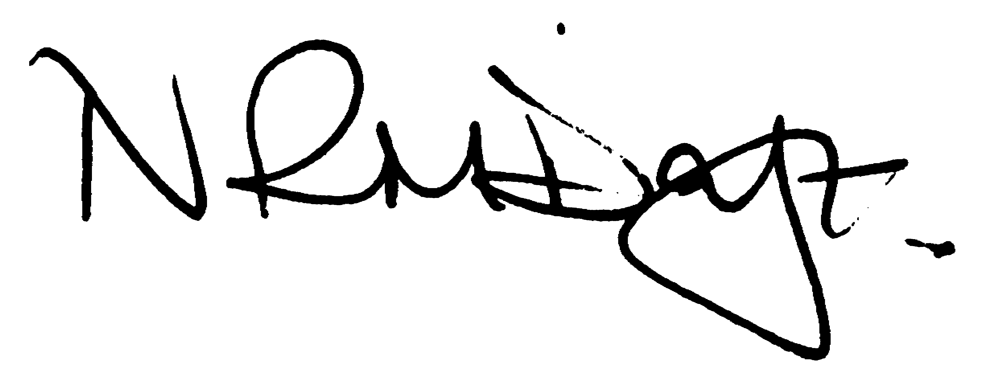

Nikki Daft – Parish Clerk

AGENDA

APOLOGIES AND ACCEPTANCE OF APOLOGIES

18/20 NOTIFICATION OF ANY DISCLOSABLE PECUNIARY INTERESTS OR OTHER INTERESTS
Only in respect of matters which are to be considered by members below. (Disclosures previously declared and registered need not be repeated).

- To receive declarations of interest
- Councillors to declare any personal interest in any items on the agenda
- Councillors to declare any personal and/or prejudicial interest in any items on the agenda and to inform the Chairman if they wish to speak on the matter during public participation

18/21 PUBLIC QUESTIONS, POLICE REPORT AND NCC UPDATE

Public participation may continue until for 15 minutes after which the public must not take part at any other time during the meeting. Any member of the public can make a recording of any part of the meeting. All audible sounds to be switched to silent unless otherwise agreed at the start of the meeting. A report only can also be given by the Police and NCC representatives

18/22 MINUTES - To approve the minutes of the meetings held on 23rd May 2018 as a true record.

18/23 RESOLUTIONS AND ACTIONS - MATTERS FROM PREVIOUS MINUTES

- Wet pore repair - ordered
- Light repairs - ordered
- Bus shelter – work instructed
- Working Men’s Club verbal response
- Email to Parsons Hall Trust - sent
- Letter to NCC Commissioners – sent
- Email to Sports Club – sent
- Letter re kerb stones in cemetery - sent
- Remembrance Day Insurance cover - confirmed
- GDPR SLA to NCALC – sent
- GDPR policies on website
- Birchwood costs - received
- Hilton Hall – in progress
- Financial Risk Assessment - amended
- Library Stage 2 – in progress
- Listed Building Planning Application - in progress

18/24 FINANCIAL/POLICIES

- To Approve Payments for June 2018 details sent to councillors via email (Clerk)
- To receive information regarding the current financial statement – reconciliation statement sent to councillors via email (Clerk)
- To agree the authorisation of the bacs payments
- To agree the amendments to the Standing Orders 2018 as recommended by NALC

18/25 RECREATION GROUNDS

- To receive and agree the reports/repairs/damage to the recreation grounds (JD)
- To discuss the issue with a neighbouring resident cutting down a tree in the recreation ground and to decide what course of action the council wish to take
- To discuss the issue that a neighbouring resident has installed a gate onto the recreation ground and the next course of action the council wish to take.
- To discuss the purchasing of a wet pore repair kit in order to patch the smaller holes in the recreation grounds
- To discuss the quote received to resurface the basketball area

18/26 HIGHWAYS

- To agree any items that need to be added to the next agenda
- To discuss the query from the Ramblers Society regarding the footbridge near to Chester Farm

18/27 LITTLE IRCHESTER/KNUSTON - To agree the Highway Warden report. Matters arising will be added to the next agenda.

18/28 PLANNING - To discuss any planning issues
- WP/18/00375/FUL – Demolition of sun lounge and part kitchen, loft conversion and 2 and single storey rear extension – 81 Gipsy Lane

18/29 NEIGHBOURHOOD PLAN - To receive an update on the progress of the NHP

18/30 CEMETERY/WAR MEMORIAL/GARDENS

- To receive the Cemetery report and decide if details should be added to the next agenda
- To receive an update regarding the unauthorised kerbstones as discussed at the previous council meeting in May 2018.
- To discuss the memorabilia currently on grave and cremated remains plots and to decide what should be done about it as per the cemetery rules and regulations
- Proposals from the Cemetery meeting held on 17th May 2018
- The Parish Council to reinstate, where possible, the headstones for the untraceable lessees graves from the Autumn 2017 Memorial Testing.
2) The Parish Council will consider individual requests for help and support for headstones laid down during the Autumn 2017 Memorial Testing.
3) The Parish Council will undertake to review its Policies on its Cemetery.
- To discuss the recommendations and costs from the April Cemetery Report written by the Clerk and to decide on the following
  - Fencing for the baby section
  - Clearing and replanting of the baby section
  - Removal of the large conifer trees and bushes
  - Gravel area for the top tree
  - Gravel area for the cremated remains plots
  - Levelling of the non-maintained grave spaces
  - Filling of the uneven ground areas

18/31 COMMUNITY/CONSULTATIONS EVENTS

- To receive information regarding the events being organised for WW1
- To discuss the consultation regarding the modifications to the Borough Council of Wellingborough Local Plan part 2
- Local Government Reform in Northamptonshire "The parish council will contribute to the consultation on the restructure of local government in the county from June 13-july 24. If necessary by calling a special meeting. (RE) The parish council considers that any restructuring should:
  - Recognise the contribution of parish councils to local government in the county
  - Consider enhancing their role and powers
  - Ensure the local voice is heard by the new authorities
  - Ensure that the needs and concerns of the vulnerable are heard and acted upon . Thinking especially of the old, disabled and less well off families"

18/32 CORRESPONDENCE To consider information received from incoming correspondence and decide on agenda items for the next meeting.

- Condition of the footway Warren Close to Arkwright Road
- Extension of the yellow lines at the corner of Arkwright Road

18/33 EXCLUSIVE TO PUBLIC AND PRESS

18/34 COMMUNITY ASSET ISSUES
To discuss how the council should proceed in regarding issues raised with the Council owned Community Assets:

- Progress with the library building/Independent Library
- Progress with Hilton Hall building
- Parsons Hall lease and charges for storage in Council owned buildings

