
The Parish Council of Irchester
Clerk  Nikki Daft PSLCC  45 Park Road  Irthlingborough  Northants  NN9 5PW |  | Telephone 07525909528  irchesterpc@gmail.com  www.hugofox.com/community/irchester-parish-council-13388/about-us

Dear Councillor 18th January 2022

You are hereby summoned to attend the ordinary meeting of Irchester Parish on Wednesday 26th January 2022 at 7.15p.m.at the Village Hall, School Road, Irchester

Yours faithfully
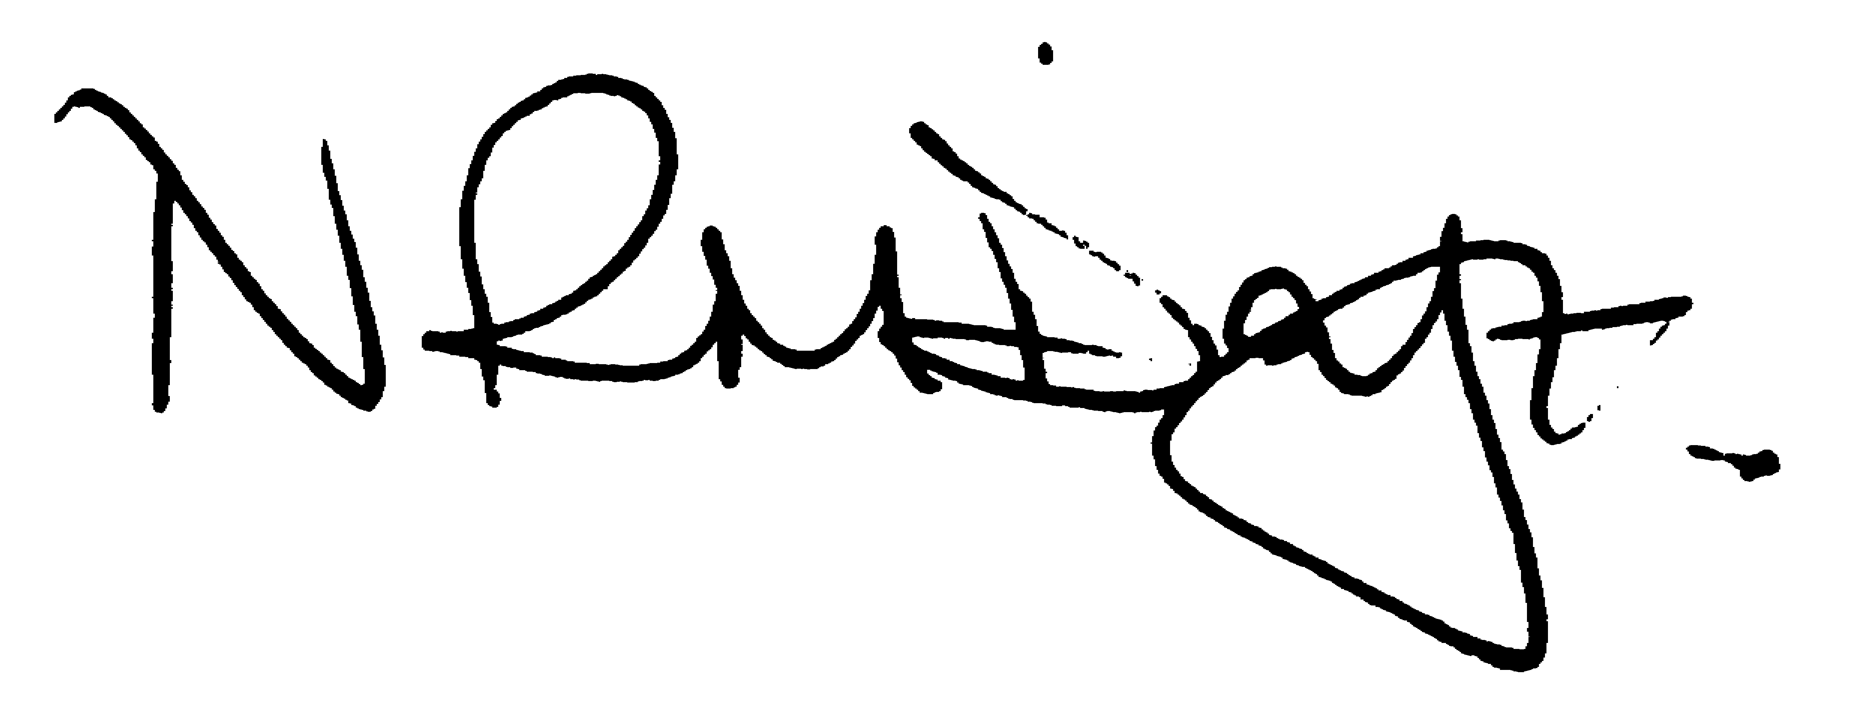

Nikki Daft – Parish Clerk

AGENDA

APOLOGIES AND ACCEPTANCE OF APOLOGIES

21/72 PUBLIC QUESTIONS, POLICE REPORT AND NNC UPDATE

Public to send questions to council prior to the meeting due to time constraints

21/73 NOTIFICATION OF ANY DISCLOSABLE PECUNIARY INTERESTS OR OTHER INTERESTS
Only in respect of matters which are to be considered by members below. (Disclosures previously declared and registered need not be repeated).

- To receive declarations of interest
- Councillors to declare any personal interest in any items on the agenda
- Councillors to declare any personal and/or prejudicial interest in any items on the agenda and to inform the Chairman if they wish to speak on the matter during public participation

21/74 MINUTES

a) To approve the minutes of the meeting held on 24th November 2021 as a true record.

21/75 FINANCIAL/POLICIES

- To Approve Payments for December 2021 and January 2022 (Clerk)
- To receive information regarding the current financial statement (Clerk)
- To agree the authorisation of the bacs payments
- To agree the acceptance of the grass cutting grant from NNC
- To agree the purchasing of two sets of defibrillator batteries

21/76 CEMETERY/WAR MEMORIAL

- To receive an update on cemetery matters

21/77 HIGHWAYS

- To receive information regarding any highways issues
- To discuss the Asset Management Project

21/78 PLAY AREAS

- To receive an update on the issues with the play areas
- To discuss the placing of table tennis tables for Irchester and Little Irchester

21/79 COMMUNITY
- To receive an update on the community orchard.
- To receive an update on the Library
- To receive an update on the Seed balls for the village
- To receive a grant request from the Village Hall Committee for the resurfacing of the Car Park

21/80 PLANNING

NW/21/01105/FUL – First floor side extension – 61 Arkwright Road
NW/21/01117/FUL – Two storey side extension – 19 Knuston Road
NW/21/01120/FUL – First floor side extension – 76 Woodlands Road
NW/22/00017/FUL - Planning permission to build a new agricultural building to the east of the holding next to the railway line and remove some of the hardstanding that has been installed by Network Rail. Location: Land Adjacent Railway Station Road Irchester

