
The Parish Council of Irchester
Clerk  Nikki Daft MILCM  45 Park Road  Irthlingborough  Northants  NN9 5PW |  | Telephone 01933384180  Parishclerk123@gmail.com

Dear Councillor 17th April 2017

You are hereby summoned to attend the Ordinary meeting of Irchester Parish Council to be held in the Village Hall School Road Irchester on Wednesday 26th April 2017 at 7.15p.m.

Yours faithfully
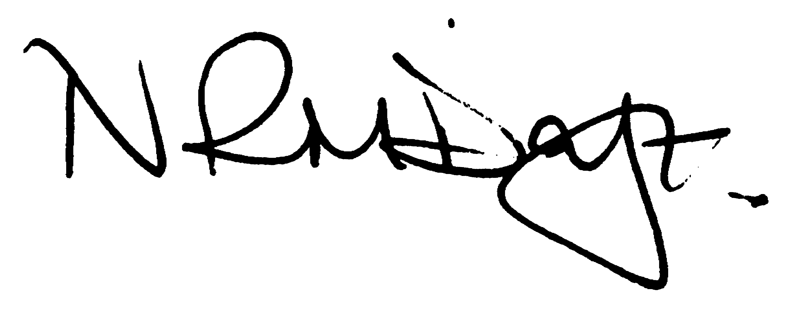

Nikki Daft – Parish Clerk

There will be a presentation by Mick George regarding a proposed planning application for Gipsy Lane Irchester.

AGENDA

APOLOGIES AND ACCEPTANCE OF APOLOGIES

16/127 NOTIFICATION OF ANY DISCLOSABLE PECUNIARY INTERESTS OR OTHER INTERESTS
Only in respect of matters which are to be considered by members below. (Disclosures previously declared and registered need not be repeated).

16/128 PUBLIC QUESTIONS, POLICE REPORT AND NCC UPDATE

Public participation may continue until for 15 minutes after which the public must not take part at any other time during the meeting. Request should be made to the Chair if any member of the public wishes to make a recording of any part of the meeting. All audible sounds to be switched to silent unless otherwise agreed at the start of the meeting. A report only can also be given by the Police and NCC representatives

16/129 MINUTES - To approve the minutes of the meetings held on 29th March 2017 as a true record

16/130 RESOLUTIONS AND ACTIONS - MATTERS FROM PREVIOUS MINUTES

- Letter to Rushden Neighbourhood Plan
- Letter to police re meeting attendance
- Letter to highways re potholes
- Nationwide account
- Contact Ramblers Association re footpath
- Order roundabout repair
- Order lighting repairs

16/131 FINANCIAL/POLICIES

- To Approve Payments for April 2017 (Clerk)
- To receive information regarding the current financial statement (Clerk)
- To agree the authorisation of the bacs payments
- To receive the end of year accounts

16/132 RECREATION GROUNDS

- To receive and agree the reports/repairs/damage to the recreation grounds (JD)

16/133 HIGHWAYS

- To agree any items that need to be added to the next agenda
- Street Doctor responses
- To receive an update re applying for a definitive footpath.
- To decide from the definitive footpaths which are the most popular used and unused routes.
- To discuss the proposals for the Section 50 licence
- To discuss the placing dog fouling signs
- To discuss the quotation for the new post for the village sign

16/134 LITTLE IRCHESTER/KNUSTON - To agree the Highway Warden report, previously circulated. Matters arising will be added to the next agenda

16/135 PLANNING - To discuss any planning issues

- WP/17/00167/FUL Retrospective re retention of sheds & containers, additional jetty, retention of clubhouse – Ditchford Pit

16/136 NEIGHBOURHOOD PLAN - To receive an update on the progress of the NHP

16/137 CEMETERY/WAR MEMORIAL

- To receive the Registrars report and decide if details should be added to the next agenda
- To discuss the cleaning of the War Memorial (request from resident)

16/138 COMMUNITY ISSUES

- To discuss the Best Village Competition as judges will be attending on Tuesday 23rd May 2017
- To discuss the registering of Community Assets within the parish

16/139 CORRESPONDENCE To consider information received from incoming correspondence and decide on agenda items for the next meeting.

- NCC consultation Sensory Impairment Service Review

