IRCHESTER PARISH COUNCIL

Minutes of the Ordinary Meeting of the Parish Council held on Wednesday 29th January 2025 at the Village Hall, School Road at 7.15p.m.

Members Present:
K Watts – In the Chair

Councillors
P Armstrong A Hurley J-P Carr P Smith D Schroll G Brotherston

The meeting started at 7.15pm. There was 1 member of the public present and NNC Cllr Partridge.

Minute silence was held for ex Councillor D Tate.

Chair welcomed the new Clerk Sarah Geyton and gave a thank you to the staff working party for their efforts.

Apologies - received and accepted from Cllrs B Leeson, I MacDonald, M May, J Dunkley, A Howden.

24/76 Notification of Any Interests

None declared.

24/77 Public Questions, Police Report and NNC Update

Public – No comments from public.

Police – Report received and sent to Cllrs prior to the meeting.

NNC Update – Leader’s report sent to councillors. NNC Cllr T Partridge Underwood mentioned about the importance of birds being registered due to the increased numbers of cases of avian influenza.

24/78 Minutes

RESOLVED - The minutes from 27th November 2024 and 8th January meetings were both agreed as a true record and signed by the Chair.

24/79 Financial Matters

- Payments – To agree the payments for December 2024 and January 2025 as listed below, noted an error on January payments payee M Wright should read M Geyton for monthly bus shelter clean.

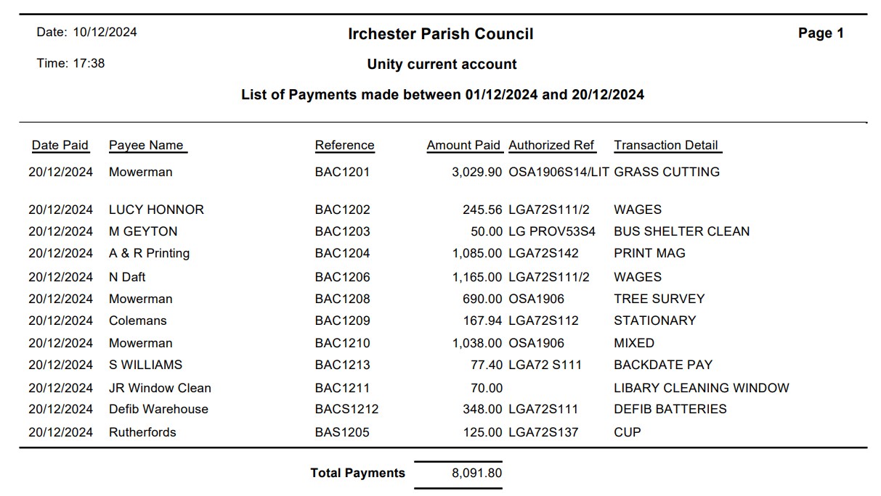
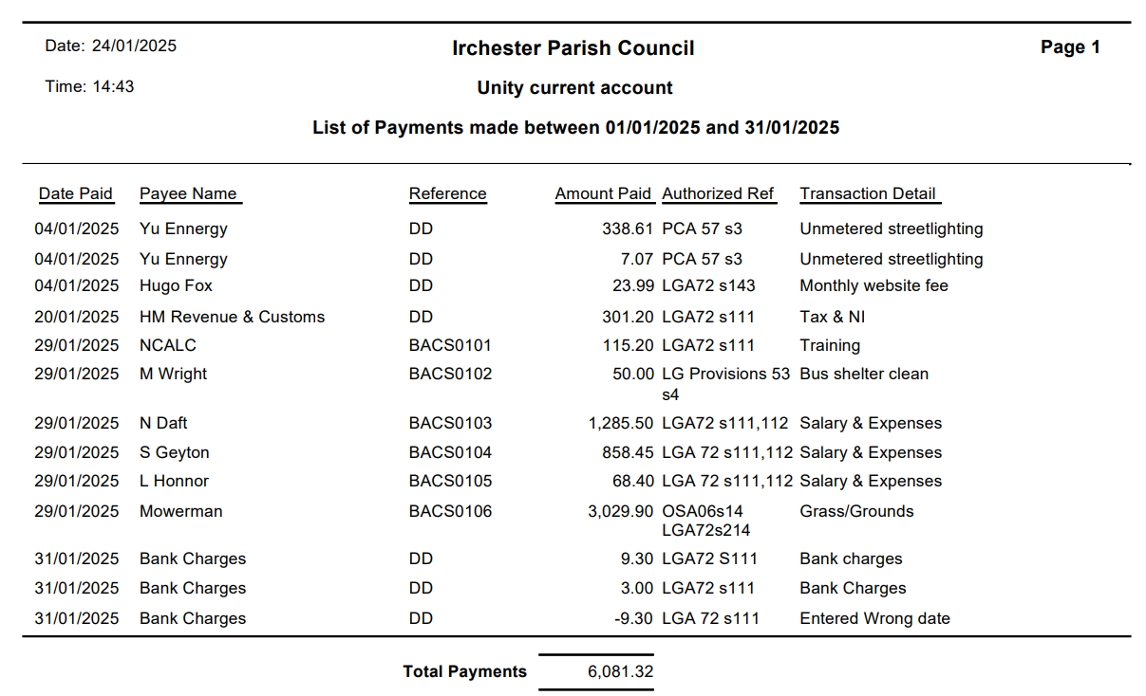
- The Current financial statement after the payments £220,767.63.
- RESOLVED that Cllrs JP Carr & P Smith to authorise the bacs payments for January 2025.
- RESOLVED to approve the office furniture list for the parish office.
- RESOLVED to approve the domain name of (irchesterparishcouncil.gov.uk) from Hugo Fox.

24/80 Recreation Grounds

- No issues raised.
- RESOLVED to accept the quotation for cleaning of play equipment.

24/81 Highways
- No issues raised. Cllr Carr advised he attended a Kier drop in at the library and raised queries about resurfacing on the High Street which is scheduled for March and the grass cutting of verges within the 30mph signs zone along Knuston.
- RESOLVED to accept the quotation for fitting the new noticeboards.
- Defib batteries have been collected by the Clerk and will be changed when needed. Also advised during an inspection of the cabinet in Lt Irchester the entry pad was recently seized up, this has now been rectified. Council have given the Clerk delegated powers to buy and arrange fitting of a new cabinet up to £800 when required.
- RESOLVED to approve to the contributions of £830 to NNC highways for the grass verge repairs and installation of bollards on the corner of Farndish Road.

24/82 Cemetery/War Memorial
  - Report sent from the Cemetery Officer advising busy with various call and queries over last few weeks. An ongoing issue with spoil in the cemetery is being dealt with. Following the memorial testing, 31 headstones had failed and 2 lessees have responded advising they will repair them. To date 29 lessees have not responded to the request. Further action to be discussed at the next meeting.
  - RESOLVED to approve of 7 grave levelling plots in the cemetery.
  - Discussed ongoing maintenance of the flag poles – no further actions, maintenance arranged.

24/83 Planning

- To note the below comments for the following planning applications received by NNC
NW/24/00719/FUL
Proposal: Single storey side extension to create new entrance porch, kitchen diner and utility room.
Location: 2 Warren Close, Irchester, Wellingborough, NN29 7HF

No comment from the council.

- No decisions to note from NNC.

24/84 Correspondence

- Email from NCALC about a new path warden scheme, Clerk recommended to wait till after the elections.

24/85 Exclusive to Public and Press

RESOLVED: That pursuant to the Public Bodies (Admission to Meetings) Act 1960, the public and press is excluded from the meeting for the item of business on the grounds that publicity would be prejudicial to the public interest by reason of the confidential nature of the business to be discussed.

24/86 Staff

- Clerk updated the council with information provided following contact from ACAS.
- Contracts have been completed and now awaiting signed copies for personnel file. Discussion took place regarding the overtime for the former Clerk and including unused holiday allowance.

Meeting closed at 9.10pm

Chair

These minutes are draft until agreed at the next full council meeting

