
The Parish Council of Irchester
Clerk  Nikki Daft PSLCC  45 Park Road  Irthlingborough  Northants  NN9 5PW |  | Telephone 07525 909528  irchesterpc@gmail.com

Dear Councillor 19th August 2019

You are hereby summoned to attend the Ordinary meeting of Irchester Parish Council to be held in the Village Hall, School Road Irchester on Wednesday 28th August 2019 at 7.15p.m.

Yours faithfully
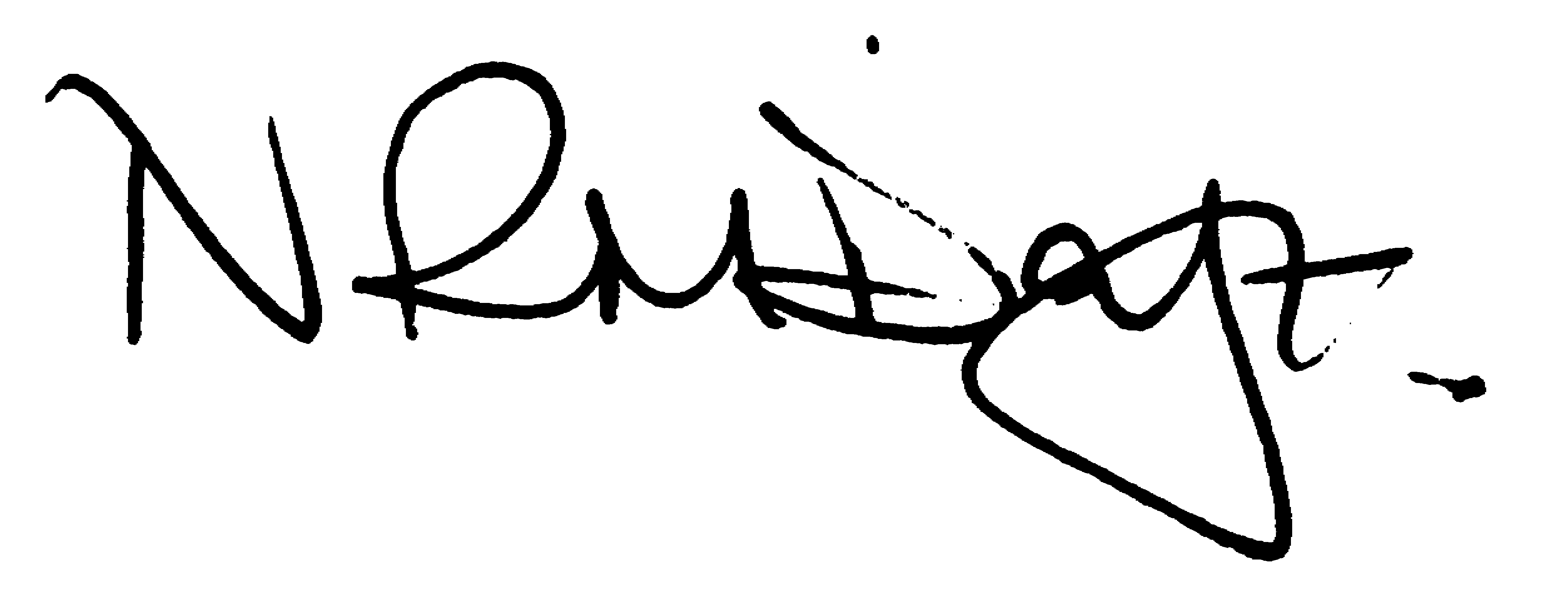

Nikki Daft – Parish Clerk

AGENDA

APOLOGIES AND ACCEPTANCE OF APOLOGIES

19/30 PUBLIC QUESTIONS AND/COMMENTS

Public participation may continue until for 15 minutes after which the public must not take part at any other time during the meeting. Any member of the public can make a recording of any part of the meeting. All audible sounds to be switched to silent unless otherwise agreed at the start of the meeting.

POLICE REPORT AND NCC UPDATE

To receive a verbal report from the Police and NCC representative if in attendance

19/31 NOTIFICATION OF ANY DISCLOSABLE PECUNIARY INTERESTS OR OTHER INTERESTS
Only in respect of matters which are to be considered by members below. (Disclosures previously declared and registered need not be repeated).

- To receive declarations of interest
- Councillors to declare any personal interest in any items on the agenda
- Councillors to declare any personal and/or prejudicial interest in any items on the agenda and to inform the Chairman if they wish to speak on the matter during public participation

19/32 MINUTES - To approve the minutes of the meetings held on 26th June 2019 as a true record.

19/33 CO OPTION – To review candidates for co-option

19/34 RESOLUTIONS AND ACTIONS - MATTERS FROM PREVIOUS MINUTES

- Cemetery – remove/mulch tree branches
- Notice board – Little Irchester ordered
- Norse/highways re refuse collection/parking
- Wetpore & park repairs
- Tree trimming

19/35 FINANCIAL/POLICIES

- To Approve Payments for July and August 2019 details sent to councillors via email (Clerk)
- To receive information regarding the current financial statement – reconciliation statement sent to councillors via email (Clerk)
- To agree the authorisation of the bacs payments
- To note recommendations from the Finance Working Party regarding the transfer of funds from the current account to the savings account and to discuss to adopt the following policies
Update to the Financial Regulations 2019
Communications Policy
Data Breach Policy v2
Data Protections Policy
Business plan v7

19/36 RECREATION GROUNDS

- To receive and agree the reports/repairs/damage to the recreation grounds (JD)
- To decide if the Saturday workshop/exercise group should be charged for using the recreation ground

19/37 HIGHWAYS

- To agree any items that need to be added to the next agenda

19/38 LITTLE IRCHESTER/KNUSTON - To agree the Highway Warden report. Matters arising will be added to the next agenda.

19/39 CEMETERY/WAR MEMORIAL/GARDENS

- To discuss the purchasing of watering cans for the cemetery

19/40 PLANNING

- WP/19/00453/FUL – Demolition of single storey conservatory and erection of single storey with roof lantern – re submission – 152 Station Road
- WP/19/00470/FUL Proposal: Two storey side extension and a single storey rear extension. Location: 39 Farndish Road, Irchester, Wellingborough, Northamptonshire, NN29 7BD

19/41 COMMUNITY/CONSULTATIONS EVENTS

- To consider the article ‘why be a councillor’ to be included in the next 2 issues of the Village Voice
- To discuss the cost of replacing the batteries in both defibrillators
- To discuss the problem with the tree roots causing damage to the Village Hall wall.

19/42 CORRESPONDENCE To consider information received from incoming correspondence and decide on agenda items for the next meeting.

19/43 EXCLUSIVE TO PUBLIC AND PRESS

Bridges – To agree the Bridges guidance
Library – to discuss the condition survey received from NCC
Parsons Hall - To discuss the setting up a new lease between the Parish Council and the Youth Centre Trust Fund as requested by their solicitors

