
The Parish Council of Irchester
Clerk  Nikki Daft  45 Park Road  Irthlingborough  Northants  NN9 5PW |  | Telephone 07525 909528  irchesterpc@gmail.com  www.hugofox.com/community/irchester-parish-council-13388/about-us

Dear Councillor 16th April 2024

You are hereby summoned to attend the Ordinary Meeting of Irchester Parish Council on Wednesday 24th April 2024 at 7.15p.m.at the Village Hall, School Road, Irchester

Yours faithfully

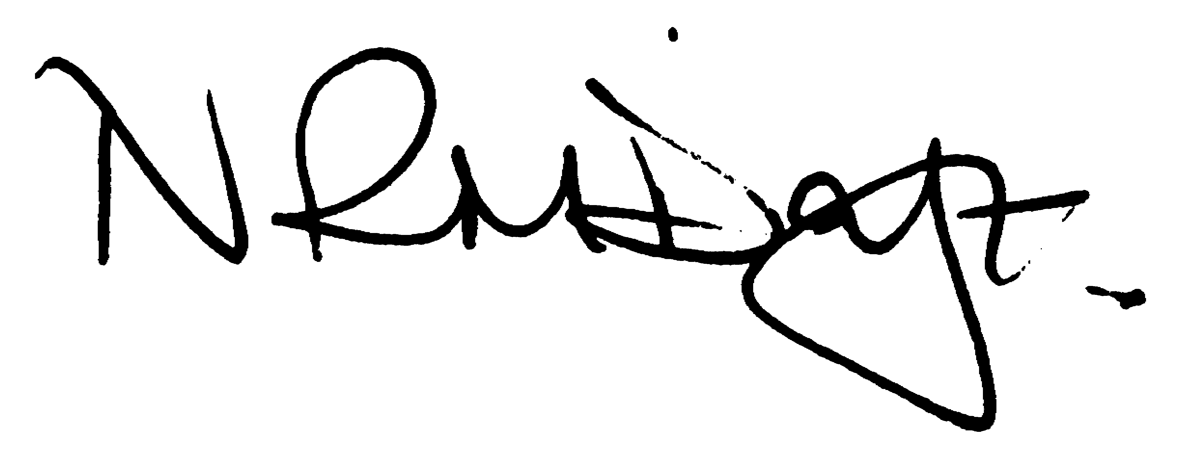

Nikki Daft – Parish Clerk

AGENDA

APOLOGIES AND ACCEPTANCE OF APOLOGIES

23/110 PUBLIC QUESTIONS, POLICE REPORT AND NNC UPDATE

Public are requested to send specific questions to council prior to the meeting due to time constraints

23/111 NOTIFICATION OF ANY DISCLOSABLE PECUNIARY INTERESTS OR OTHER INTERESTS
Only in respect of matters which are to be considered by members below. (Disclosures previously declared and registered need not be repeated).

- To receive declarations of interest
- Councillors to declare any personal interest in any items on the agenda
- Councillors to declare any personal and/or prejudicial interest in any items on the agenda and to inform the Chairman if they wish to speak on the matter during public participation

23/112 CO-OPTION

To receive details of co-option

23/113 MINUTES

- To approve the minutes of the meeting held on 27th March 2024 as a true record.

23/114 FINANCIAL/POLICIES

- To Approve Payments for April 2024 (Clerk)
- To receive information regarding the current financial statement (Clerk)
- To agree the authorisation of the bacs payments
- To receive the year end reports for 2023/24
- To receive the Internal Audit report
- To agree Section 1 of the AGAR
- To agree Section 2 of the AGAR

23/115 CEMETERY/WAR MEMORIAL

- To receive an update on cemetery matters

23/116 HIGHWAYS

- To receive an update on any Highways issues
- To discuss the monitoring of the dog bin in Woodlands Road
- To receive details regarding the NNC parking restriction procedures

23/117 PLAY AREAS

- To receive an update of the play areas
- To agree the request from Taylors Amusements to use the recreation ground from 17th June to 23rd June 24

23/118 COMMUNITY

To receive an update on the community orchard

23/119 CORRESPONDENCE

- Information regarding Boundary changes
- Letter received from Village Hall Committee withdrawing funding request
- Letter received from resident regarding replacing a bench

23/120 EXCLUSIVE TO PUBLIC AND PRESS

To agree to discuss the following item exclusive to public and press

23/121 COMMUNITY BUILDINGS UPDATE

To receive an update regarding the leases to the pc community buildings

