IRCHESTER PARISH COUNCIL

Minutes of the Ordinary Meeting of the Parish Council held on Tuesday 13th December 2022 at
the Irchester Library, High Street, Irchester at 7.15p.m.

Members Present:
P Armstrong – In the Chair

Councillors
P Smith K Watts L Brown JP Carr K Clarke
S Bridge C Ashford M May D Shroll S East

The meeting started at 7.15pm. There was 5 members of the public present.

Apologies - Agreed and Accepted from Cllr J Dunkley and T Maguire.

22/66 Public Questions, Police Report and NNC Update

Public Query was raised regarding the new streetlight on the corner of Station Road which is due to be replaced in January 2023. It was stated that the trees on Wollaston Road are causing an issue with leaves blocking drains and branches causing visibility issues. NNC councillor stated NNC would issue a tree maintenance programme in the new year. It was also noted that it would appear tree roots were damaging a driveway which needs to be reported direct to NNC. It was requested that the council write to NNC about asking to start the programme as soon as possible.

NNC Received an update following the Highways review in the village which has been carried out and issues raised regarding resurfacing on High Street, drop kerbs in Knuston, the embankment on Farndish Road/East Street and the kerb on left corner, damaged bollard outside the Co-op, Knuston ford and flooding, and the sign in Little Irchester and when it is to be replaced. Planning training to be organised by NNC for parish councillors following peer review. A Query was raised regarding Knuston Hall and advised that there was no further update on this following the marketing material being sent through.

22/67 Notification of Any Interests

Cllr Carr 22/70 item i

22/68 Minutes

The minutes from 26th October 2022 and 30th November 2022 were agreed as a true record and signed by the Chair.

22/69 CO-OPTION

• RESOLVED to transfer Cllr East from the Irchester Ward to represent the Ward of Little Irchester.
• RESOLVED that Mr Vassell and Miss Blake be co-opted as councillors for the Irchester Ward. Acceptance of Office paperwork was signed and witnessed by the Clerk.

22/70 Financial Matters

- Payments – RESOLVED: That the payments for November £20,008.88 were approved.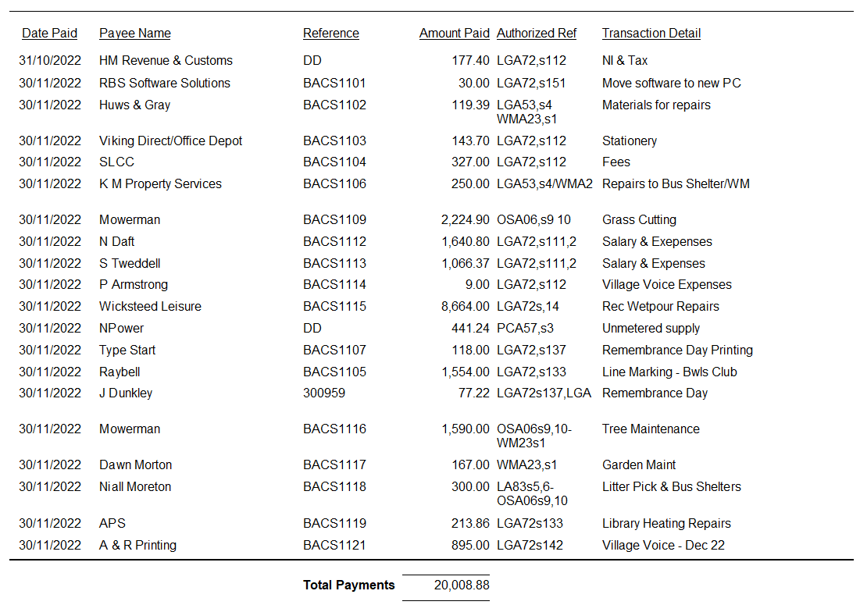

- The Current financial statement after the November payments being £192,379.09.
- RESOLVED to accept the Budget of £146,260.00 for 2023/2024.
- RESOLVED to request from NNC a Precept of £100,268.00 for 2023/2024.
- RESOLVED to adopt the standing orders and financial regulations without alternations.
- RESOLVED to accept the Business Plan for 2022 to 2025 adding the latest census figures.
- RESOLVED to add Cllr Watts & Cllr Ashford as new signatories for the online banking and cheques. Cllr Smith to be added to the online banking.

Cllr Carr left the meeting.
- RESOLVED to provide a grant to the library community management group of £1200 to be paid in 2 instalments (December and March). The grant allocated to be used to pay for the library utilities. Any further grant funding to be applied for through the councils grants system.

Cllr Carr returned to the meeting.

22/71 Cemetery/War Memorial

- Bookings have been made for January 2023 and war graves have been checked. Memorial testing of the headstones is due in 2023/24. The current headstones in need of repair to be addressed at the next Working Party meeting.

22/72 Highways

- NNC have issued a licence for the oak tree to be planted on their land opposite Parsons Hall.
22/73 Play Areas

- The seats and wetpour repairs have been completed and the recommended repairs from the annual inspection to the play equipment in the recreation ground has now been ordered. Lead time is approximately 12 weeks.
- Quotations for new play area equipment in Daniels Road, Little Irchester to be received for the next council meeting. A donation from the 1-100 club will be sent to the council towards the purchase of new equipment.
- There is some wear and tear to the concrete housing for the metal rails at the stake park in Austin Close which is being monitored.

22/74 Community Projects

- Orchard – New trees and bulbs have arrived and due to be planted when the weather improves.
- Library – Held 113th birthday party for the local community. Volunteers have been trained. New books are being ordered quarterly. Warm Space is being made available on Friday mornings between 9am and 1pm. The vegetation in the library grounds is slowly being cleared. It was noted that there were approximately 200 visitors through the door in November.
- King Charles III Coronation – May 2023 – It was agreed to look into the cost of a new coronation bench for peartree corner.

22/75 Planning

The following planning applications were discussed:
- NW/22/00796/FUL - Location: High Farm 400 Station Road Irchester Wellingborough NN29 7EY
Proposal: Demolition of the attached lean-to structures to centralised brick building (former cottage) and extension and conversion to form a three-bedroom residential dwelling. No comment.
- NW/22/00872/FUL – Location: 14 Baker Crescent Irchester Wellingborough NN29 7BB
Proposal: First floor extensions to side and rear of property and front porch. Agree with Highways.

It was stated that the planning application for the Solar farm in Little Irchester had been determined. Community funds from this application will be available from 2024.

22/76 CORRESPONDENCE

The Parish Councillors were advised of the new trustees for the Bowls Club as per their constitution.

22/77 Exclusive to Public and Press

RESOLVED: That pursuant to the Public Bodies (Admission to Meetings) Act 1960, the public and press is excluded from the meeting for the item of business on the grounds that publicity would be prejudicial to the public interest by reason of the confidential nature of the business to be discussed.

22/78 Village Voice

- Discussion took place regarding changes to the current Village Voice magazine. RESOLVED to buy a new publisher package and training book for up to £150. It was also agreed to create a new email address for village articles. Follow up discussions at next meeting.

Meeting closed at 9.30pm

Chair

