
The Parish Council of Irchester
Clerk  Nikki Daft MILCM  45 Park Road  Irthlingborough  Northants  NN9 5PW |  | Telephone 01933384180  Parishclerk123@gmail.com

Dear Councillor 9th May 2016

You are hereby summoned to attend the Annual meeting of Irchester Parish Council followed by the ordinary meeting of the Parish Council to be held at Village Hall, School Lane, Irchester on Wednesday 18th May 2016 at 7.15p.m.

Yours faithfully
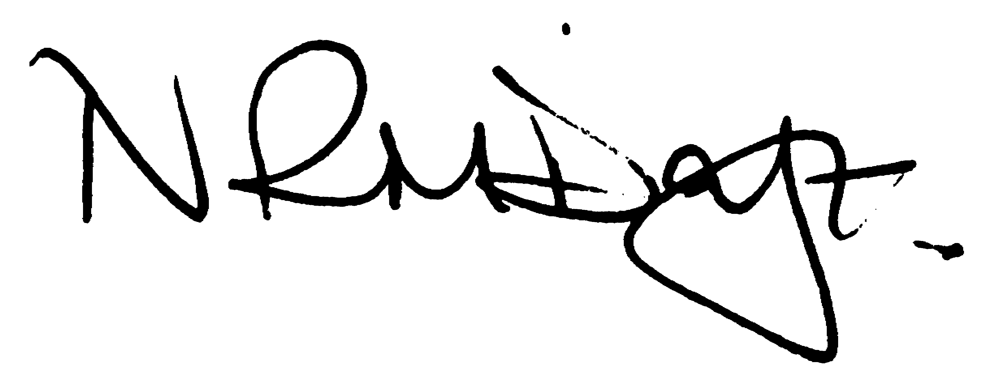

Nikki Daft – Parish Clerk

AGENDA

APOLOGIES AND ACCEPTANCE OF APOLOGIES

16/1 COUNCILLORS, CHAIRMAN ELECTION AND ACCEPTANCE OF OFFICE

- To receive nominations and elect a Chair for the Parish Council for the ensuing year. Declaration of acceptance of office to be completed.

16/2 CO-OPTION

- To receive applications from interested parties to be co-opted on to the council in order to fill the current vacancy

16/3 NOTIFICATION OF ANY DISCLOSABLE PECUNIARY INTERESTS OR OTHER INTERESTS
only in respect of matters which are to be considered by members below. (Disclosures previously declared and registered need not be repeated).

16/4 APPOINTMENTS OF MEMBERS to the following specific areas of interest:

a) Vice Chair b) Internal Accounts Controller and Digital Overseer
c) Footpaths d) Highway Warden Irchester
e) Highway Warden Little Irchester and Knuston

16/5 APPOINTMENT OF ADVISORY GROUPS

- Public lighting
- Finance
- Recreation
- Cemetery
- Planning
- Village Voice
g) Emergency planning/flooding

16/6 APPOINTMENT OF REPRESENTATIVES ON OUTSIDE BODIES

To appoint representatives on Outside Bodies for the following:

a) Irchester Sports Association (2) b) Village Hall Committee
c) Youth Centre Management Committee d) Allotment Association
e) Bowling Club Committee

15/7 DATES OF COUNCIL MEETINGS 2016/17

To approve the dates and venues for meetings throughout 2015/16

29th June 2016 25th January 2017
31st August 2016 22nd February 2017
28th September 2016 (HH) 29th March 2017 (HH)
26th October 2016 26th April 2017
30th November 2016 24th May or 31st 2017 Annual Meeting

To commence the Ordinary Meeting of Irchester Parish Council

16/8 MINUTES

a) To approve the minutes of the meeting held on 27th April 2016 as a true record

16/9 PUBLIC QUESTIONS, POLICE REPORT AND NCC UPDATE

Public participation may continue until for 15 minutes after which the public must not take part at any other time during the meeting. Request should be made to the Chair if any member of the public wishes to make a recording of any part of the meeting. All audible sounds to be switched to silent unless otherwise agreed at the start of the meeting. A report only can also be given by the Police and NCC representatives

16/10 RESOLUTIONS AND ACTIONS - MATTERS FROM PREVIOUS MINUTES
Agenda | Task | By | Completed/comments
April | Letter to post office re parking, hrs & security | Clerk | Sent 29/4
 | Play equipment review | Rec Grp | To organise
 | NHW information | Clerk | Requested 29/4
 | 10th Edition Charles Arnold Baker | Clerk | Pending for July
 | Order chains for swings in Daniels Road | Clerk | Monitoring
 | Highways visit re section 50 licence | Clerk | Requested
 | Fair attending, cost & H & S check | Clk/JD | Info requested
 | Denton Close | Clerk
 | Cemetery tree works | Clerk | Ordered
 | Welcome leaflet draft | Cllrs | Draft
 | Response re contribution to recycling centre | Clerk | Sent 29/4

16/11 FINANCIAL/POLICIES

- To Approve Payments for May 2016 (Clerk)
- To receive information regarding the current financial statement (Clerk)
- To agree the authorisation of the bacs payments
- To review the Standing Orders, Financial Regs, Risk Assessment and Internal Audit Controls for 2016/17
- To agree the Annual Governance for the External Auditor and receive the Internal Auditors Report for the accounts ending 2015/16
- To discuss the lengthsman attending a weed spraying course at Moulton College for a fee of £195.00
- To receive information from Lark Energy regarding grant funding for Little Irchester
- To discuss the valuation of all parish council owned land/property

16/12 RECREATION GROUNDS

- To receive and agree the reports/repairs/damage to the recreation grounds (JD)

16/13 HIGHWAYS

- To agree the Highway Warden report, previously circulated. Matters arising will be added to the next agenda
- To consider placing a dog bin/litter bin in Farndish Road

16/14 LITTLE IRCHESTER/KNUSTON

- To agree the Highway Warden report, previously circulated. Matters arising will be added to the next agenda

16/15 PLANNING

- WP/16/002200/FUL – Single storey and side extension 15 Prospect Avenue
- Construction of viewing platform Irchester Country Park

16/16 NEIGHBOURHOOD PLAN

- To receive an update on the NHP

16/17 CEMETERY/WAR MEMORIAL

- To receive the Registrars report, previously circulated, and decide if details should be added to the next agenda

16/18 COMMUNITY

- To receive an update on the Best Village Competition
- To discuss the draft Welcome to Irchester leaflet
- To discuss the positioning of the defibrillator for Little Irchester
- To agree the response for the Wellingborough Local Plan

16/19 CORRESPONDENCE

To consider information received from incoming correspondence and decide on agenda items for the next meeting.

