IRCHESTER PARISH COUNCIL

Minutes of the Annual and Ordinary Meeting of the Parish Council held on
Wednesday 21st May 2025 at the Village Hall, School Road at 7.15p.m.

Members Present:
K Watts – In the Chair

Councillors:
M May, JP Carr, J Dunkley, B Leeson, A Hurley, P Smith, G Brotherston, A Howden

The meeting started at 7.15pm. there were 4 members of the public present

Apologies - Received and accepted from Cllrs I McDonald.
- Election of Chair
  - Nominations and Seconders for the Chair were received for Cllr Hurley and Cllr Leeson.
RESOLVED Cllr Leeson be elected as Chair for the forthcoming year. The declaration of acceptance of office was signed and witnessed by the Clerk.

- Acceptance of office
  - The declaration of acceptance of office for newly elected parish councillors was signed and witnessed by the Clerk.

- Declaration of Interest
No interests declared.

- Co-Option
  - RESOLVED to co-opt Davina Shroll onto the Little Irchester Ward. Declaration of office was signed and witnessed by the Clerk.

- Appointment of Members to the following specific areas of interest
  - Vice Chair – Nominations and Seconders were received for Cllr Carr, Cllr Hurley & Cllr Smith – RESOLVED Cllr Smith appointed as Vice Chair for the forthcoming year.
  - Internal accounts Controller – Cllr M May
  - Footpaths – Cllr G Brotherston
  - Highway Wardens Irchester, Little Irchester and Knuston – Cllr J Dunkley
  - H & S Representative – Cllr J Dunkley

- Appointment of Advisory Groups/Working Parties - Chair and Vice Chair being ex-officios
Groups below to be set up as and when required:
Recreation Cemetery Highways and Lighting Orchard

The following established Working Parties
  - Finance, Staff & Policies – Members being Chair, Vice Chair, Cllrs JP Carr, D Shroll & A Hurley.
  - Planning – Members being Chair, Vice Chair, Cllrs JP Carr, & J Dunkley.
  - Emergency planning/flooding – Members being Chair, Vice Chair & Cllrs P Smith, M May, J Dunkley.
  - Community Projects – Members being Chair, Vice Chair, Cllrs Carr, A Hurley & G Brotherston.
  - Village Magazine – Members being Chair, Vice Chair Cllr Carr & member of the public Pam Armstrong.
  - Youth Council – Chair, Vice Chair Cllr G Brotherston.
  - AI and Technology – Chair, Vice Chair Cllr G Brotherston.

- Appointment of Representatives on Outside Bodies
  - Irchester Sports Association (2) Cllr P Smith & A Hurley
  - Village Hall Committee – Cllr P Smith
  - Youth Centre Management Committee – Cllr A Howden
  - Allotment Association – Deferred
  - Bowling Club Committee – Deferred
  - Library – Deferred

- Dates of Council meetings 2025-26
RESOLVED the dates for council meetings throughout 2025/26 being

25th June 2025 30th July 2025 24th September 2025
29th October 2025 26th November 2025 28th January 2026
25th February 2026 25th March 2026 29th April 2026

Minutes of the Ordinary Meeting of the Parish Council

- Public Questions, Police Report and NNC Update
Public – Member raised that the trees are overgrown at the zebra crossing on Wollaston Road. Member reported the potholes that have been repaired are breaking away again and requesting to raise this further with NNC.

NNC Update – No new updates. NNC Cllr Tom Partridge-Underwood gave his apologies.

- Minutes
  - RESOLVED to approve the minutes held on 30th April 2025 and signed by the Chair as a true record.

- Financial Matters
  - Payments – Resolved that the payments of £8,646.52 for May 2025 were approved.
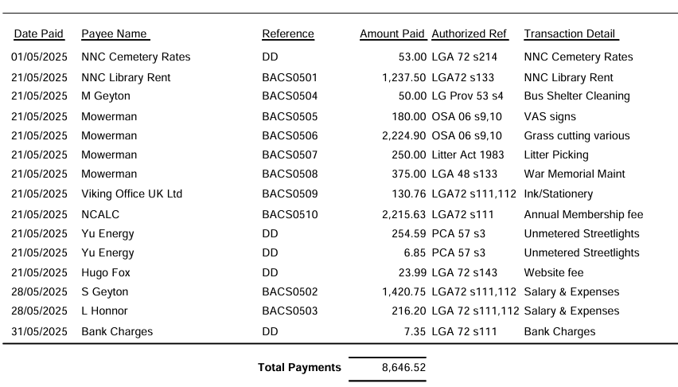
  - The Current financial statement after the payments £299,631.43.
  - RESOLVED that Cllrs Carr and Cllr Smith to authorise the bacs payments for May 2025
  - Bank signatories deferred to next the meeting.
  - Financial Risk Assessment, Standing Orders and Financial Regulations deferred to next the meeting due to changes to model, Clerk to review.

- Recreation Ground
  - Wet pour at the swings on Wollaston Road have been inspected by Edspace and a full refit has been recommended at £6,334.00. RESOLVED to accept the quotation. Monthly checks of recreation grounds showed the springer base at Wollaston Road was loose and in need of repair, Clerk to contact the supplier for quotation to repair. Also raised that the large slide wet pour edges are coming away in 4 places quotation received from Edspace for £175 each section. RESOLVED to accept the quotation and work to be scheduled in with other repair.

- Highways
  - No new issues reported

- Cemetery/War Memorial
  - No report provided. Several queries have been received and visits to the cemetery.

- Planning
  - To note the below comments for the following planning applications received by NNC
- NW/25/00158/FUL – Proposal: Proposed erection of two, two-storey extensions and recladding to an existing commercial office – Location: Victoria Mills, London Road, Little Irchester, Wellingborough, NN8 2DT – No comments.

- NW/25/00243/FUL – Proposal: Demolition of double garage at 191 Wollaston Road and erection of a detached two storey 3-bedroom dwelling to side of 191 Wollaston Road – Location: 191 Wollaston Road, Irchester, Wellingborough, NN29 7DG – PC has the below comments on the application.

- The Parish Council agrees with the comments raised by NNC Highways. We also feel they go against the aspect of adequate parking provision/layout and highways safety as explained in the Joint Core Strategy, Policy 8, Section Bi, Bii and Biii
- The lost of garden and substantial fully grown trees is detrimental to the streetscape and again goes aspect of the Joint Core Strategy, Policy 8, Di and Dii and Ei
- The Parish Council feel that the overall layout and size of the dwelling in the plot provided, and its nearness to it Neighbours at 193 Wollaston Road. The plan is detrimental as laid out in the Joint Core Strategy, Policy 8, Ei
- The Parish Council also thinks the overall frontage of the property is out of keeping with the character of the street and also goes against Policy 8, Di and Dii.

  - No decisions to note from NNC.

- Correspondence
All correspondence has been emailed to council and nothing further to raise.

Item for next agenda update on the Sports Association lease.

Meeting closed at 8.19pm Chair 25th June 2025

