
The Parish Council of Irchester
Clerk  Nikki Daft  45 Park Road  Irthlingborough  Northants  NN9 5PW |  | Telephone 07525909528  irchesterpc@gmail.com  www.hugofox.com/community/irchester-parish-council-13388/about-us

Dear Councillor 22nd May 2023

You are hereby summoned to attend the Annual meeting of Irchester Parish Council followed by the ordinary meeting of the Parish Council to be held at Village Hall, School Lane, Irchester on Wednesday 31st May 2023 at 7.15p.m.

Yours faithfully
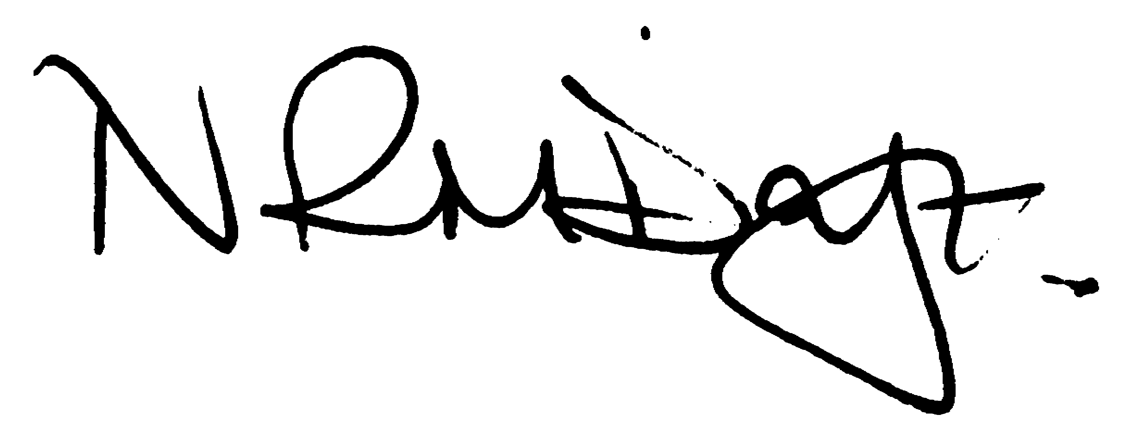

Nikki Daft – Parish Clerk

AGENDA

APOLOGIES AND ACCEPTANCE OF APOLOGIES

23/1 CHAIRMAN ELECTION AND ACCEPTANCE OF OFFICE

- To receive nominations and elect a Chair for the Parish Council for the ensuing year. Declaration of acceptance of office to be completed.

23/2 NOTIFICATION OF ANY DISCLOSABLE PECUNIARY INTERESTS OR OTHER INTERESTS
Only in respect of matters which are to be considered by members below. (Disclosures previously declared and registered need not be repeated).

- To receive declarations of interest
- Councillors to declare any personal interest in any items on the agenda
- Councillors to declare any personal and/or prejudicial interest in any items on the agenda and to inform the Chairman if they wish to speak on the matter during public participation

23/3 APPOINTMENTS OF MEMBERS to the following specific areas of interest:

a) Vice Chair b) Internal Accounts Controller
c) Footpaths d) Highway Wardens for Irchester, Little Irchester and Knuston
e) H & S Representative

23/4 APPOINTMENT OF ADVISORY GROUPS/WORKING PARTIES

- Finance/Staff
- Recreation
- Cemetery
- Highways & Lighting
- Planning
- Orchard & Wild Flower areas
- Emergency planning/flooding
- Community Projects
- Village Voice

23/5 APPOINTMENT OF REPRESENTATIVES ON OUTSIDE BODIES

To appoint representatives on Outside Bodies for the following:

a) Irchester Sports Association (2) b) Village Hall Committee
c) Youth Centre Management Committee d) Allotment Association
e) Bowling Club Committee f) Library

23/6 DATES OF COUNCIL MEETINGS 2022//23

To approve the dates for meetings throughout 2023/24

28th June 2023 30th August 2023
27th September 2023 25th October 2023
29th November 2023 31st January 2024
28th February 2024 27th March 2024
24th April 2024 29th May 2024 (Annual Parish Meeting)

To commence the Ordinary Meeting of Irchester Parish Council

23/7 PUBLIC QUESTIONS, POLICE REPORT AND NCC UPDATE

Public participation may continue until for 15 minutes after which the public must not take part at any other time during the meeting. Request should be made to the Chair if any member of the public wishes to make a recording of any part of the meeting. All audible sounds to be switched to silent unless otherwise agreed at the start of the meeting. A report only can also be given by the Police and NCC representatives

23/8 MINUTES

a) To approve the minutes of the meeting held on 26th April 2023 as a true record

23/9 FINANCIAL/POLICIES

- To Approve Payments for May 2023 (RFO)
- To receive information regarding the current financial statement (RFO)
- To agree the authorisation of the bacs payments
- To review the financial risk assessment, standing orders and financial regulations

23/10 RECREATION GROUNDS

- To receive and agree the reports/repairs/damage to the recreation grounds

23/11 HIGHWAYS

- To determine highways issues to be added to the next agenda
- To receive an update regarding the PCC funding request for VAS signs

23/12 CEMETERY/WAR MEMORIAL

- To receive information regarding the cemetery

23/13 CORRESPONDENCE

To consider information received from incoming correspondence and decide on agenda items for the next meeting.

23/14 EXCLUSIVE TO PUBLIC AND PRESS

23/15 STAFF APPRAISALS

To discuss appraisal of staff

