
The Parish Council of Irchester
Clerk  Nikki Daft PSLCC  45 Park Road  Irthlingborough  Northants  NN9 5PW |  | Telephone 01933 384180  irchesterpc@gmail.com  www.hugofox.com/community/irchester-parish-council-13388/about-us

Dear Councillor 11th August 2021

You are hereby summoned to attend the ordinary meeting of Irchester Parish on Wednesday 18th August 2021 at 7.15p.m.at the Village Hall, School Road, Irchester

Yours faithfully
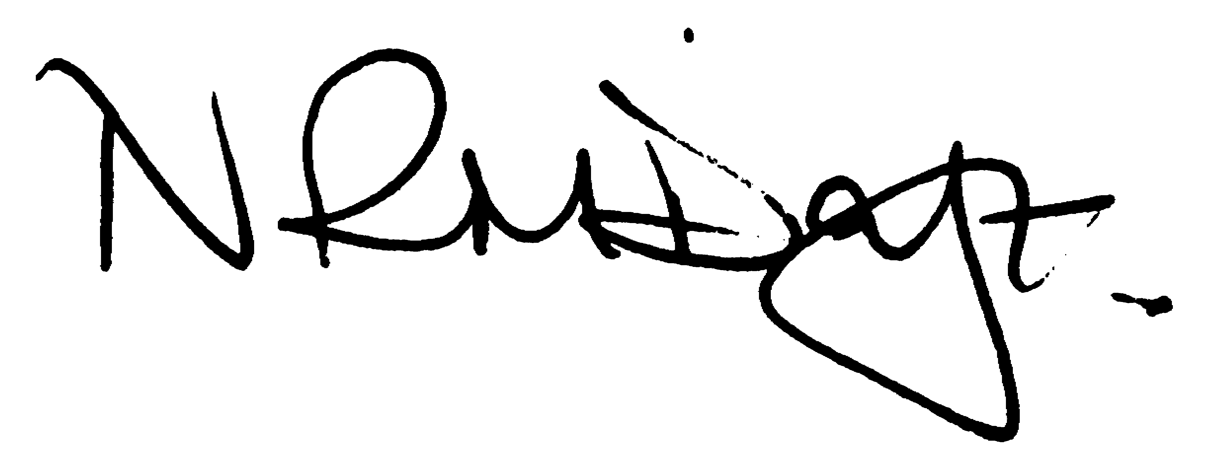

Nikki Daft – Parish Clerk

There will be a 15 minute presentation from Crimewave

AGENDA

APOLOGIES AND ACCEPTANCE OF APOLOGIES

21/29 PUBLIC QUESTIONS, POLICE REPORT AND NNC UPDATE

Public to send questions to council prior to the meeting due to time constraints

21/30 NOTIFICATION OF ANY DISCLOSABLE PECUNIARY INTERESTS OR OTHER INTERESTS
Only in respect of matters which are to be considered by members below. (Disclosures previously declared and registered need not be repeated).

- To receive declarations of interest
- Councillors to declare any personal interest in any items on the agenda
- Councillors to declare any personal and/or prejudicial interest in any items on the agenda and to inform the Chairman if they wish to speak on the matter during public participation

21/31 MINUTES

a) To approve the minutes of the meeting held on 30th June 2021 as a true record.

21/32 FINANCIAL/POLICIES

- To Approve Payments for July and August 2021 (Clerk)
- To receive information regarding the current financial statement (Clerk)
- To agree the authorisation of the bacs payments
- To set up a staff working party

21/33 CEMETERY/WAR MEMORIAL

- To receive an update on cemetery matters
- To receive costs for replanting bushes near to the baby section

21/34 PLANNING

- NW21/00624/LBC – Installation of play equipment, Replace staircase, Install kitchen equipment and reroute gas main within farmhouse – Chester House
- NW/21/00597/FUL – Rear and side extension – 134 Arkwright Road
- NW/21/00661/FUL – Change of use for several buildings – Chester House
- NW/21/00695/VAR – increase to 20 persons attending meditation sessions – Knuston Vale Station Road
- NW/21/00696/FUL – 2 storey single extension – Knuston Vale Station Road

21/35 HIGHWAYS

To receive information regarding any highways issues

21/36 PLAY AREAS

- To receive an update regarding the installation of the new play equipment
- To decide if the Sports Club can use the recreation ground as an overspill car park for an FA game (date to be confirmed)
- To discuss the painting of the play equipment on the recreation ground

21/37 COMMUNITY

- To discuss the cost of signage for the community buildings car parks
- To discuss the quotation received in order to reduce the hedge in Parsons Hall/Bowls Club care park

21/38 CORRESPONDENCE

To consider information received from incoming correspondence and decide on agenda items for the next meeting.
- To decide who wishes to attend the NCALC AGM on Saturday 2nd October 10am to 1pm at One Angel Square Northampton.
- To discuss the placing of a clothes bin for the Air Ambulance

21/39 EXCLUSIVE TO PUBLIC AND PRESS

21/40 AUSTIN CLOSE

To receive an update regarding the Promotion Agreement for Austin Close

