
The Parish Council of Irchester
Clerk  Nikki Daft PSLCC  45 Park Road  Irthlingborough  Northants  NN9 5PW |  | Telephone 01933384180  irchesterpc@gmail.com

Dear Councillor January 2018

You are hereby summoned to attend the Ordinary meeting of Irchester Parish Council to be held in the Village Hall, School Road Irchester on Wednesday 31st January 2018 at 7.15p.m.

Yours faithfully
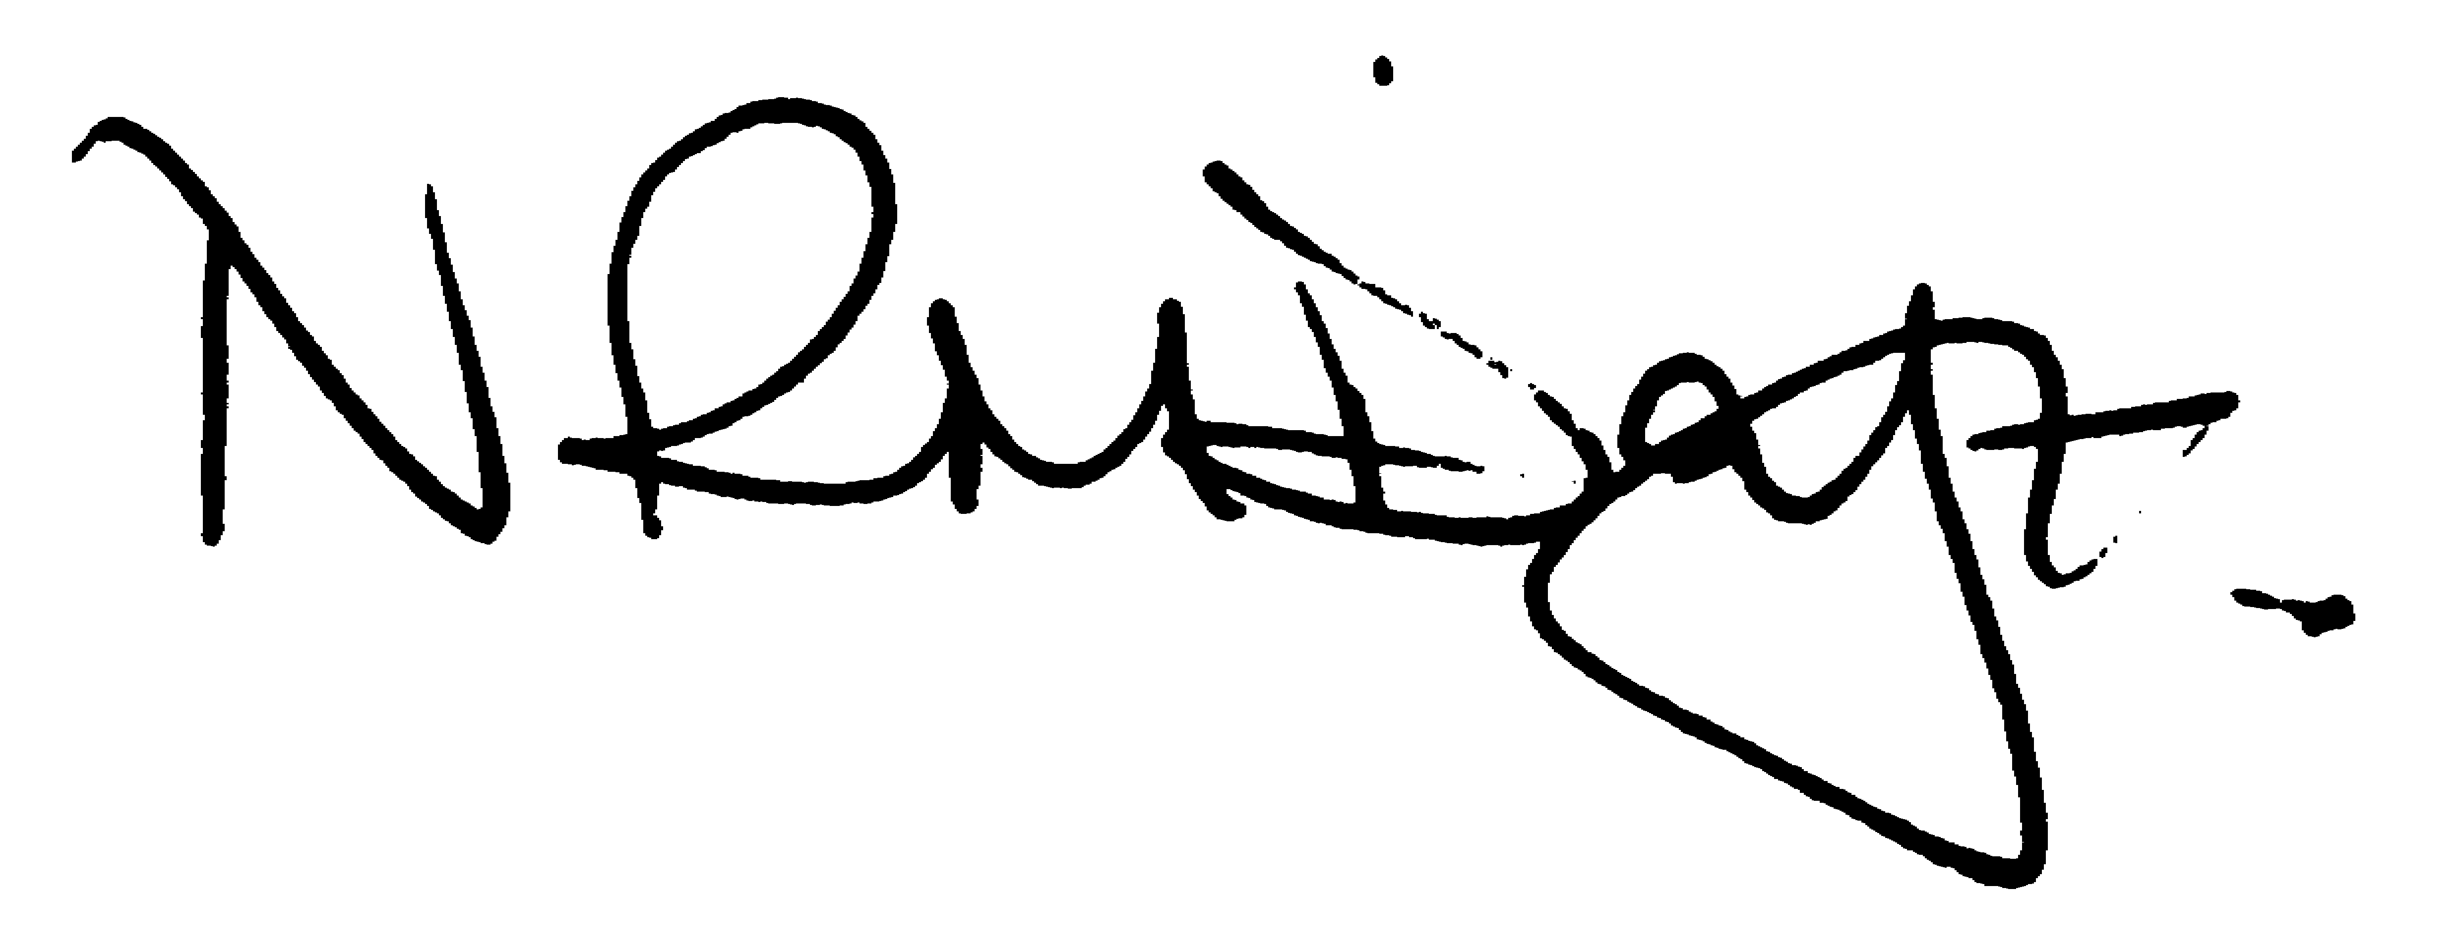

Nikki Daft – Parish Clerk

AGENDA

APOLOGIES AND ACCEPTANCE OF APOLOGIES

17/98 NOTIFICATION OF ANY DISCLOSABLE PECUNIARY INTERESTS OR OTHER INTERESTS
Only in respect of matters which are to be considered by members below. (Disclosures previously declared and registered need not be repeated).

- To receive declarations of interest
- Councillors to declare any personal interest in any items on the agenda
- Councillors to declare any personal and/or prejudicial interest in any items on the agenda and to inform the Chairman if they wish to speak on the matter during public participation

17/99 PUBLIC QUESTIONS, POLICE REPORT AND NCC UPDATE

Public participation may continue until for 15 minutes after which the public must not take part at any other time during the meeting. Request should be made to the Chair if any member of the public wishes to make a recording of any part of the meeting. All audible sounds to be switched to silent unless otherwise agreed at the start of the meeting. A report only can also be given by the Police and NCC representatives

17/100 MINUTES - To approve the minutes of the meetings held on 29th November 2017 as a true record.

17/101 RESOLUTIONS AND ACTIONS - MATTERS FROM PREVIOUS MINUTES

- Tree Memorial quotes – see agenda item 17/108
- Dates for training – 1st February 2018
- Mend fence at allotments – work instructed
- Organise a working party for 100 years war agenda 17/109

17/102 FINANCIAL/POLICIES

- To Approve Payments for January 2018 details sent to councillors via email (Clerk)
- To receive information regarding the current financial statement – reconciliation statement sent to councillors via email (Clerk)
- To agree the authorisation of the bacs payments
- To formally adopt the addition to the current Standing Orders to include councillors receiving notes from advisory group meetings - Standing Order 4 being ‘Advisory Groups should appoint 1 of their members to make notes of the outcome of the meeting which should then be sent to the Clerk for circulation to the other councillors’
- To agree the budget for 2018/19 and submit the precept to BCW of £98,302.00 for 2018/19

17/103 RECREATION GROUNDS

- To receive and agree the reports/repairs/damage to the recreation grounds (JD)

17/104 HIGHWAYS

- To agree any items that need to be added to the next agenda
- To discuss the condition of the footpaths, particularly the block paving and what course of action, if any, the council can take in order for improvements to be made (MM)
- Quote to supply and fit new notice board to Bradshaw Way (TM)

17/105 LITTLE IRCHESTER/KNUSTON - To agree the Highway Warden report, previously circulated. Matters arising will be added to the next agenda. To discuss the following problems that have arisen in the village:

- Damage to the wooden bus shelter – to discuss the repair
- Anti social behaviour within the village – to discuss what, if any, action that the council can take in order to combat asb
- Condition of housing association gardens – to discuss what, if any, action the council can take in order to improve the state of the gardens
- Grass cutting schedule for 2018 – to discuss the state of the grass verge and to determine if the grass cutting schedule should or can be changed.
- To discuss the cost of maintenance of the flag pole in Little Irchester as attention is needed in order to raise and lower the flag safely

17/106 PLANNING - To discuss any planning issues

WP/18/00012/FUL – 19th Public House to change into a dwelling
18/00004/FUL - Construction of a new link road between Ditchford Lane and Rushden Lakes (with associated site clearance and earthworks) alongside junction works, footpaths, cycleways, lighting, hard and soft landscaping and associated works at Land West Of Rushden Lakes Ditchford Lane Rushden Northamptonshire
17/00040/WASFUL - Importation of inert waste materials for improved restoration as Lowland Meadow habitat Land Off Gipsy Lane, Irchester
Appeal to Secretary of State regarding BCW refusal of planning application for Hilton Hall Little Irchester – to determine if further comment can be made from the Parish Council.

17/107 NEIGHBOURHOOD PLAN - To receive an update on the progress of the NHP

17/108 CEMETERY/WAR MEMORIAL

- To receive the Registrars report and decide if details should be added to the next agenda
- To discuss the quotations received in order for the tree on the war memorial to be pollarded.
- Motion 1 In line with 6a of standing orders a special motion " The Parish council shall consider a motion on the recent memorial testing and the website statement that amends any agreed resolution, action or policy on this subject and agree any expenditure required by the new motion"
proposed Cllr Richard Elliott
Seconded Cllr Kevin Watts
- Motion 2 " The parish council will restore the cemetery as far as safely possible to its original state before the recent memorial testing and will assist the berieved who have already restored their memorials.
The clerk will obtain quotations for the work for the next meeting and allocate finances from the budget including if necessary the balances to meet the cost after any liabilities by the memorial masons have been discharged."
Proposed Cllr Richard Elliott
Seconded Cllr Kevin Watts

17/109 COMMUNITY ISSUES

- To discuss organising a working party in order to organise events to commemorate World War One 100 years.
- To discuss the flag policy regarding lowering the flag on the death of a councillor/previous councillor
- Review of polling stations as per email sent via BCW

17/110 CORRESPONDENCE To consider information received from incoming correspondence and decide on agenda items for the next meeting.

17/111 EXCLUSIVE TO PUBLIC AND PRESS

17/112 COMPLAINTS

- To receive information regarding complaints and to access any help requested

17/113 COMMUNITY ASSETS

- To discuss how the council should proceed in securing Community Assets

17/114 REGISTRAR VACANCY

- To discuss the position of Cemetery Registrar

