IRCHESTER PARISH COUNCIL

Minutes of the Virtual Ordinary Meeting of the Parish Council held on Wednesday 26th August 2020 via Zoom at 7.15p.m.

Members Present:
P Armstrong – In the Chair

Councillors
P Smith D May JP Carr R Elliott A May
L Brown A Drage K Watts V Wilkinson

The meeting started at 7.15pm. There were no members of the public present.

Apologies - Agreed and Accepted from Cllr J Dunkley, D Shroll, Lesley Ellis Day & T Maguire
Apologies were received from Cllr A May for M May

20/18 Public participation/Police Report/NCC Update

No members of the public present. NCC Cllr M Griffiths attended the meeting.

Cllr M Griffiths stated that the centre of Wellingborough had been subjected to a fire and recent flooding. Concern was raised regarding the increased Covid 19 cases as many of the workers and families of the Greencore workplace lived in the Wellingborough area. A walk in testing station was being set up on the Market Square. Current concerns were being raised regarding the horse fair taking place over the bank holiday weekend. Advice from Public Health was that it doesn’t present a further covid risk however risk assessments etc have been carried out regarding the event. BCW have no power to prevent the event and neither do the police. It is thought that approximately 150-250 friends and family members are due to attend the site in Hardwater Lane. Some shops and businesses are concerned and will be closing over the weekend. It was stated that if public have concerns to ring the police and quote Operation Bailey.

Cllr Griffiths left the meeting

20/19 Declaration of Interest

Cllrs P Armstrong and L Brown regarding agenda item 20/28

20/20 Minutes

The minutes from 24th June 2020 were agreed as a true record.

20/21 Financial Matters

- Payments – Resolved: That the payments of £6681.50 for July and £5370.84 August 2020 be approved
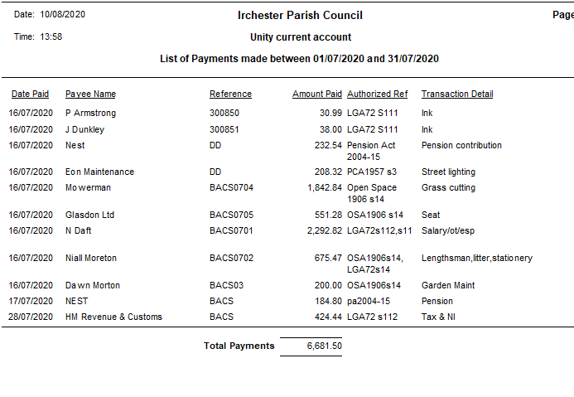
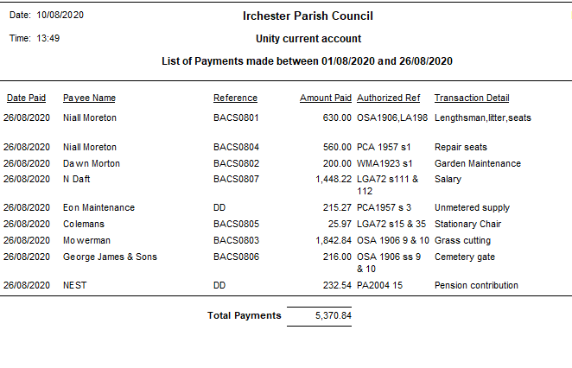
- Current financial statement £195,499.29 details sent to councillors prior to the meeting.
- RESOLVED that Cllrs JP Carr and L Brown to authorise the bacs payments for August 2020
- RESOLVED that the Standing Orders be adopted with the amendments to delegated powers for the Clerk, Chair and Vice Chair. It was also RESOLVED to increase the amount of delegated powers from £250 to £1000.00. It was also stated that the old Village Voice laptop had stopped working so there was no backup files for the cemetery database. RESOLVED to purchase a new laptop
- RESOLVED to accept the draft Accessibility Statement.
- It was stated that SLCC/NALC had agreed the pay rises for Clerks of 2.75% which would be back dated to April 2020

20/22 Village/Cemetery/War Memorial
- RESOLVED to increase the fees from 1st January 2021 as per the Working Party recommendations
- RESOLVED to split the Rules and Regulations into Contractors and Lessees
- RESOLVED to adopt the recommendations for improvements to the cemetery as listed in the Cemetery Report.
- RESOLVED to repair the pathways in the cemetery at a cost of £9400.00

20/23 Planning
- WP/20/00348 – Convert garage into kitchen – 14 Mansfield Way – refused by BCW
- WP/20/00380/LBC – Replaced cracked cement fillets around chimney – 57 High Street - completed
- WP/20/00389 – Remove conservatory install single storey – 43 Saxon Rise – no comments
- WP/20/00455 – Retrospective erect a boundary fence – 30 Arkwright Road – no comments
- WP/20/00465/FUL - The proposed development is the construction of a floating landing stage and canoe portage capable of accommodating waterbourne traffic to Chester House Farm. A temporary construction of a site compound and launch site 2 miles downstream from which all materials, plant and personnel will access the construction site. Re-submission Location: Chester House No 1, Higham Road, Irchester – no comment other than to state that the pedestrian access to the mooring is unclear.

20/24 Highways
- It was agreed to replace the bus shelter along Gipsy Lane in October 2020
- Discussion took place regarding the request to move/remove the street light outside of 1 Orchard Place in order for the resident to widen the driveway was discussed. It was agreed that should the resident wish to have the lamp removed they would have to pay the cost to the council before the order could be raised.
- RESOLVED to replace the 2nd set of batteries for the speed cameras
- Discussion took place regarding flag poles maintenance and servicing at a cost of £295.00 each. It was agreed to have all three flag poles serviced
- Regarding the consultation for ANPR Camera for Station Road Irchester the council had no comments to make
- Discussion took place regarding the repairing of the bus shelter opposite the Recreation Ground to either replace the Perspex or replace with the Littlethorpe wooden panes. RESOLVED to replace all the Perspex panes with timber ones.
- Discussion took place regarding the possibility of requesting parking restrictions along the bank area in Farndish Road near to the junction. It was agreed to approach NCC regarding this.

20/25 Play Areas
- It was stated that a couple of seats on the roundabout needed to be replaced due to wear and tear where the wood had deteriorated through the bolts and were no longer secure. It was agreed that a visual inspection rota be organised for councillors
- It was agreed to look at the requirement of trimming trees and clearing weeds around the perimeter of the recreation ground. The council delegated powers to the Clerk in order to get the work done.

20/26 Community Information
- Discussion took place regarding organising some form of memorial event for families that had lost loved ones throughout the pandemic. It was agreed to defer the discussion to later in the year.
- Discussion took place regarding the Remembrance Day Service. It was stated that an announcement from the Royal British Legion was due before specific arrangements could be made regarding a service and laying of wreaths.

20/27 Correspondence

- Discussion took place regarding reinstating the CCTV on the Recreation Ground. It was agreed not to pursue this as a project due to cost and low criminal activity in the area.
- It was stated that the Irchester Post Master had now resigned.
- A request was made for the VAS signs to be placed in Berrill Street however this area was included in the Section 50 licence. It was however agreed to place the 30mph sign boards on the lamps posts in Berrill Street for a few weeks to remind drivers of the speed limits.

20/28 Exclusive to Public and Press
RESOLVED: That pursuant to the Public Bodies (Admission to Meetings) Act 1960, the public and press is excluded from the meeting for the item of business on the grounds that publicity would be prejudicial to the public interest by reason of the confidential nature of the business to be discussed.

- Grant funding –

Irchester Sports Association RESOLVED to award a grant of £1000

Village Hall - As the Chair had declared an interest and was not able to vote on the subject councillors voted Cllr JP Carr into the Chair to deal with this item. RESOLVED to award a grant of £8500.00 to the Village Hall
Cllr Armstrong returned as Chair
- Library – Discussion took place regarding the signing of the lease for the library. Two items were outstanding to complete being tidying the vegetation outside the building and the redecoration of the water damaged wall. Concern was raised regarding the timing of the lease due to the current crisis and what restrictions would need to be put into place before the building could be opened safely. Recruiting and training of volunteers was still to take place and it was not yet possible to hold funding events. Councillors were willing to sign the lease but needed more clarification from NCC on the issues raised and negotiation on the take over date.

.Meeting closed at 21.53 pm Chair

Please not that these minutes remain as drafts until agreed and signed at the next full council meeting

