
The Parish Council of Irchester
Clerk  Nikki Daft MILCM  45 Park Road  Irthlingborough  Northants  NN9 5PW |  | Telephone 01933384180  Parishclerk123@gmail.com

Dear Councillor 16th May 2017

You are hereby summoned to attend the Annual meeting of Irchester Parish Council followed by the ordinary meeting of the Parish Council to be held at Village Hall, School Lane, Irchester on Wednesday 24th May 2017 at 7.15p.m.

Yours faithfully
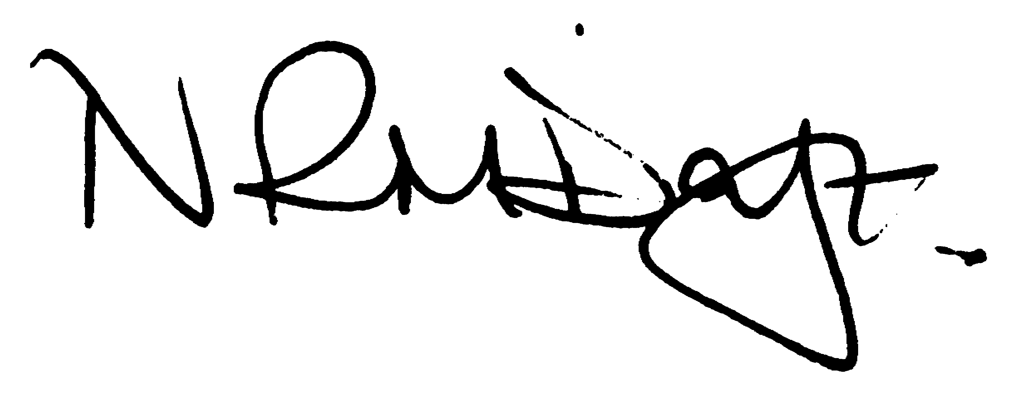

Nikki Daft – Parish Clerk

AGENDA

APOLOGIES AND ACCEPTANCE OF APOLOGIES

17/1 CHAIRMAN ELECTION AND ACCEPTANCE OF OFFICE

- To receive nominations and elect a Chair for the Parish Council for the ensuing year. Declaration of acceptance of office to be completed.

17/2 NOTIFICATION OF ANY DISCLOSABLE PECUNIARY INTERESTS OR OTHER INTERESTS
only in respect of matters which are to be considered by members below. (Disclosures previously declared and registered need not be repeated).

17/3 APPOINTMENTS OF MEMBERS to the following specific areas of interest:

a) Vice Chair b) Internal Accounts Controller and Digital Overseer
c) Footpaths d) Highway Warden Irchester
e) Highway Warden Little Irchester and Knuston

17/4 APPOINTMENT OF ADVISORY GROUPS

- Public lighting
- Finance
- Recreation
- Cemetery
- Planning
- Village Voice
g) Emergency planning/flooding

17/5 APPOINTMENT OF REPRESENTATIVES ON OUTSIDE BODIES

To appoint representatives on Outside Bodies for the following:

a) Irchester Sports Association (2) b) Village Hall Committee
c) Youth Centre Management Committee d) Allotment Association
e) Bowling Club Committee

17/6 DATES OF COUNCIL MEETINGS 2017/18

To approve the dates and venues for meetings throughout 2017/18

28th June 2017 31st January 2018
30th August 2017 28th February 2018
27th September 2017 28th March 2018
25th October 2017 25th April 2018
29th November 2017 23rd May 2018 Annual Meeting

To commence the Ordinary Meeting of Irchester Parish Council

17/7 MINUTES

a) To approve the minutes of the meeting held on 26th April 2017 as a true record

17/8 PUBLIC QUESTIONS, POLICE REPORT AND NCC UPDATE

Public participation may continue until for 15 minutes after which the public must not take part at any other time during the meeting. Request should be made to the Chair if any member of the public wishes to make a recording of any part of the meeting. All audible sounds to be switched to silent unless otherwise agreed at the start of the meeting. A report only can also be given by the Police and NCC representatives

17/9 RESOLUTIONS AND ACTIONS - MATTERS FROM PREVIOUS MINUTES
- Letter NCC re Section 50 licence
- Arrange visit to Mick George Ringstead
- Write to Clerk at Ringstead

17/10 FINANCIAL/POLICIES

- To Approve Payments for May 2017 (Clerk)
- To receive information regarding the current financial statement (Clerk)
- To agree the authorisation of the bacs payments
- To agree the Councils Insurance for 2017/18
- To review the Standing Orders, Financial Regs, Risk Assessment and Internal Audit Controls for 2017/18
- To agree the Annual Governance for the External Auditor and receive the Internal Auditors Report for the accounts ending 2016/17
- To agree a date for the finance training

17/11 RECREATION GROUNDS

- To receive and agree the reports/repairs/damage to the recreation grounds (JD)

17/12 HIGHWAYS

- To agree the Highway Warden report, previously circulated. Matters arising will be added to the next agenda
- To receive information regarding the useage of the footpath for the NCC report (DM)
- To receive the response from highways re the Section 50 licence

17/13 LITTLE IRCHESTER/KNUSTON

- To agree the Highway Warden report

17/14 PLANNING

- Update on the visit to Mick George
- WP/17/00259/FUL – Conversion of existing building to create a detached house and garage – Congregational hall Lt Irchester

17/15 NEIGHBOURHOOD PLAN

- To receive an update on the NHP

17/16 CEMETERY/WAR MEMORIAL

- To receive the Registrars report, previously circulated, and decide if details should be added to the next agenda
- To receive information regarding the cleaning of the war memorial (TM)
- To discuss the memorial testing for 2017

17/17 COMMUNITY

- To receive an update on the Best Village Competition
- To discuss the registering of assets within the parish

17/18 CORRESPONDENCE

To consider information received from incoming correspondence and decide on agenda items for the next meeting.

