
The Parish Council of Irchester
Clerk  Nikki Daft MILCM  45 Park Road  Irthlingborough  Northants  NN9 5PW |  | Telephone 01933384180  Parishclerk123@gmail.com

Dear Councillor 21st May 2015

You are hereby summoned to attend the planning meeting of Irchester Parish Council to be held at Village Hall, School Lane, Irchester on Wednesday 3rd June 2015 at 7.00p.m.

Yours faithfully
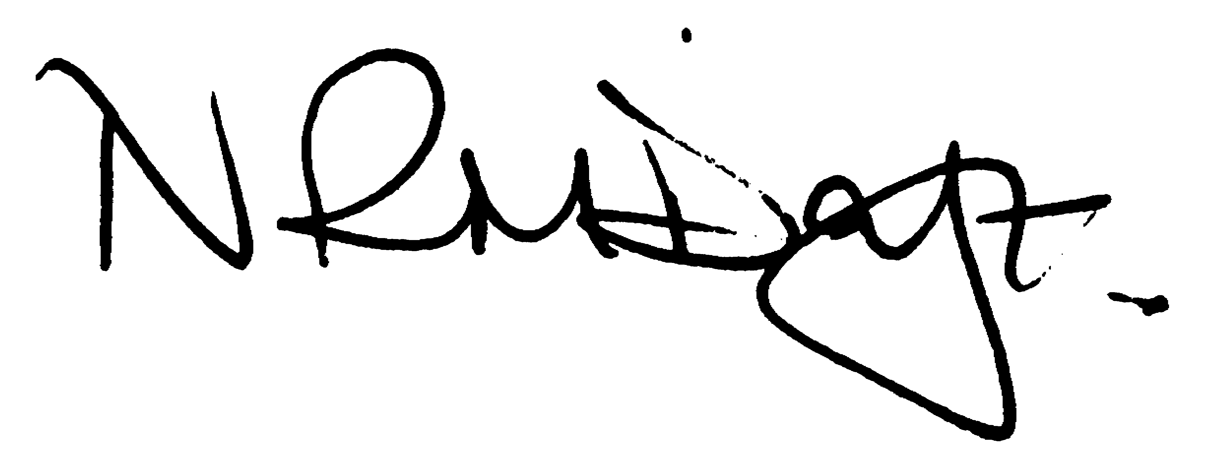

Nikki Daft – Parish Clerk

AGENDA

APOLOGIES AND ACCEPTANCE OF APOLOGIES

15/18 NOTIFICATION OF DISCLOSABLE PERCUNIARY INTERESTS OR OTHER INTERESTS

15/19 PLANNING

WP/15/00281/OUT - Outline application with all matters reserved apart from access for the erection of up to 59

Location: Land West Of 123, High Street, Irchester, Wellingborough, Northamptonshire,

dwellings (including affordable homes), new vehicular and pedestrian access, open space and

landscaping.

