
The Parish Council of Irchester
Clerk  Nikki Daft MILCM  45 Park Road  Irthlingborough  Northants  NN9 5PW |  | Telephone 01933384180  Parishclerk123@gmail.com

Dear Councillor 13th February 2017

You are hereby summoned to attend the Ordinary meeting of Irchester Parish Council to be held in the Village Hall School Road Irchester on Wednesday 22nd February 2017 at 7.15p.m.

Yours faithfully
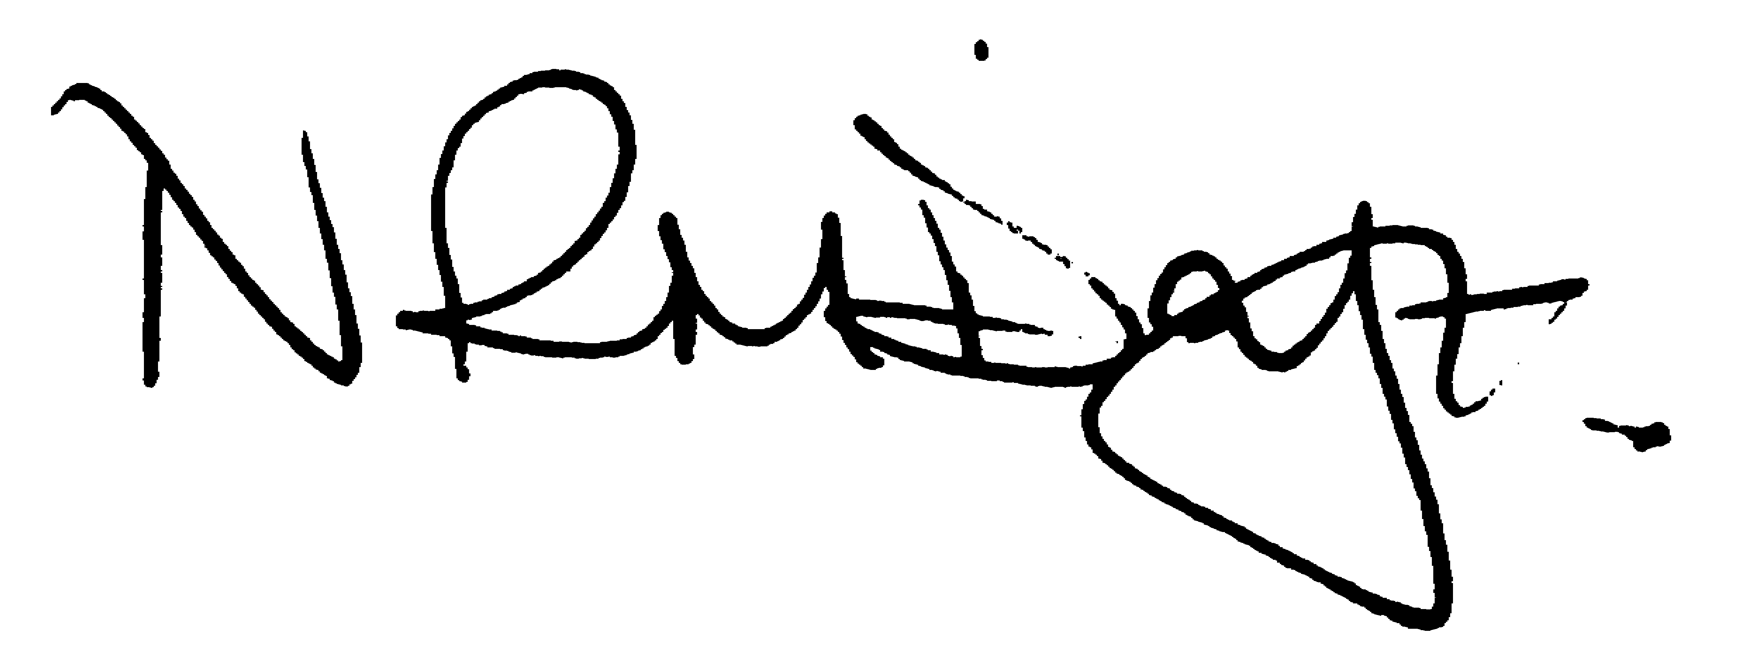

Nikki Daft – Parish Clerk

AGENDA

APOLOGIES AND ACCEPTANCE OF APOLOGIES

16/101 NOTIFICATION OF ANY DISCLOSABLE PECUNIARY INTERESTS OR OTHER INTERESTS
Only in respect of matters which are to be considered by members below. (Disclosures previously declared and registered need not be repeated).

16/102 PUBLIC QUESTIONS, POLICE REPORT AND NCC UPDATE

Public participation may continue until for 15 minutes after which the public must not take part at any other time during the meeting. Request should be made to the Chair if any member of the public wishes to make a recording of any part of the meeting. All audible sounds to be switched to silent unless otherwise agreed at the start of the meeting. A report only can also be given by the Police and NCC representatives

16/103 MINUTES - To approve the minutes of the meetings held on 25th January 2017 as a true record

16/104 RESOLUTIONS AND ACTIONS - MATTERS FROM PREVIOUS MINUTES

- Letter to land owner re ditch A509
- Write to MP re Post Office Response
- Order replacement village sign
- Submit Enhancement Gang job list
- Write to Congregational Trust re Chapel Little Irchester
- Write to residents and NCC re litter/dog bin Farndish Road

16/105 FINANCIAL/POLICIES

- To Approve Payments for February 2017 (Clerk)
- To receive information regarding the current financial statement (Clerk)
- To agree the authorisation of the bacs payments
- To discuss the proposals/changes and launch of 3 year Business Plan

16/106 RECREATION GROUNDS

- To receive and agree the reports/repairs/damage to the recreation grounds (JD)
- To receive information regarding the spares required from the annual inspection report that the lengthsman can complete
- To discuss the request from Tyanna Circus to attend the village in July/August for a week and at what cost.

16/107 HIGHWAYS

- To agree any items that need to be added to the next agenda
- Street Doctor responses
849494 – Grit bin to be replaced
- To receive an update re applying for a definitive footpath.
- To discuss the objections received from NCC re parking restriction in Arkwright, Station and Parsons Road
- To discuss the questionnaire from Highways
- To discuss the TR22 lighting report and receive a quotation regarding repairs.

16/108 LITTLE IRCHESTER/KNUSTON - To agree the Highway Warden report, previously circulated. Matters arising will be added to the next agenda

16/109 PLANNING - To discuss any planning issues

- WP/17/00058/FUL – Conversion of pump house for toilet block, office area and temp accommodation – London Road Little Irchester

16/110 NEIGHBOURHOOD PLAN - To receive an update on the progress of the NHP

16/111 CEMETERY/WAR MEMORIAL

- To receive the Registrars report and decide if details should be added to the next agenda
- To discuss the cemetery letter regarding maintenance of graves

16/112 COMMUNITY ISSUES

- To receive an update regarding lighting the alleyway in School Road
- To discuss the parking problems with Parsons Hall and the Bowls Club
- To discuss the organising of the Best Village Competition
- To receive information regarding the school budget cuts

16/113 CORRESPONDENCE To consider information received from incoming correspondence and decide on agenda items for the next meeting.

