
The Parish Council of Irchester
Clerk  Nikki Daft PSLCC  45 Park Road  Irthlingborough  Northants  NN9 5PW |  | Telephone 01933 384180  irchesterpc@gmail.com  www.hugofox.com/community/irchester-parish-council-13388/about-us

Dear Councillor 13th May 2019

You are hereby summoned to attend the Annual meeting of Irchester Parish Council followed by the ordinary meeting of the Parish Council to be held at Village Hall, School Lane, Irchester on Wednesday 22nd May 2019 at 7.15p.m.

Yours faithfully
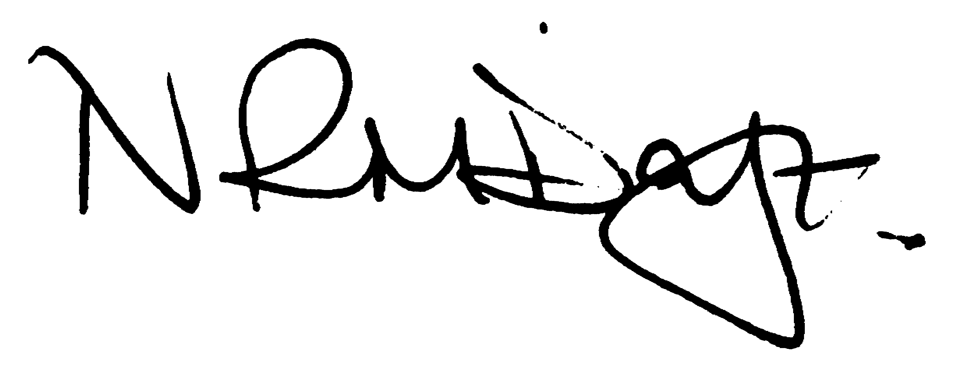

Nikki Daft – Parish Clerk

AGENDA

APOLOGIES AND ACCEPTANCE OF APOLOGIES

19/1 CHAIRMAN ELECTION AND ACCEPTANCE OF OFFICE

- To receive nominations and elect a Chair for the Parish Council for the ensuing year. Declaration of acceptance of office to be completed.

19/2 NOTIFICATION OF ANY DISCLOSABLE PECUNIARY INTERESTS OR OTHER INTERESTS
Only in respect of matters which are to be considered by members below. (Disclosures previously declared and registered need not be repeated).

- To receive declarations of interest
- Councillors to declare any personal interest in any items on the agenda
- Councillors to declare any personal and/or prejudicial interest in any items on the agenda and to inform the Chairman if they wish to speak on the matter during public participation

19/3 APPOINTMENTS OF MEMBERS to the following specific areas of interest:

a) Vice Chair b) Internal Accounts Controller
c) Footpaths d) Highway Wardens for Irchester, Little Irchester and Knuston
e) H & S Representative

19/4 APPOINTMENT OF ADVISORY GROUPS

- Finance
- Recreation
- Cemetery
- Planning
g) Emergency planning/flooding

19/5 APPOINTMENT OF REPRESENTATIVES ON OUTSIDE BODIES

To appoint representatives on Outside Bodies for the following:

a) Irchester Sports Association (2) b) Village Hall Committee
c) Youth Centre Management Committee d) Allotment Association
e) Bowling Club Committee

19/6 DATES OF COUNCIL MEETINGS 2019/20

To approve the dates and venues for meetings throughout 2019/20

26th June 2019 29th January 2020
28th August 2019 26th February 2020
25th September 2019 25th March 2020
30th October 2019 29th April 2020
27th November 2019 May 2020 meeting to be agreed as election year

To commence the Ordinary Meeting of Irchester Parish Council

19/7 PUBLIC QUESTIONS, POLICE REPORT AND NCC UPDATE

Public participation may continue until for 15 minutes after which the public must not take part at any other time during the meeting. Request should be made to the Chair if any member of the public wishes to make a recording of any part of the meeting. All audible sounds to be switched to silent unless otherwise agreed at the start of the meeting. A report only can also be given by the Police and NCC representatives

19/8 MINUTES

a) To approve the minutes of the meeting held on 24th April 2019 as a true record

19/9 RESOLUTIONS AND ACTIONS - MATTERS FROM PREVIOUS MINUTES

- Grave levelling to organise - Memorial testing notices displayed - Church Clock maintenance agreed – Bootcamp agreed

19/10 FINANCIAL/POLICIES

- To Approve Payments for May 2019 (Clerk)
- To receive information regarding the current financial statement (Clerk)
- To agree the authorisation of the bacs payments
- To review the Standing Orders, Financial Regulations, Risk Assessment and Internal Audit Controls for 2019/20
- To set up a meeting of the Finance Working party in order to review policy and procedures

19/11 RECREATION GROUNDS

- To receive and agree the reports/repairs/damage to the recreation grounds (JD)
- To agree the quotation of £345 in order for the quarter pipe on the skate park to be mended

19/12 HIGHWAYS

- To determine highways issues to be added to the next agenda from the Highways Wardens for Irchester and Little Irchester

19/13 LITTLE IRCHESTER/KNUSTON

- To discuss the replacing of the noticeboard on the A509

19/14 PLANNING

- Application No. WP/19/00230/FUL Proposal: Single storey rear extension plus front porch Location: 2 Gray Street, Irchester, Wellingborough, Northamptonshire, NN29 7DS
- Application No. WP/19/00138/FUL Proposal: Demolition of bungalow and erection of a replacement 2 storey dwelling, a vehicular access crossing and area of hardstanding off Prospect Avenue Location: 203 Wollaston Road, Irchester, Wellingborough, Northamptonshire, NN29 7DG

19/15 CEMETERY/WAR MEMORIAL

- To receive information from the Cemetery Working party and decide if anything should be added to the next agenda

19/16 CONSULTATIONS

- To receive information from the Village Voice working party and decide if anything should be added to the next agenda
- To receive information from the Parsons Hall working party and decide if anything should be added to the next agenda
- Motion - To support the establishment of a Community Managed Library in Irchester, overseen by a Library Management Steering Group.
- A decision will be made by Northamptonshire County Council for Community Managed Libraries on the 14th May 2019. A timeframe of 6 weeks (until 26th June 2019) has been given for successful libraries to submit a business plan and a budget for up to 5 years.
- To enable a management group to go forward with producing a business plan and managing to keep Irchester Library open they will need both moral and financial support from the Parish Council. This would include operational costs on a ¼ year basis when a transfer has taken place and until such time a management group has secured other means of funding the library. This should be reviewed annually.
Proposed: Jon-Paul Carr Seconded: Pam Armstrong Dated: 8th May 2019
19/17 CORRESPONDENCE

To consider information received from incoming correspondence and decide on agenda items for the next meeting.

