IRCHESTER PARISH COUNCIL

Minutes of the Ordinary Meeting of the Parish Council held on Wednesday 26th January 2022 at the Village Hall, School Road at 7.15p.m.

Members Present:
P Armstrong – In the Chair

Councillors
P Smith K Watts D Shroll V Wilkinson L Brown JP Carr M May

The meeting started at 7.15pm. there were 3 members of the public present.

Apologies - Agreed and Accepted from Cllr T Maguire, J Dunkley & N Gibbons
Concern was raised regarding the vacant council seats. An article has been included in the March Village Voice.

21/81 Public participation/Police Report/North Northants Council

Public - Concern was raised regarding highways signs left on the road, signs which need replacing lack of post office facilities within the village. It was stated that Highways issues need to be raised with fixmystreet and the post office facilities to be raised with the MP.

NNC – Cllr T Partridge-Underwood attended the meeting and stated that the meeting with the ward parishes had been successful and issued raised were being addressed by the NNC councillors. Copy of the meeting notes to be sent to councillors.

21/82 Declaration of Interest

Cllrs P Armstrong & L Brown declared an interest in agenda item 21/92

21/83 Minutes

- The minutes from 26th January 2022 were agreed as a true record to be signed by the Chair.

21/84 Financial Matters

- Payments – Resolved: That the payments of £10,594.59 for February were approved
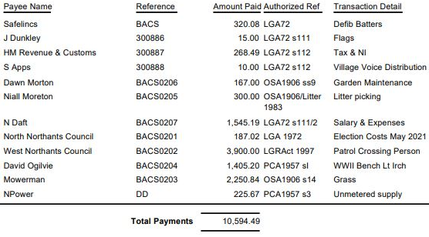

- The Current financial statement after the payments being £185,710.49
- RESOLVED that Cllrs V Wilkinson & P Armstrong to authorise the bacs payments for February 2022

21/85 Cemetery/War Memorial
- There had been a few interments in the cemetery.
- Suggestion was made to plant a memorial tree for all those who have died from the recent pandemic. It was agreed that the Cemetery Working Party meet then add the item to the agenda.

21/86 Highways

- The Asset Mapping Working Party had met and highlighted and assets and services provided by NNC had been recorded. Details to be sent to councillors
- VAS batteries – RESOLVED to order replacement batteries

.21/87 Play Areas

- There had been some issues with the play area in Little Irchester having mud on the surface and equipment. This had been cleaned however continued to occur.
- Discussion took place regarding the updated quotation for the table tennis tables. It was agreed to defer a decision on this matter and that the Recreation Working Party were to meet to discuss future requirements.

21/88 Community Projects

- A visit had taken place from the organisers of the Northampton orchard who had stated that the area looked good and the trees had taken well. Volunteers were also working in the area on a weekly basis. A report was sent for inclusion in the Village Voice.
- Library – NNC had issued Works orders for trees, electrics and roof repairs etc. Scaffolding had currently been erected to look at the roofing problems
- A steering group had been set up of community volunteers to organise a Big Lunch on Sunday 4th June to celebrate the Queens Platinum Jubilee. The seed balls and a leaflet for saving the date was being distributed throughout the parish.
- RESOLVED that S Gregory become a trustee of the Feoffee Charity

21/89 Planning

- NW/22/00058/FUL - Construction of a four bedroomed detached part two part single storey house, hardstanding to front, vehicular access crossing, landscaping and boundary treatments Location: Land Between 27 And 31 Gipsy Lane – No objections
- NW/22/00066/FUL - Conversion of garage to habitable accommodation and the removal of a garage door and replacement with a window and brick infilling. Location: 4 Biscay Close Irchester – No objections
- NW/22/00067/FUL - Two storey side extension Location: 8 Orchard Place Irchester – No objections
- Scott Properties had sent an email regarding NNC Call for Sites. It was suggested that they be directed to the NNC planning department.

21/90 Exclusive to Public and Press

RESOLVED: That pursuant to the Public Bodies (Admission to Meetings) Act 1960, the public and press is excluded from the meeting for the item of business on the grounds that publicity would be prejudicial to the public interest by reason of the confidential nature of the business to be discussed.

21/91 Sports Ground Lease

Discussion took place regarding the renewal of the Sports Group Lease and it was agreed that the Clerk visit the Council solicitor for recommendation to the Council

21/93 OLB

It was agreed that Cllrs Carr, L Brown and the Clerk report the procedure for OLB.

Cllrs P Armstrong and L Brown left the meeting – Cllr Carr was voted as Chair for the following agenda item

21/92 Village Hall Lease/Grant

Discussion was made regarding the Car Park at the Village Hall and it was RESOLVED that the Parish Council would take on the responsibility for the major repairs to the car park with the Village Hall Trust being responsible for the day to day maintenance. The Village Hall trust stated that, on this occasion, they were able to contribute towards half the nett cost to the major repairs for resurfacing the area.

Meeting closed at 9.15pm

Chair

