
The Parish Council of Irchester
Clerk  Nikki Daft PSLCC  45 Park Road  Irthlingborough  Northants  NN9 5PW |  | Telephone 07525 909528  irchesterpc@gmail.com

Dear Councillor 21st January 2019

You are hereby summoned to attend the Ordinary meeting of Irchester Parish Council to be held in the Village Hall, School Road Irchester on Wednesday 30th January 2019 at 7.15p.m.

Yours faithfully
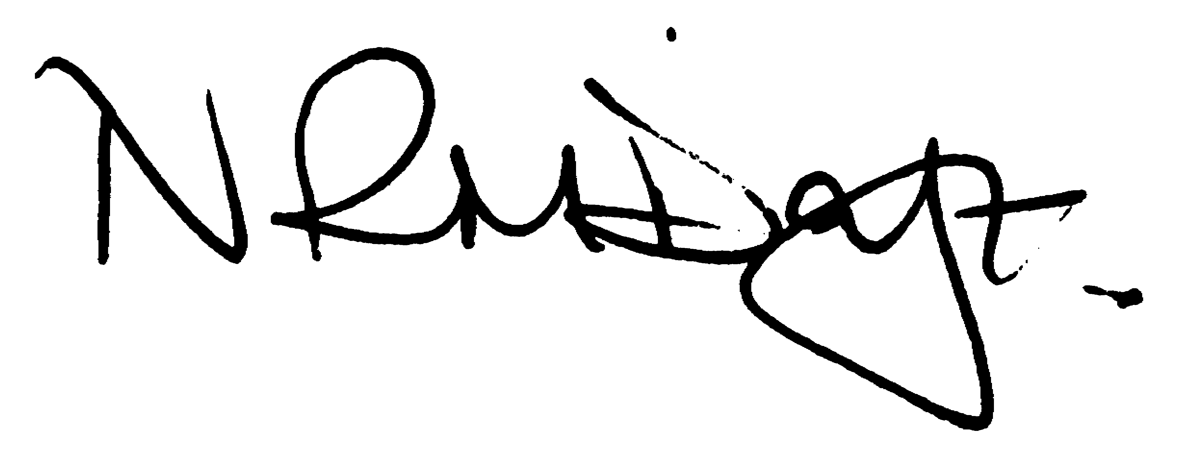

Nikki Daft – Parish Clerk

Scott Descrochers for Northants Police to attend

AGENDA

APOLOGIES AND ACCEPTANCE OF APOLOGIES

18/89 PUBLIC QUESTIONS AND/COMMENTS

Public participation may continue until for 15 minutes after which the public must not take part at any other time during the meeting. Any member of the public can make a recording of any part of the meeting. All audible sounds to be switched to silent unless otherwise agreed at the start of the meeting.

POLICE REPORT AND NCC UPDATE

To receive a verbal report from the Police and NCC representative if in attendance
To receive an update from the recent JAG meeting

18/90 NOTIFICATION OF ANY DISCLOSABLE PECUNIARY INTERESTS OR OTHER INTERESTS
Only in respect of matters which are to be considered by members below. (Disclosures previously declared and registered need not be repeated).

- To receive declarations of interest
- Councillors to declare any personal interest in any items on the agenda
- Councillors to declare any personal and/or prejudicial interest in any items on the agenda and to inform the Chairman if they wish to speak on the matter during public participation

18/91 MINUTES - To approve the minutes of the meetings held on 28th November 2018 as a true record.

18/92 RESOLUTIONS AND ACTIONS - MATTERS FROM PREVIOUS MINUTES

- Planning responses – completed
- Birchwood Associates commissioned
- Letter sent Traveller site re horses
- Police – letter sent – response received
- Byelaw information ]
- Letter NCC library
- Unitary talk updated to February meeting

18/93 FINANCIAL/POLICIES

- To Approve Payments for December 2018 and January 2019 details sent to councillors via email (Clerk)
- To receive information regarding the current financial statement – reconciliation statement sent to councillors via email (Clerk)
- To agree the authorisation of the bacs payments
- To agree the precept requirement for 2019/2020
- To discuss the recommendations from the Staffing Working Party notes regarding training and equipment proposed by the Clerk.

- New Printer – Price £74.18 New lockable 4 shelf cabinet £189.99
- Storage of Parish Council Paperwork - The Village Hall Trust had offered storage under the Stage – to agree expenditure up to £250 for plastic storage boxes for these records
- To discuss details regarding the Cemetery Course on Management, Rights of Burial, Operation on 18th June 2019 organised NCALC– Price £89.00
- To discuss three different type courses on Health & Safety for the Clerk to run through - £95, £35 and £320

18/94 RECREATION GROUNDS

- To receive and agree the reports/repairs/damage to the recreation grounds (JD) and to discuss the cost of repairs reported from the Annual Inspection.
- To discuss the usage of the park by Circus Tyanna from 2nd till 9th June and at what cost

18/95 HIGHWAYS

- To agree any items that need to be added to the next agenda
- To agree the Section 136 Grass mowing agreement with NCC for 2019/20

18/96 LITTLE IRCHESTER/KNUSTON - To agree the Highway Warden report. Matters arising will be added to the next agenda.

18/97 PLANNING - To discuss any planning issues

- WP/19/00001/FUL Proposal: The retention of an existing Network Rail vehicle track and compound., Location: Land Off Ditchford Road, Irchester
- WP/19/00009/FUL Proposal: Retention of roof mounted 9.87KWp solar photovoltaic panels on front elevation Location: Irchester Bowls Club, 110 High Street, Irchester
- WP/19/00014/FUL Proposal: Single storey rear extension Location: 49 Gipsy Lane, Irchester,
- WP/19/00017/FUL Proposal: Proposed single storey dwelling with off road parking and amenity land Location: Former Garden Land Adjacent, 7 Bradshaw Way, Irchester,

18/98 CEMETERY/WAR MEMORIAL/GARDENS

- To agree the notes from the Cemetery Working Party and discuss the recommendations as follows:

- To receive quotations regarding the removal of the mounds of earth from graves that have been left for a number of years.
- To agree that the PC contact the relevant persons where the spoil has been removed after a recent burial, requesting that the grave be topped back up as the grave has sunk to an unacceptable level.
- To discuss the removal or the bushes to the Irchester lettering on Station Road corner

18/99 COMMUNITY/CONSULTATIONS EVENTS

- To agree the notes from Village Voice Working Party and discuss the following recommendations

- That the prices for the current adverts be increased by £5.00
  - Current Prices:
    - Whole Page A5 Colour - £100
    - Whole Page A5 Black and White - £80
    - Half Page A5 Colour - £60
    - Half Page A5 Black and White - £40
    - Quarter Page A5 Colour - £30
    - Quarter Page A5 Black and White - £20
- To advertise the increase details in the next Village Voice
- To place a large, half a page, advert in the Village Voice for a volunteer to organise and take over the advertisements, in the next edition.
- To discuss the NCC agreed consultation proposals regarding the library and what the PC can do to enhance the process.

18/100 CORRESPONDENCE To consider information received from incoming correspondence and decide on agenda items for the next meeting.

- Eon price increases
- Street Watch introduction
- Recycling crisp packets programme

18/101 EXCLUSIVE TO PUBLIC AND PRESS

- Communication

