
The Parish Council of Irchester
Clerk  Nikki Daft PSLCC  45 Park Road  Irthlingborough  Northants  NN9 5PW |  | Telephone 07525 909528  irchesterpc@gmail.com

Dear Councillor 22nd August 2018

You are hereby summoned to attend the Ordinary meeting of Irchester Parish Council to be held in the Village Hall, School Road Irchester on Wednesday 29th August 2018 at 7.15p.m.

Yours faithfully
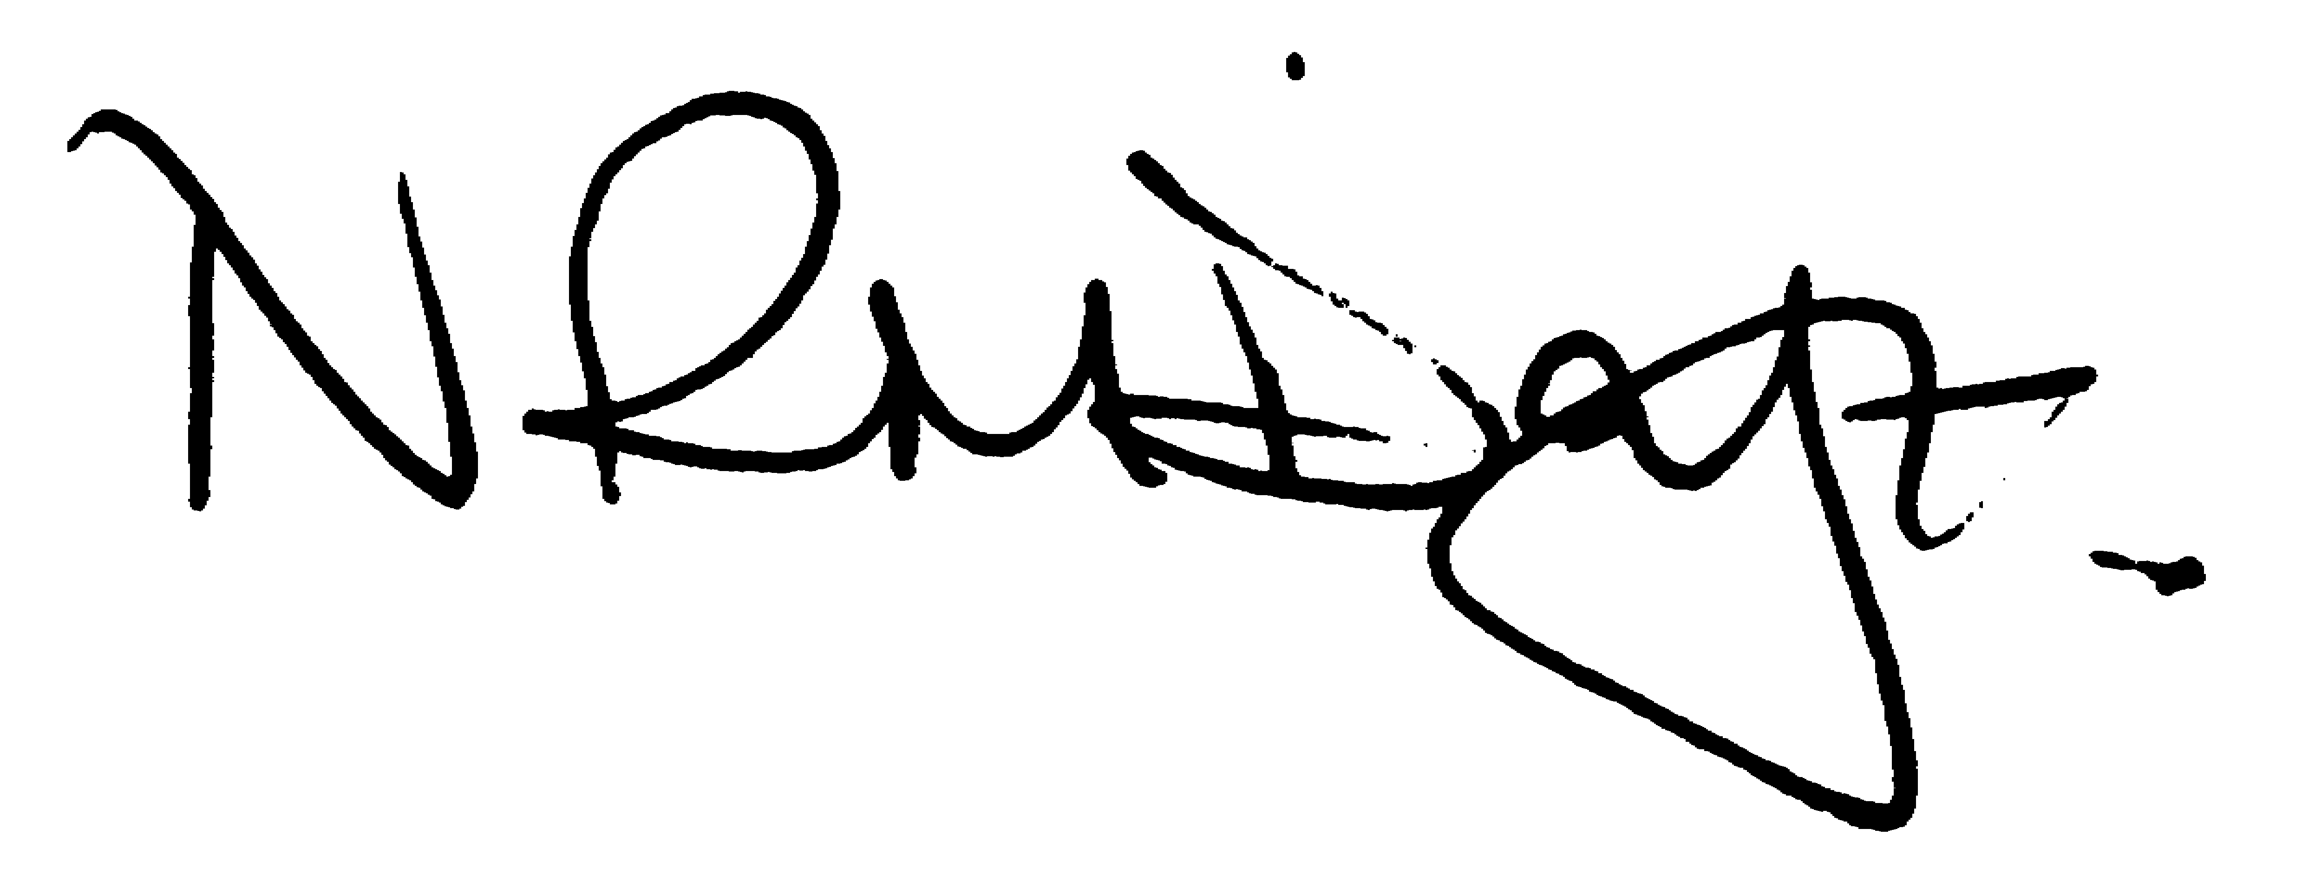

Nikki Daft – Parish Clerk

AGENDA

APOLOGIES AND ACCEPTANCE OF APOLOGIES

18/35 NOTIFICATION OF ANY DISCLOSABLE PECUNIARY INTERESTS OR OTHER INTERESTS
Only in respect of matters which are to be considered by members below. (Disclosures previously declared and registered need not be repeated).

- To receive declarations of interest
- Councillors to declare any personal interest in any items on the agenda
- Councillors to declare any personal and/or prejudicial interest in any items on the agenda and to inform the Chairman if they wish to speak on the matter during public participation

18/36 PUBLIC QUESTIONS, POLICE REPORT AND NCC UPDATE

Public participation may continue until for 15 minutes after which the public must not take part at any other time during the meeting. Any member of the public can make a recording of any part of the meeting. All audible sounds to be switched to silent unless otherwise agreed at the start of the meeting. A report only can also be given by the Police and NCC representatives

18/37 MINUTES - To approve the minutes of the meetings held on 27th June 2018 as a true record.

18/38 RESOLUTIONS AND ACTIONS - MATTERS FROM PREVIOUS MINUTES

- Letter residents adjoining Recreation Ground – written
- Response to Ramblers re Black Bridge – sent
- 30mph sign Little Irchester – vegetation removed
- Tree removal cemetery – completed
- Cemetery notices – memorabilia/help and support – done
- Headstone Repairs - ordered
- Meeting YC Trustees – cancelled by the Chairman

18/39 FINANCIAL/POLICIES

- To Approve Payments for July and August 2018 details sent to councillors via email (Clerk)
- To receive information regarding the current financial statement – reconciliation statement sent to councillors via email (Clerk)
- To agree the authorisation of the bacs payments

18/40 RECREATION GROUNDS

- To receive and agree the reports/repairs/damage to the recreation grounds (JD)
- To discuss the broken notice board on the recreations ground
- To discuss the request from Methodist Church to use the recreation ground in 2019 for an event
- Request for a skip to be placed on the Recreation Ground to support building work of adjoining property.

18/41 HIGHWAYS

- To agree any items that need to be added to the next agenda
- To discuss the purchasing of a new dog bin for the alleyway in Woodlands Road
- To discuss the tree branches and brambles near the Vicarage (MM)
- To discuss the quotation for the Street light near Knuston Hill
- To discuss the request to place a banner to promote the village show on the ground at the corner of Station Road
- Annual waiting restriction review 2018/19 – New Street

18/42 LITTLE IRCHESTER/KNUSTON - To agree the Highway Warden report. Matters arising will be added to the next agenda.

18/43 PLANNING - To discuss any planning issues

- WP/18/00448/FUL - Sub-division of plot for the erection of 1No. dormer bungalow and the creation of an area of hardstanding for parking - re-submission Land To The Rear Of, 31 Edward Road, Irchester
- WP/18/00466/FUL – 188 Station Road – change agricultural building to residential
- WP/18/00535/FUL Hedgerow removal Proposed 2/3 bedroom detached bungalow adjacent to 2 Wollaston Road, Irchester. - 2 Wollaston Road, Irchester,
- WP/18/00499/FUL Demolition of existing rear extension and replacement with an enlarged single storey rear extension with a roof lantern 152 Station Road, Irchester

18/44 NEIGHBOURHOOD PLAN - To receive an update on the progress of the NHP

18/45 CEMETERY/WAR MEMORIAL/GARDENS

- To agree the reimbursement of funds for a request to sell a cemetery plot back to the council
- To discuss the recommendations from the Cemetery Working Party and to decide if the following items are still required and details of quotations received.
  - Fencing for the baby section
  - Removal of the large conifer trees and bushes
  - Gravel area for the top tree and cremated remains plots
  - Levelling of the non-maintained grave spaces
  - Filling of the uneven ground areas
- To receive details regarding help and support requested from the council regarding the repair of lessees owned headstones.

18/46 COMMUNITY/CONSULTATIONS EVENTS

- To receive information regarding the events being organised for WW1
- Consultation on the draft Northamptonshire All Age Autism Strategy
- Progress regarding the library situation

18/47 CORRESPONDENCE To consider information received from incoming correspondence and decide on agenda items for the next meeting.

- NCALC AGM – members wishing to attend
- Further correspondence received regarding the fence adjacent to the recreation ground
- Correspondence received regarding the culvert at the back of Woodlands Road
- NCC Grit bin maintenance
- Ownership of land in Grange Close

18/48 EXCLUSIVE TO PUBLIC AND PRESS

18/49 COMMUNITY ASSETS
To discuss how the council should proceed in regarding issues raised with the Council owned Community Assets:

- Chairman Report
- Parsons Hall – to receive an update regarding the issues raised

