
The Parish Council of Irchester
Clerk  Nikki Daft PSLCC  45 Park Road  Irthlingborough  Northants  NN9 5PW |  | Telephone 07525 909528  irchesterpc@gmail.com

Dear Councillor 20th November 2019

You are hereby summoned to attend the Ordinary meeting of Irchester Parish Council to be held in the Village Hall, School Road Irchester on Wednesday 27th November 2019 at 7.15p.m.

Yours faithfully
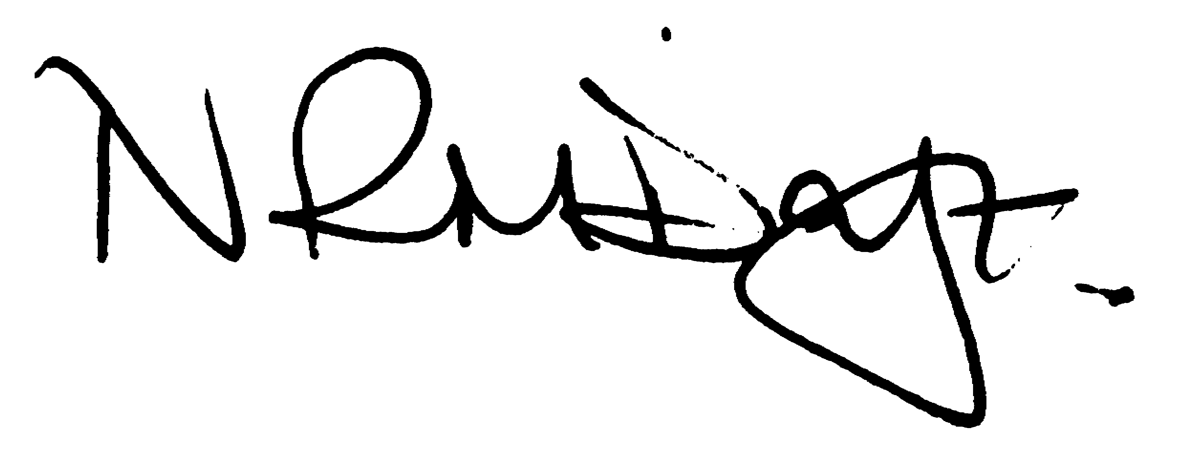

Nikki Daft – Parish Clerk

AGENDA

APOLOGIES AND ACCEPTANCE OF APOLOGIES

19/70 PUBLIC QUESTIONS AND/COMMENTS

Public participation may continue until for 15 minutes after which the public must not take part at any other time during the meeting. Any member of the public can make a recording of any part of the meeting. All audible sounds to be switched to silent unless otherwise agreed at the start of the meeting.

POLICE REPORT AND NCC UPDATE

To receive a verbal report from the Police and NCC representative if in attendance

19/71 NOTIFICATION OF ANY DISCLOSABLE PECUNIARY INTERESTS OR OTHER INTERESTS
Only in respect of matters which are to be considered by members below. (Disclosures previously declared and registered need not be repeated).

- To receive declarations of interest
- Councillors to declare any personal interest in any items on the agenda
- Councillors to declare any personal and/or prejudicial interest in any items on the agenda and to inform the Chairman if they wish to speak on the matter during public participation

19/72 MINUTES - To approve the minutes of the meetings held on 30th October 2019 as a true record.

19/73 RESOLUTIONS AND ACTIONS - MATTERS FROM PREVIOUS MINUTES

- Write to NCC highways re Farndish Rd trees & parking bays
- IPC solicitor library lease
- Quotes dog signs
- Order litter bin and grit bit

19/74 FINANCIAL/POLICIES

- To Approve Payments for November 2019 details sent to councillors via email (Clerk)
- To receive information regarding the current financial statement – reconciliation statement sent to councillors via email (Clerk)
- To agree the authorisation of the bacs payments
- To agree the budget and set the precept for 2020/2021

19/75 RECREATION GROUNDS

- To receive and agree the reports/repairs/damage to the recreation grounds (JD)
- To discuss the annual inspection report and decide what repairs need to be carried out

19/76 HIGHWAYS

- To agree any items that need to be added to the next agenda
- To discuss the proposal from Northants County Council regarding the changes to Station Road corner
- To discuss the quotation regarding the street light in the alleyway between Arkwright and Denton Close

19/77 LITTLE IRCHESTER/KNUSTON - To agree the Highway Warden report. Matters arising will be added to the next agenda.

19/78 CEMETERY/WAR MEMORIAL/GARDENS

To receive an update regarding cemetery matters

19/79 PLANNING

- WP/19/00626/LBC Proposal: Listed Building Consent for the demolition of dilapidated conservatory and proposed 600mm high brick built garden wall. Location: 1A London End, Irchester
- WP/19/00653/OUT Proposal: Outline Planning application for 2No. dwellings including off road parking and amenity land with all matters reserved except for access. Location: 1A London End, Irchester, Wellingborough, Northamptonshire, NN29 7BH

19/80 COMMUNITY/CONSULTATIONS EVENTS

- To discuss the Christmas tree festival theme, decorations and cost(PA/LED)

19/81 CORRESPONDENCE To consider information received from incoming correspondence and decide on agenda items for the next meeting.

- Information on What3words
- Tandem taxi service

19/82 EXCLUSIVE TO PUBLIC AND PRESS

Library – to receive details from the solicitor regarding the NCC proposed lease for the library

