
The Parish Council of Irchester
Clerk  Nikki Daft  45 Park Road  Irthlingborough  Northants  NN9 5PW |  | Telephone 07525909528  irchesterpc@gmail.com  www.hugofox.com/community/irchester-parish-council-13388/about-us

Dear Councillor 13th February 2023

You are hereby summoned to attend the ordinary meeting of Irchester Parish on Wednesday 22nd February 2023 at 7.15p.m.at the Village Hall, School Road, Irchester

Yours faithfully
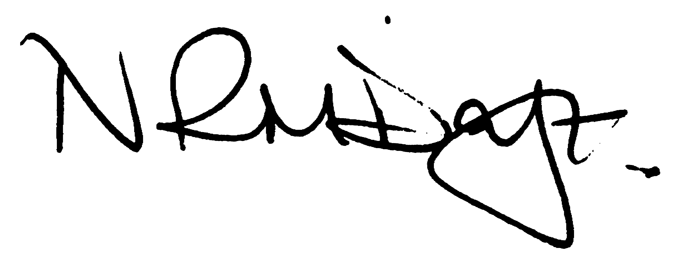

Nikki Daft – Parish Clerk

AGENDA

APOLOGIES AND ACCEPTANCE OF APOLOGIES

22/92 PUBLIC QUESTIONS, POLICE REPORT AND NNC UPDATE

Public are requested to send specific questions to council prior to the meeting due to time constraints

22/93 NOTIFICATION OF ANY DISCLOSABLE PECUNIARY INTERESTS OR OTHER INTERESTS
Only in respect of matters which are to be considered by members below. (Disclosures previously declared and registered need not be repeated).

- To receive declarations of interest
- Councillors to declare any personal interest in any items on the agenda
- Councillors to declare any personal and/or prejudicial interest in any items on the agenda and to inform the Chairman if they wish to speak on the matter during public participation

22/94 MINUTES

a) To approve the minutes of the meeting held on 25th January 2023 as a true record.

22/95 FINANCIAL/POLICIES

- To Approve Payments for February (RFO)
- To receive information regarding the current financial statement (RFO)
- To agree the authorisation of the bacs payments
- To discuss the request for grant funding for Irchester Players as per information previously sent to councillors

22/96 CEMETERY/WAR MEMORIAL

- To receive an update on cemetery matters

22/97 HIGHWAYS

- To receive an update on the Highways traffic calming issues raised at the public meeting and to set up a working party with councillors and residents in order to discuss possible improvements for the parish
- To discuss the issue with rubbish near to the War Memorial in Wollaston Road and to determine if a litter bin can be placed within the vicinity

22/98 PLAY AREAS

- To receive an update regarding the play areas
- To discuss the wording for a plaque regarding the donation from the 1-100 club

22/99 COMMUNITY

- To receive a report from the community orchard.
- To receive information regarding the Village Voice distribution
- To receive an update on the Library.
- To discuss the cost of a bench for the Kings Coronation
- To discuss organising a ‘brain storming’ session regarding future requirements for the parish

22/100 CORRESPONDENCE

To discuss items required for the next agenda.

