
The Parish Council of Irchester
Clerk  Nikki Daft PSLCC  45 Park Road  Irthlingborough  Northants  NN9 5PW |  | Telephone 01933384180  irchesterpc@gmail.com

Dear Councillor 19th March 2018

You are hereby summoned to attend the Ordinary meeting of Irchester Parish Council to be held in the Village Hall, School Road Irchester on Wednesday 28th March 2018 at 7.15p.m.

Yours faithfully
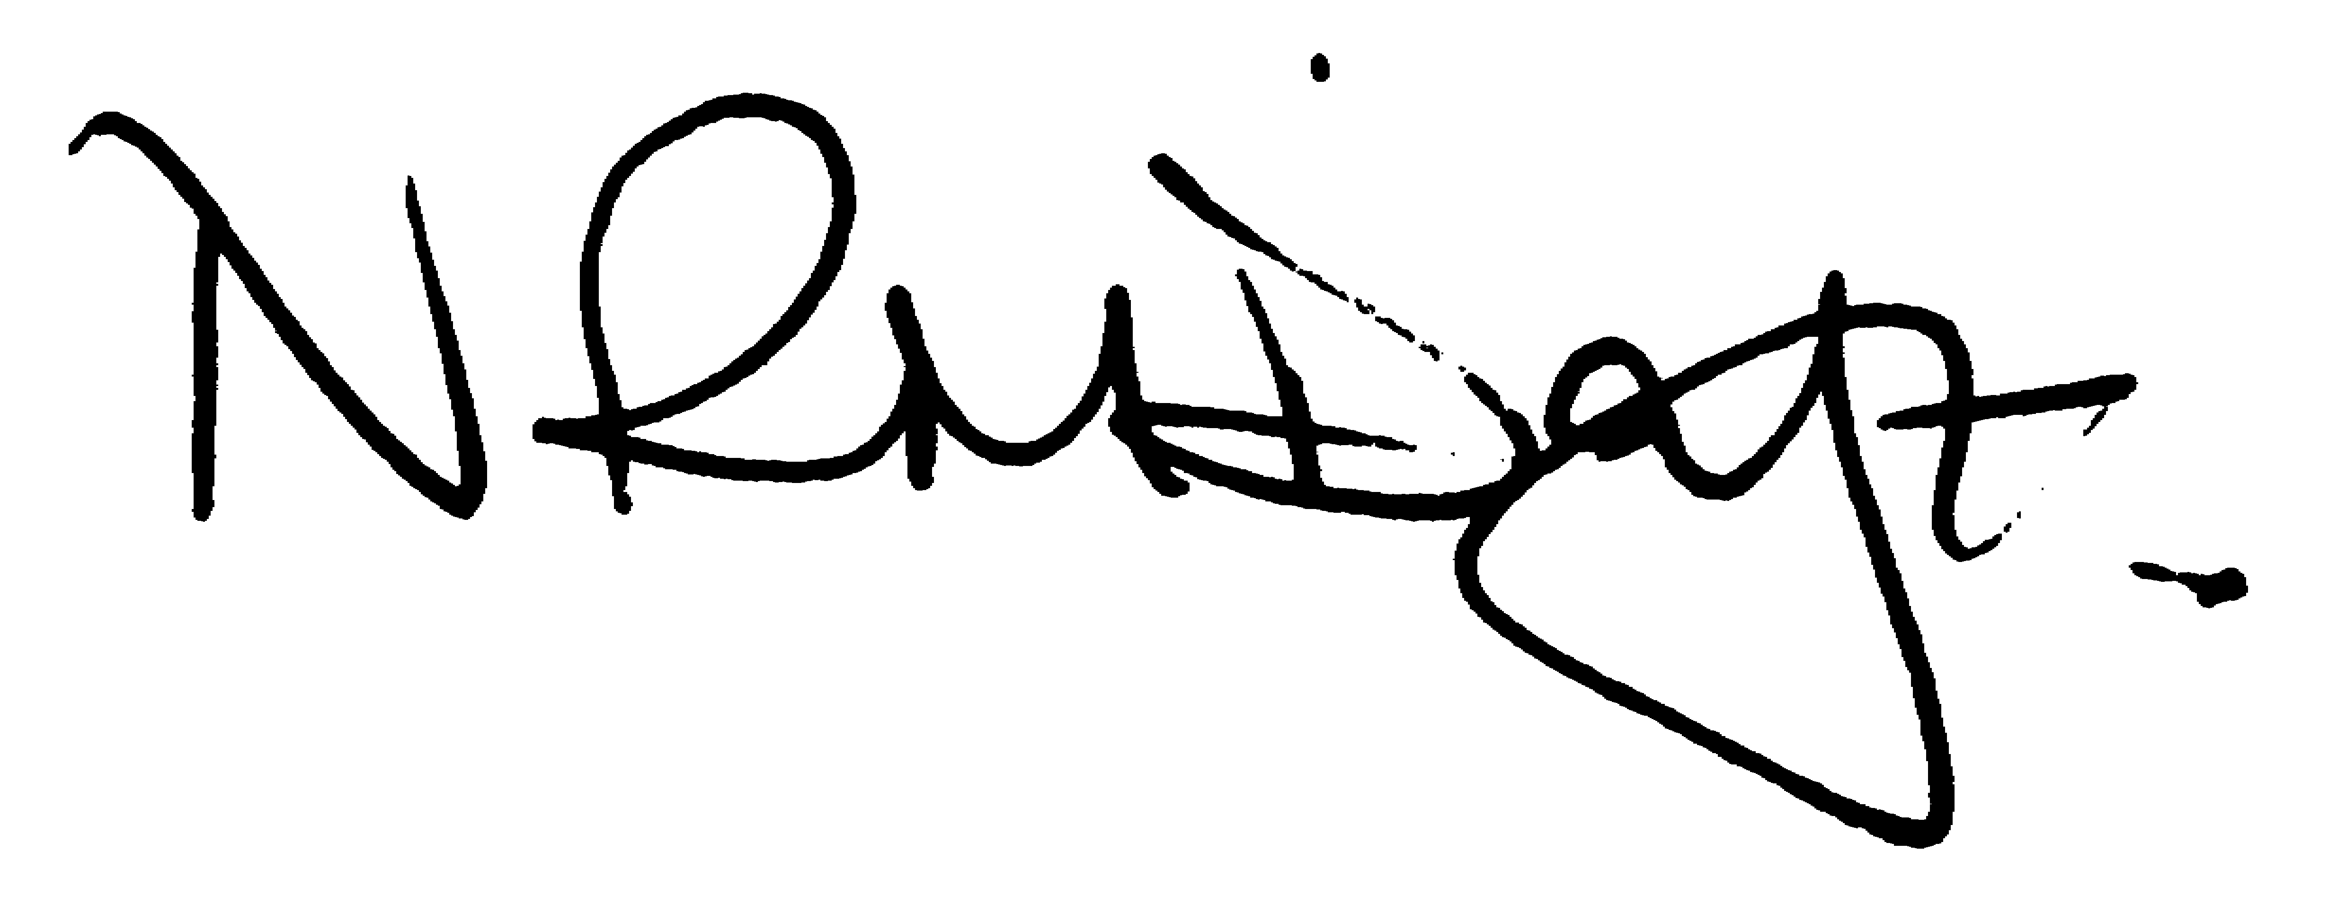

Nikki Daft – Parish Clerk

AGENDA

APOLOGIES AND ACCEPTANCE OF APOLOGIES

17/131 NOTIFICATION OF ANY DISCLOSABLE PECUNIARY INTERESTS OR OTHER INTERESTS
Only in respect of matters which are to be considered by members below. (Disclosures previously declared and registered need not be repeated).

- To receive declarations of interest
- Councillors to declare any personal interest in any items on the agenda
- Councillors to declare any personal and/or prejudicial interest in any items on the agenda and to inform the Chairman if they wish to speak on the matter during public participation

17/132 PUBLIC QUESTIONS, POLICE REPORT AND NCC UPDATE

Public participation may continue until for 15 minutes after which the public must not take part at any other time during the meeting. Request should be made to the Chair if any member of the public wishes to make a recording of any part of the meeting. All audible sounds to be switched to silent unless otherwise agreed at the start of the meeting. A report only can also be given by the Police and NCC representatives

17/133 MINUTES - To approve the minutes of the meetings held on 28th February 2018 as a true record.

17/134 RESOLUTIONS AND ACTIONS - MATTERS FROM PREVIOUS MINUTES

- Letter Wellingborough NHW – response received see minute 17/138
- Letter re volunteering sent
- Street Doctor repairs reported
- Letter re headstone request sent
- Update Flag Policy

17/135 FINANCIAL/POLICIES

- To Approve Payments for March 2018 details sent to councillors via email (Clerk)
- To receive information regarding the current financial statement – reconciliation statement sent to councillors via email (Clerk)
- To agree the authorisation of the bacs payments
- To discuss the request for bus subsidy in order to keep the W8 bus
- To receive information regarding the GDRP lelgislation which comes into force in May 2018
- To receive a report and recommendations from the Finance Working party and agree which items should be added to a future agenda

17/136 RECREATION GROUNDS

- To receive and agree the reports/repairs/damage to the recreation grounds (JD)

17/137 HIGHWAYS

- To agree any items that need to be added to the next agenda
- Update on Street Doctor 928737

17/138 LITTLE IRCHESTER/KNUSTON - To agree the Highway Warden report, previously circulated. Matters arising will be added to the next agenda. To discuss the following problems that have arisen in the village:

- To discuss the request from Wellingborough Neighbourhood Watch for a contribution towards the signs which were damaged in Little Irchester

17/139 PLANNING - To discuss any planning issues

- WP/18/00125/FUL – Change of use from open scrubland to B8 open storage – Land rear 60 London Rd, Little Irchester
- WP/18/00129/FUL – Loft conversion and 2 new bedrooms and bathroom – 132 Wollaston Rd
- WP/18/00154/FUL – Front canopy open to front of house plus boundary fencing(resubmitted) – 2 Wollaston Rd

17/140 NEIGHBOURHOOD PLAN - To receive an update on the progress of the NHP

17/141 CEMETERY/WAR MEMORIAL

- To receive the Cemetery report and decide if details should be added to the next agenda
- To receive a report and recommendations from the Cemetery Working Party and agree which items should be added to a future agenda

17/142 CORRESPONDENCE To consider information received from incoming correspondence and decide on agenda items for the next meeting.

- Ditchford Bridge Road Closure – 26th March to 3rd April 9.30am to 15.30pm

17/143 EXCLUSIVE TO PUBLIC AND PRESS

17/144 COMMUNITY ASSETS

- To discuss how the council should proceed in securing Community Assets

17/145 CEMETERY VACANCY

- To discuss the position of Cemetery Administrator

