
The Parish Council of Irchester
Clerk  Nikki Daft MILCM  45 Park Road  Irthlingborough  Northants  NN9 5PW |  | Telephone 01933384180  Parishclerk123@gmail.com

Dear Councillor 20th June 2017

You are hereby summoned to attend the Ordinary meeting of Irchester Parish Council to be held in the Village Hall, School Road Irchester on Wednesday 28th June 2017 at 7.15p.m.

Yours faithfully
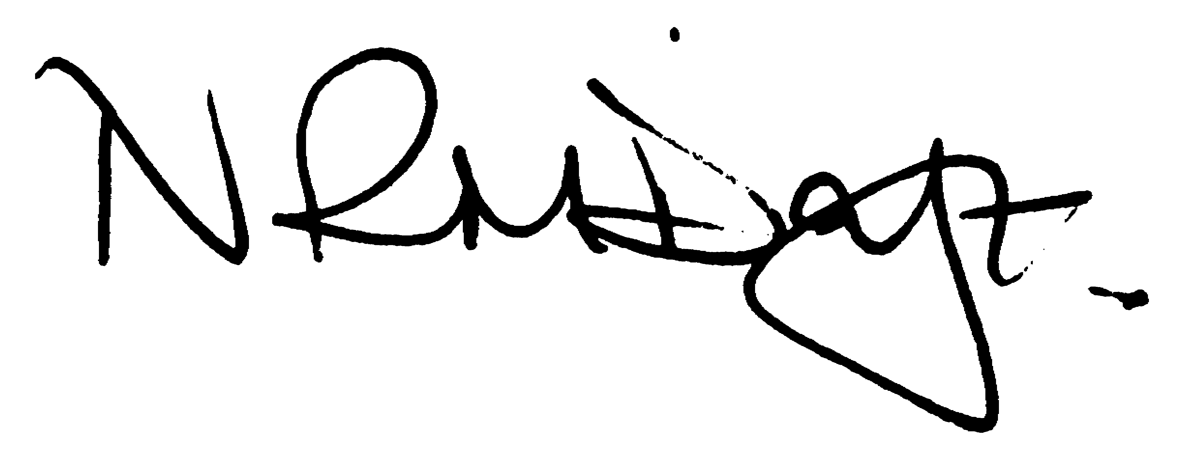

Nikki Daft – Parish Clerk

AGENDA

APOLOGIES AND ACCEPTANCE OF APOLOGIES

17/20 NOTIFICATION OF ANY DISCLOSABLE PECUNIARY INTERESTS OR OTHER INTERESTS
Only in respect of matters which are to be considered by members below. (Disclosures previously declared and registered need not be repeated).

17/21 PUBLIC QUESTIONS, POLICE REPORT AND NCC UPDATE

Public participation may continue until for 15 minutes after which the public must not take part at any other time during the meeting. Request should be made to the Chair if any member of the public wishes to make a recording of any part of the meeting. All audible sounds to be switched to silent unless otherwise agreed at the start of the meeting. A report only can also be given by the Police and NCC representatives

17/22 MINUTES - To approve the minutes of the meetings held on 24th May 2017 and 22nd June 2017 as true records.
17/23 RESOLUTIONS AND ACTIONS - MATTERS FROM PREVIOUS MINUTES

- Letter re road repairs
- Councillors declaration of interests
- Finance training
- Section 50 licence

17/24 FINANCIAL/POLICIES

- To Approve Payments for June 2017 (Clerk)
- To receive information regarding the current financial statement (Clerk)
- To agree the authorisation of the bacs payments
- To receive budget report

17/25 RECREATION GROUNDS

- To receive and agree the reports/repairs/damage to the recreation grounds (JD)
- To receive a request to join the recreation working party (TM)

17/26 HIGHWAYS

- To agree any items that need to be added to the next agenda
- Street Doctor responses
- To receive a response for the Section 50 licence
- To discuss the placing of a dog bin near to the railway bridge on Knuston Hill

17/27 LITTLE IRCHESTER/KNUSTON - To agree the Highway Warden report, previously circulated. Matters arising will be added to the next agenda

17/28 PLANNING - To discuss any planning issues

17/29 NEIGHBOURHOOD PLAN - To receive an update on the progress of the NHP

17/30 CEMETERY/WAR MEMORIAL

- To receive the Registrars report and decide if details should be added to the next agenda
- To discuss the cleaning of the War Memorial (TM)
- To discuss the cemetery risk assessment and testing policy
- To discuss the flower planting of the war memorial
- To receive a request to join the cemetery working party (TM)
- To form a volunteer working party to work with the gardeners to clear/cut back/remove perennial weeds etc the garden so it is in good shape for future maintenance. (RE)

17/31 COMMUNITY ISSUES

- To discuss the registering of Community Assets – update
- To discuss the trees in the Parsons car park to decide if they need cutting back and lowering.
- To discuss the wording for the Village Voice for the launch of the Business Plan and Memorial testing
- To discuss the organising of the Remembrance Day Service
- To investigate the options for a sound system to make the meetings accessible to those with less acute hearing to comply with our equalities policy (RE)

17/32 CORRESPONDENCE To consider information received from incoming correspondence and decide on agenda items for the next meeting.

17/33 EXCLUSIVE TO PUBLIC AND PRESS

- To discuss email correspondence and meetings
- To discuss the parish council accounting system

