
The Parish Council of Irchester
Clerk  Nikki Daft  45 Park Road  Irthlingborough  Northants  NN9 5PW |  | Telephone 07525 909528  irchesterpc@gmail.com  www.hugofox.com/community/irchester-parish-council-13388/about-us

Dear Councillor 20th November 2023

You are hereby summoned to attend the Ordinary Meeting of Irchester Parish on Wednesday 29th November 2023 at 7.15p.m.at the Village Hall, School Road, Irchester

Yours faithfully

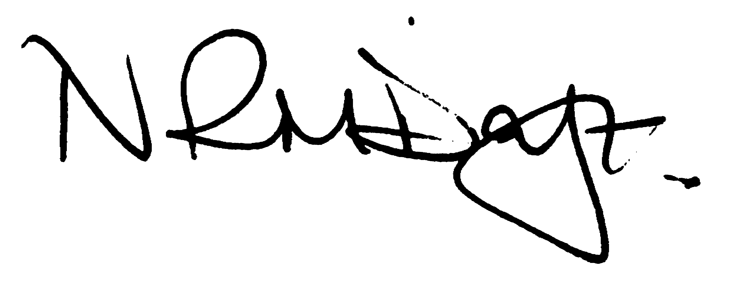

Nikki Daft – Parish Clerk

AGENDA

APOLOGIES AND ACCEPTANCE OF APOLOGIES

23/60 PUBLIC QUESTIONS, POLICE REPORT AND NNC UPDATE

Public are requested to send specific questions to council prior to the meeting due to time constraints

23/61 NOTIFICATION OF ANY DISCLOSABLE PECUNIARY INTERESTS OR OTHER INTERESTS
Only in respect of matters which are to be considered by members below. (Disclosures previously declared and registered need not be repeated).

- To receive declarations of interest
- Councillors to declare any personal interest in any items on the agenda
- Councillors to declare any personal and/or prejudicial interest in any items on the agenda and to inform the Chairman if they wish to speak on the matter during public participation

23/62 MINUTES

- To approve the minutes of the meeting held on 25th October 2023 as a true record.

23/63 FINANCIAL/POLICIES

- To Approve Payments for November(Clerk)
- To receive information regarding the current financial statement (Clerk)
- To agree the authorisation of the bacs payments
- To discuss the grant application received from Irchester Players
  - To discuss the request from the Community Library for funds towards cleaning materials as per the Gala donation
- To agree and adopt the General Reserves Policy
- To agree and adopt the Equal Opportunities Policy
- To agree the budget for 2024/25 and set the precept for 2024/25

23/64 CEMETERY/WAR MEMORIAL

- To receive an update on cemetery matters
- To discuss becoming members of the Institute of Cemetery and Crematoria Management (ICCM)

23/65 HIGHWAYS

- To receive an update on any Highways issues
- To receive an update from NNC Highways regarding the village alleyways
- To discuss the quotation for the Testing and TR22 Inventory of the Street Lights

23/66 PLAY AREAS

- To receive an update of the play areas

23/67 PLANNING

- NW/23/00665/FUL – New one bed bungalow and 2 parking spaces 2 Warren Close
- NW/23/00759/FUL - Conversion of old stable/workshop/garage, addition of a first floor and single storey rear extension to form a new dwelling, hardstanding for parking and vehicular access off Orchard Place. Location: 15 Thrift Street Irchester

23/68 CORRESPONDENCE

- To discuss the complaint received by a resident regarding the footpath in Arkwright Road
- To discuss a request from the Rural Market Town Group for the Council to join the group

23/69 EXCLUSIVE TO PUBLIC AND PRESS

To agree to discuss the following item exclusive to public and press

23/70 UPDATE ON AUSTIN CLOSE PROMOTION AGREEMENT

To discuss further information regarding the proposed promotion agreement

