
The Parish Council of Irchester
Clerk  Nikki Daft  45 Park Road  Irthlingborough  Northants  NN9 5PW |  | Telephone 07525909528  irchesterpc@gmail.com  www.hugofox.com/community/irchester-parish-council-13388/about-us

Dear Councillor 18th September 2023

You are hereby summoned to attend the ordinary meeting of Irchester Parish on Wednesday 27th September 2023 at 7.15p.m.at the Village Hall, School Road, Irchester

Yours faithfully

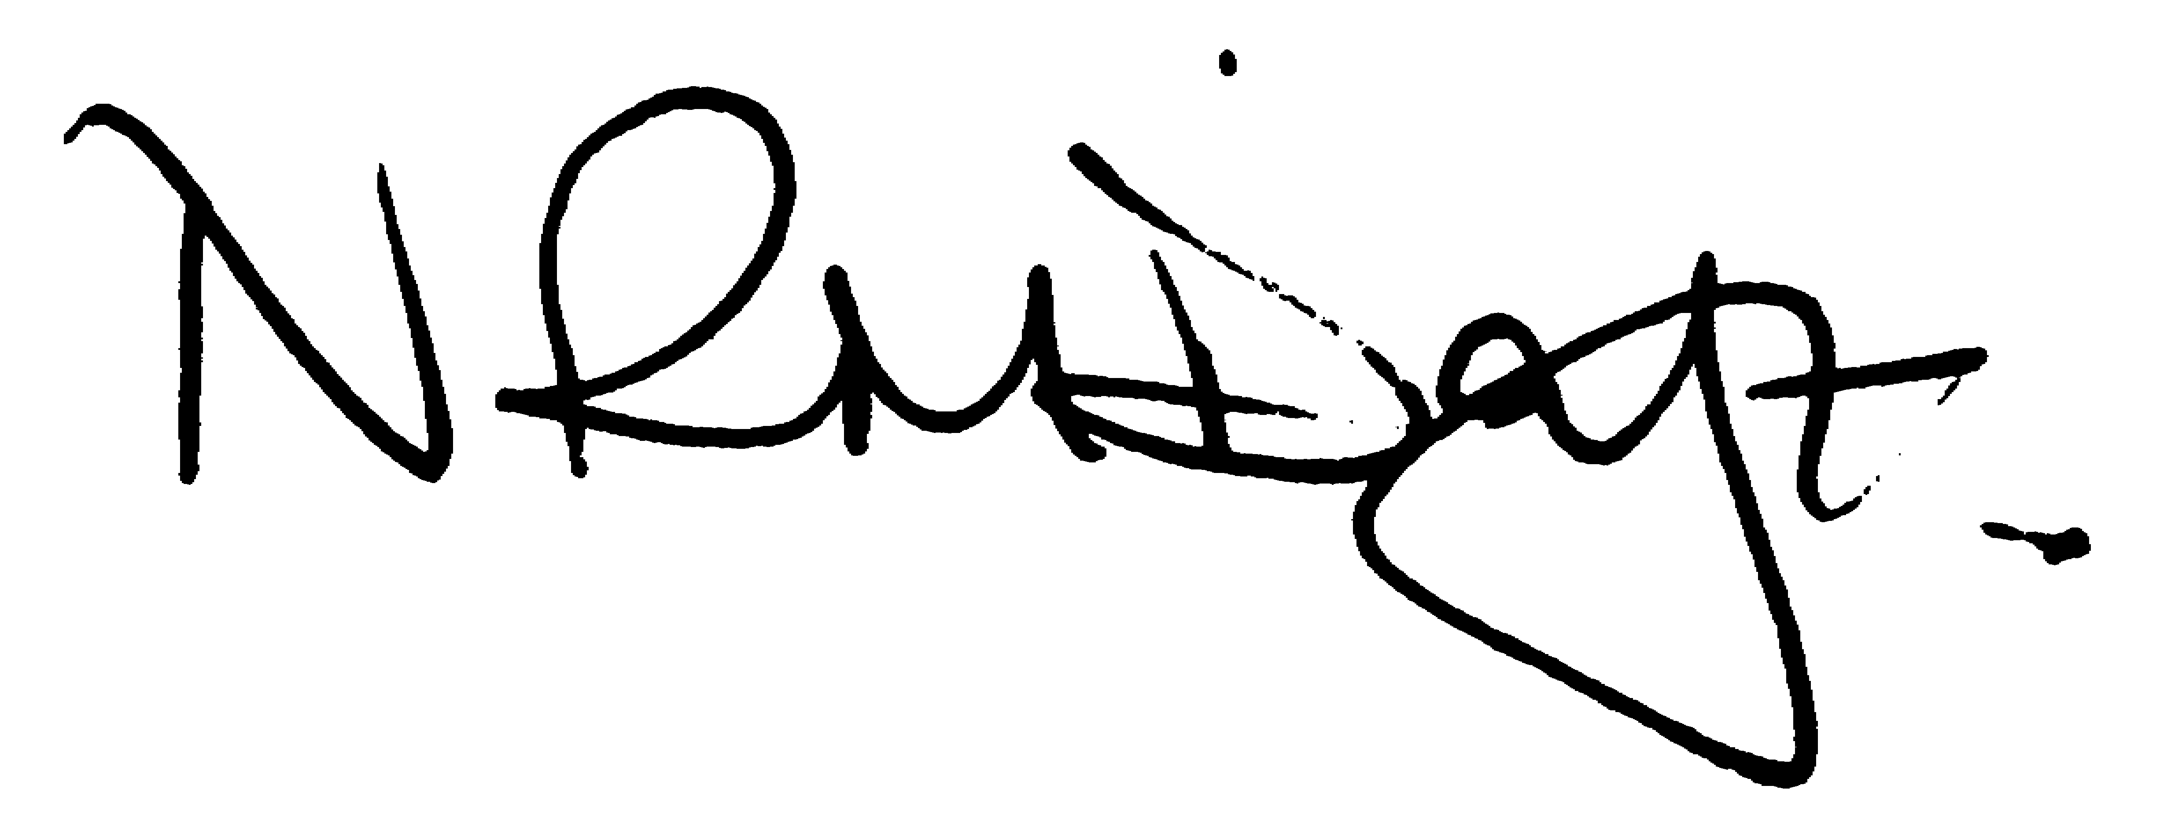

Nikki Daft – Parish Clerk

AGENDA

APOLOGIES AND ACCEPTANCE OF APOLOGIES

23/37 PUBLIC QUESTIONS, POLICE REPORT AND NNC UPDATE

Public are requested to send specific questions to council prior to the meeting due to time constraints

23/38 NOTIFICATION OF ANY DISCLOSABLE PECUNIARY INTERESTS OR OTHER INTERESTS
Only in respect of matters which are to be considered by members below. (Disclosures previously declared and registered need not be repeated).

- To receive declarations of interest
- Councillors to declare any personal interest in any items on the agenda
- Councillors to declare any personal and/or prejudicial interest in any items on the agenda and to inform the Chairman if they wish to speak on the matter during public participation

23/39 MINUTES

- To approve the minutes of the meeting held on 30th August 2023 as a true record.

23/40 FINANCIAL/POLICIES

- To Approve Payments for September(Clerk)
- To receive information regarding the current financial statement (Clerk)
- To agree the authorisation of the bacs payments
- To discuss the parish council website costs and to decide on which of the three packages required.

23/41 CEMETERY/WAR MEMORIAL

- To receive an update on cemetery matters

23/42 HIGHWAYS

- To receive an update on any Highways issues
- To discuss the replacing of the litter bin on the corner of School Road and Baker Crescent
- To discuss the quotation for the strimming, removal and weed spraying of the alleyways Recreation Ground to Sports Ground, High Street to School Road, Baker Crescent to School and to School Gates.
- To receive an update on the mph proposals from NNC highways for Gipsy Lane

23/43 PLAY AREAS

- To receive an update regarding the annual inspection of the play areas
- To discuss issues raised regarding antisocial behaviour on the recreation ground

23/44 COMMUNITY

- To discuss the progress of Remembrance Day Service for November 2023 and to confirm if the pc wish the WI to decorate both memorials for the event.
- To discuss the setting up of a Working Party in order to produce a questionnaire for residents to notify the council of important issues relative to the village (BL)

23/45 CORRESPONDENCE

To discuss any items required for the next agenda.
- To receive details regarding a Wildlife Conservation Proposal

23/46 EXCLUSIVE TO PUBLIC AND PRESS

To agree to discuss the following item exclusive to public and press

23/47 UPDATE ON AUSTIN CLOSE PROMOTION AGREEMENT

To discuss further information regarding the proposed promotion agreement

