
The Parish Council of Irchester
Clerk  Nikki Daft  45 Park Road  Irthlingborough  Northants  NN9 5PW |  | Telephone 07525 909528  irchesterpc@gmail.com  www.hugofox.com/community/irchester-parish-council-13388/about-us

Dear Councillor 22nd January 2024

You are hereby summoned to attend the Ordinary Meeting of Irchester Parish on Wednesday 31st January 2024 at 7.15p.m.at the Village Hall, School Road, Irchester

Yours faithfully

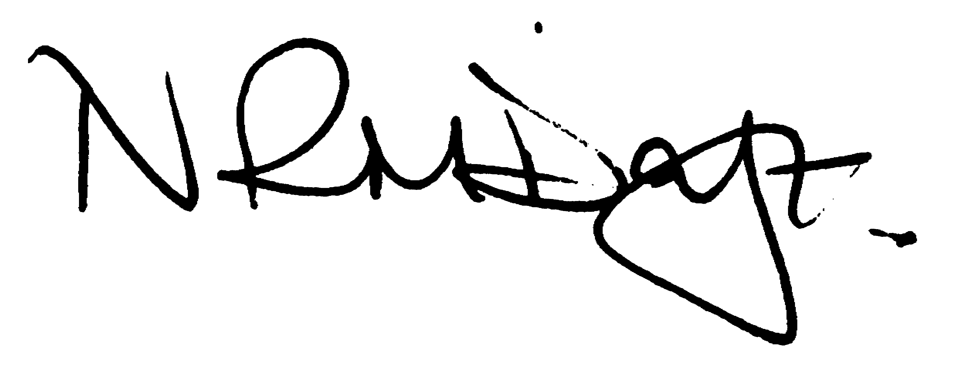

Nikki Daft – Parish Clerk

AGENDA

APOLOGIES AND ACCEPTANCE OF APOLOGIES

23/71 PUBLIC QUESTIONS, POLICE REPORT AND NNC UPDATE

Public are requested to send specific questions to council prior to the meeting due to time constraints

23/72 NOTIFICATION OF ANY DISCLOSABLE PECUNIARY INTERESTS OR OTHER INTERESTS
Only in respect of matters which are to be considered by members below. (Disclosures previously declared and registered need not be repeated).

- To receive declarations of interest
- Councillors to declare any personal interest in any items on the agenda
- Councillors to declare any personal and/or prejudicial interest in any items on the agenda and to inform the Chairman if they wish to speak on the matter during public participation

23/73 MINUTES

- To approve the minutes of the meeting held on 29th November 2023 as a true record.

23/74 FINANCIAL/POLICIES

- To Approve Payments for December 2023 and January 2024 (Clerk)
- To receive information regarding the current financial statement (Clerk)
- To agree the authorisation of the bacs payments

23/75 CEMETERY/WAR MEMORIAL

- To receive an update on cemetery matters
- To discuss the quotation to have graves repaired and gravelled in the old section.
- To note the requirement for the levelling of graves.
- To agree the Memorial Testing Policy for 2024

23/76 HIGHWAYS

- To receive an update on any Highways issues
- To receive an update from NNC Highways regarding the village alleyways
- To discuss if the council would like representatives on the Working Party for the Wellingborough, Wollaston and Irchester Cycleway
- To discuss the 40mph restriction proposed by NNC in Gypsy Lane by the Country Park
- To discuss the parking restrictions in the following areas Farndish Road Irchester - Request received via the CLO on behalf of councillors as parking restricts visibility for vehicles exiting East Street
Daniels Road/ Newcomen Road Little Irchester – Request received via the CLO on behalf of councillors to add to existing lines in situ to prevent vehicles from parking to avoid paying the fee at the local park which persons can gain access to from locations and to keep the junction clear.

23/77 PLAY AREAS

- To receive an update of the play areas
- To note the issues received regarding the skatepark repairs

23/78 PLANNING

- NW/23/00763/FUL - Proposed New Vehicular Access Crossing onto B569 Wollaston Road, hardstanding, the removal of part of an existing hedgerow and replacement hedgerow Location: 132 Wollaston Road Irchester Wellingborough NN29 7DH
- NW/23/00812/FUL – Single storey rear, side and front extensions including 2 bedrooms – 33 Knuston Spinney Irchester

23/79 COMMUNITY BUILDINGS

- To discuss the quotation from the Community library for the cleaning of the windows. Request to use monies allocated from the Gala donation.
- To receive feedback for the meeting with the YCT Committee

23/80 CORRESPONDENCE

To discuss any items required for the next agenda

- To note complaints received from 4 residents regarding the block paving being slippery in wet and icy weather.
- To note a complaint received regarding the dog bin in Woodlands Road not being used/emptied properly

23/81 EXCLUSIVE TO PUBLIC AND PRESS

To agree to discuss the following item exclusive to public and press

23/82 UPDATE ON AUSTIN CLOSE PROMOTION AGREEMENT

To discuss further information regarding the proposed promotion agreement

