
The Parish Council of Irchester
Clerk  Nikki Daft  45 Park Road  Irthlingborough  Northants  NN9 5PW |  | Telephone 07525909528  irchesterpc@gmail.com  www.hugofox.com/community/irchester-parish-council-13388/about-us

Dear Councillor 21st August 2023

You are hereby summoned to attend the ordinary meeting of Irchester Parish on Wednesday 30th August 2023 at 7.15p.m.at the Village Hall, School Road, Irchester

Yours faithfully

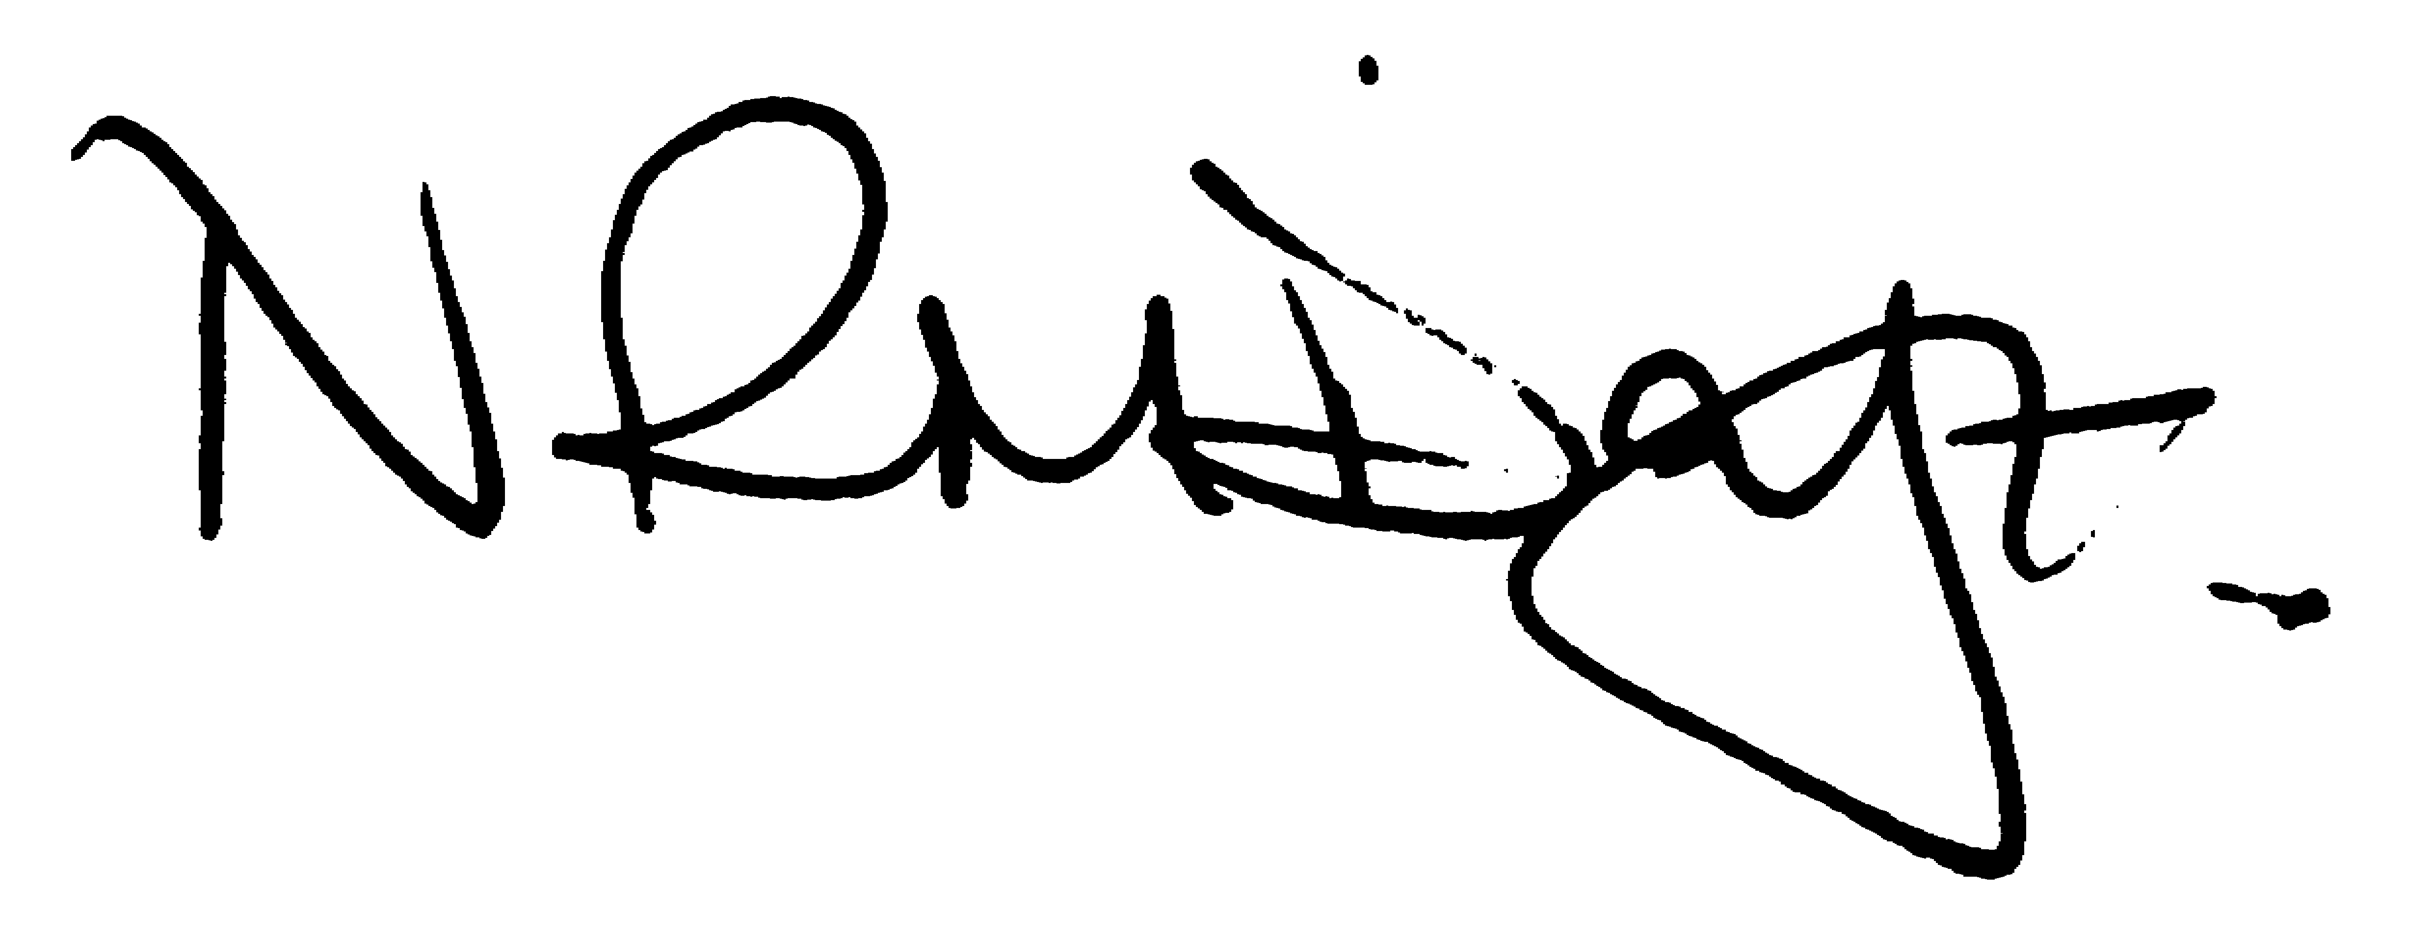

Nikki Daft – Parish Clerk

AGENDA

CHAIR TO WELCOME NEW ELECTED COUNCILLORS

APOLOGIES AND ACCEPTANCE OF APOLOGIES

23/26 PUBLIC QUESTIONS, POLICE REPORT AND NNC UPDATE

Public are requested to send specific questions to council prior to the meeting due to time constraints

23/27 NOTIFICATION OF ANY DISCLOSABLE PECUNIARY INTERESTS OR OTHER INTERESTS
Only in respect of matters which are to be considered by members below. (Disclosures previously declared and registered need not be repeated).

- To receive declarations of interest
- Councillors to declare any personal interest in any items on the agenda
- Councillors to declare any personal and/or prejudicial interest in any items on the agenda and to inform the Chairman if they wish to speak on the matter during public participation

23/28 MINUTES

- To approve the minutes of the meeting held on 28th June 2023 as a true record.

23/29 FINANCIAL/POLICIES

- To Approve Payments for August (Clerk)
- To receive information regarding the current financial statement (Clerk)
- To agree the authorisation of the bacs payments
- To discuss the request for a grant from the Village Hall Committee regarding the repairs to the roof.

23/30 CEMETERY/WAR MEMORIAL

- To receive an update on cemetery matters

23/31 HIGHWAYS

- To receive an update on any Highways issues
- To discuss problems with parking in Little Irchester
- To discuss the quotation for weed spraying several alleyways within the village
- To discuss the proposal from highways to reduce the speed limit to 40mph by Irchester Country Park

23/32 PLAY AREAS

- To receive an update regarding the play areas
- To receive a request for additional seating on the recreation ground near to the swings

23/33 COMMUNITY

- To discuss the Remembrance Day Service for November 2023
- To decide if councillors still wish to hold a separate meeting with the Parsons Hall Committee

23/34 CORRESPONDENCE

To discuss any items required for the next agenda.

- Irchester Community Library registered Asset

23/35 EXCLUSIVE TO PUBLIC AND PRESS

To agree to discuss the following item exclusive to public and press

23/36 UPDATE ON AUSTIN CLOSE PROMOTION AGREEMENT

To discuss further information regarding the proposed promotion agreement

