
The Parish Council of Irchester
Clerk  Nikki Daft MILCM  45 Park Road  Irthlingborough  Northants  NN9 5PW |  | Telephone 01933 384180  Parishclerk123@gmail.com

Dear Councillor 18th April 2016

You are hereby summoned to attend the Ordinary meeting of Irchester Parish Council to be held at Village Hall, Irchester on Wednesday 27th April 2016 at 7.15p.m.

Yours faithfully
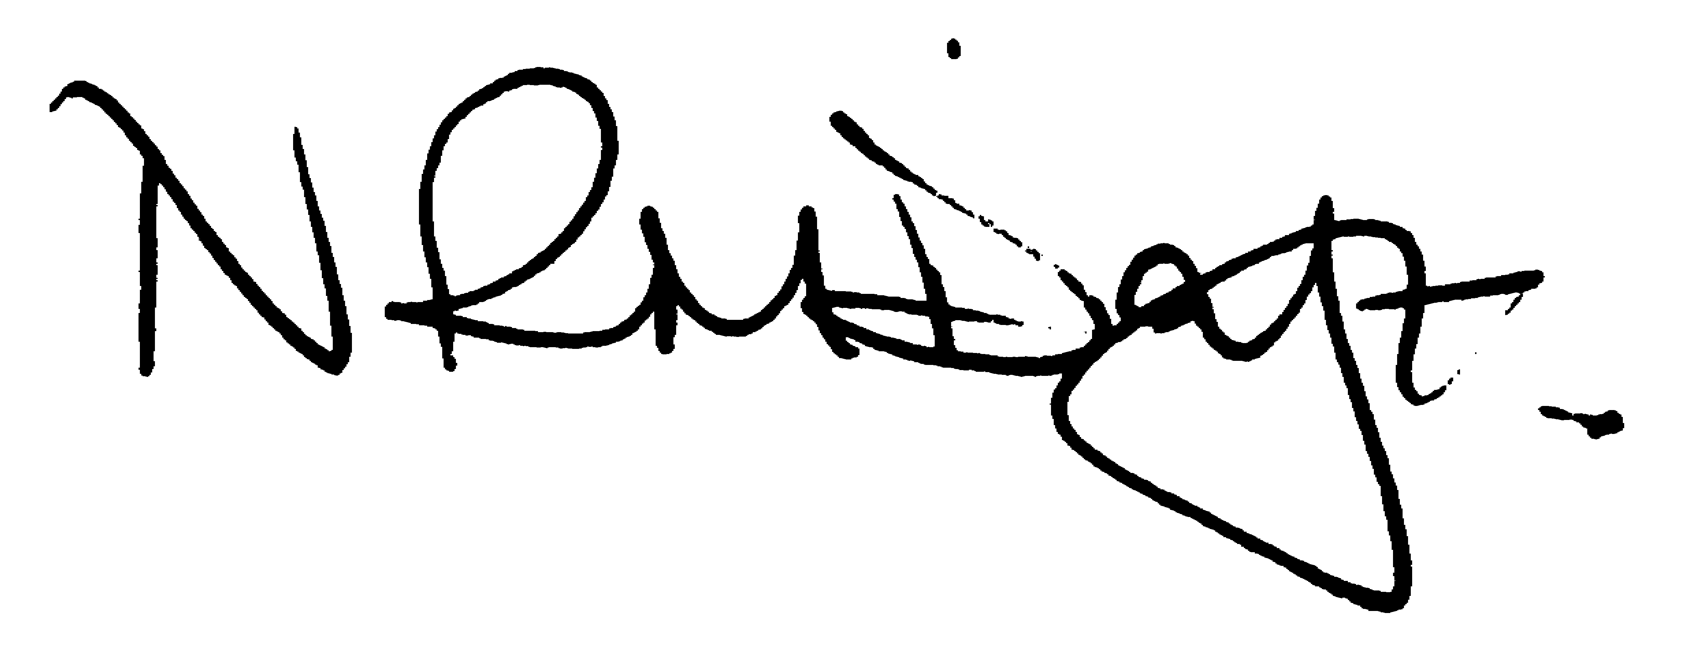

Nikki Daft – Parish Clerk

AGENDA

APOLOGIES AND ACCEPTANCE OF APOLOGIES

15/125 NOTIFICATION OF ANY DISCLOSABLE PECUNIARY INTERESTS OR OTHER INTERESTS
Only in respect of matters which are to be considered by members below. (Disclosures previously declared and registered need not be repeated).
• To receive written requests for dispensations for disclosable pecuniary interests (if any)
• To consider any requests for dispensations as appropriate

15/126 MINUTES

a) To approve the minutes of the meetings held on 30th March 2016 as true records

15/127 PUBLIC QUESTIONS, POLICE REPORT AND NCC UPDATE

Public participation may continue until for 15 minutes after which the public must not take part at any other time during the meeting. Please note that the meeting maybe recorded. All audible sounds to be switched to silent unless otherwise agreed at the start of the meeting. A report only can also be given by the Police and NCC representatives

15/128 RESOLUTIONS AND ACTIONS - MATTERS FROM PREVIOUS MINUTES
Agenda | Task | By | Completed/comments
March | Reports to Street Dr re Newtown Rd path and Irchester crossing | Clerk | 770978/9
 | Play equipment review | Rec Grp | To organise
 | Order 2 Defibrilators | Clerk | Ordered
 | Parking School Road/Lane | Cllrs | Monitor after works completed
 | Order chains for swings in Daniels Road | Clerk | Ongoing
 | Contact Development Control Manager re Solar farm | Clerk | Emailed 31/3/16
 | Confirm Patrol Crossing funding | Clerk | Completed 31/3/16
 | Highways Station Road | TM
 | Write to post office regarding changes | Clerk | Completed
 | Waste Licence application | Clerk | Completed
 | Balfour Beatty light no 33 Station Rd/Parsons corner | Clerk | Letter sent

15/129 FINANCIAL/POLICIES

- To Approve Payments for AprIl 2016 (Clerk)
- To receive information regarding the current financial statement (Clerk)
- To agree the authorisation of the bacs payments
- To discuss the request for grant funding for the Neighbourhood Watch
- To consider the purchasing of 10th Edition of Local Council Administration

15/130 RECREATION GROUNDS

- To receive and agree the reports/repairs/damage to the recreation grounds
- To discuss the fair attending the village from 16th May to 23rd May 2016
- To look at Denton Close play area and discuss ways to improve the site.

15/131 HIGHWAYS

- Street Doctor updates
- To receive information regarding the accidents being reported and review the comments from NCC highways
- To receive the response from Lighting Northamptonshire regarding the positioning of the light on the corner of Station/Parsons Road
- To decide if the council should cut back the overhanging vegetation in the alleyway between School Lane and Bakers Crescent
- To discuss the possibility of installing a dog bin near London End and Wollaston Road/Gypsy Lane(near the roundabout).
- To agree the Highway Warden report. Matters arising will be added to the next agenda

15/132 LITTLE IRCHESTER/KNUSTON

- To agree the Highway Warden report. Matters arising will be added to the next agenda
- Village sign base

15/133 PLANNING

To receive an update on planning matters
- WP/16/00121/OUT – Matters reserved amended re 2 single dwellings 94 and Annex Farndish Road
- WP/16/00160/FUL – Rear single storey annex and 1st floor ext 28 James Street
- WP/16/00179/FUL – Rear extension 6 Pendered Road Wellingborough
- WP/16/00159/LBC – Ensure future preservation of Chester Farm
- WP/16/00133/VAR – Variation of condition 3 landscaping works – Lark Energy

15/134 NEIGHBOURHOOD PLAN

- To receive an update on the NH Plan

15/135 CEMETERY/WAR MEMORIAL

- Registrar report – matters for next agenda
- To agree when the tree work should be carried out as per the quotation received for the budget meeting

15/136 COMMUNITY

- Update on the Best Village Competition
- To discuss the production of a Village Welcome Leaflet
- To discuss the housing of a defibrillator for Little Irchester.
- To receive a response from the Post Office regarding the proposed changes.
- To discuss the Wellingborough Local Plan consultation details
- To discuss if the parish council wish to make a contribution towards Wollaston Waste Recycle Centre

15/137 CORRESPONDENCE

To consider information received from incoming correspondence and decide on agenda items for the next meeting

- Wellingborough Annual Meeting invitation

