IRCHESTER PARISH C
Minutes of the Ordinary Meeting of the Parish Council held on Wednesday 27th October 2021 at the Village Hall, School Road at 7.15p.m.

Members Present:
P Armstrong – In the Chair

Councillors

P Smith JP Carr K Watts D Shroll M May V Wilkinson L Brown

The meeting started at 7.15pm. there were 3 members of the public present including NNC Cllr M Griffiths

Apologies - Agreed and Accepted from Cllr T Maguire & J Dunkley

21/53 Public participation/Police Report/North Northants Council

Public : Council thanked for replacing bench at Arkwright Road. Suggest repairing the concrete surrounding it.
NHW AGM meeting held, no councillors attended.
NCC : It was stated that the communication with NNC and parish councils was very poor and hopefully this could be improved. Query was raised regarding the cost of the Covid 19 leaflet which had little detail included in it. Potholes were also discussed stating that the temporary repairs were not up to a satisfactory standard. Temporary repairs were carried out by thermal imaging and are inspected. NNC stated that some of the roads were to be resurfaced however this information was not yet on the highways schedule. NNC Cllrs to chase and inform pc of their progress.

21/54 Declaration of Interest

None Declared

21/55 Minutes

- The minutes from 29th September 2021 were agreed as a true record to be signed by the Chair.

21/56 Financial Matters

- Payments – Resolved: That the payments of £8655.40 for October 2021 be approved
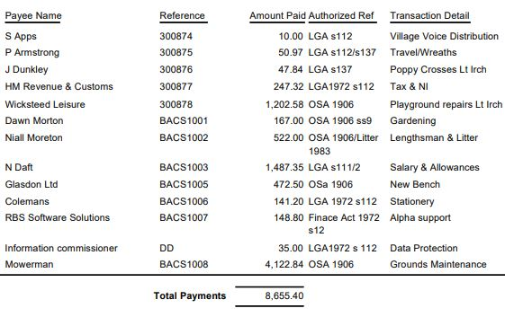

- The Current financial statement after the payments is £162,801.12
- RESOLVED that Cllrs P Armstrong & J P Carr to authorise the bacs payments for October 2021

21/57 Cemetery/War Memorial
- There had been a few interments in the cemetery. Spoil had been removed from the baby section and also several graves
- Discussion took place regarding the planting of bushes along the fence line near to the baby section. It would take about 12 bushes at £5.99 each. Cllrs DS,PA & PS agreed to help plant the bushes.
- Concern was raised regarding a mop visiting the cemetery for long periods of time throughout all weathers. It was suggested this may be a safe guarding issue. SO suspended. Cllr M Griffiths suggested reporting it to NNC Cllr David Watts head of social services SO Resumed.
- The grassed area near to the centre tree had been measured, as this area was not located on any plans, which can accommodate 17 burial plots and 44 cremated remains plots. The plots had been added to the maps and it was agreed to commence using them.

21/58 Planning

NW/21/00895/FUL - A detached 4 bedroom dormer bungalow, which will constitute a rural worker dwelling on the holding, with associated gardens and an internal garage and hardstanding for parking. Vehicular access is proposed via an existing private road with a junction to the B529 Location: High Farm 400 Station Road Irchester –No comments – Support application
NW/21/921 First floor side extension 74 Woodlands Road – No comments
NW/21/927 Single storey rear extension – 7 Redwood Close – No Comments
NW/21/930 Granny Annex 89 Gipsy Lane – No comments

21/59 Highways

- The new recycled bench had been installed for corner of Arkwright Road.
- RESOLVED to order a new notice board for corner of School Road being the Tradition Dual Door measuring 750mm x1200mm supplied and fitted at a cost of £649.70 finished in green.

.21/60 Play Areas

- Rotas had been sent to councillors regarding the checking of the play areas. The new equipment is successful however it is suggested to consider installing equipment for 12 to 14 year olds and adults. Recreation group to meet to look at the area and programme of installation which would also include public consultation.

21/61 Community Projects

- Details were received regarding the setting up of a community orchard in the open space area at Bradshaw Way. Details had been looked into regarding the suggestion of underground pipework but no drain covers etc were found. However it was agreed that Anglian Water be contacted as clarification that no pipes were present in that area. A letter to the adjoining residents was to be sent out/spoken to. It was proposed to commit to the orchard subject to a favourable response from Anglian Water regarding the pipework and if no further problems arose then 12 apple and 1 crab tree could be planted this season.
- Discussion regarding the Remembrance Day services. The insurance of the event was covered under the pc certificate as long as the event was organised safely with up to date risk assessments in place. Wreaths had been ordered. Knitted poppies would be displayed at the memorial sites and inspected daily. Lt Irchester service to commence at 2.30pm and Irchester 10.50am Cllr Carr was thanked for organising the event.

21/62 Correspondence
No correspondence bought to council

Meeting closed at 9.10 pm

Chair

