IRCHESTER PARISH COUNCIL

Minutes of the Meeting of the Parish Council held on Wednesday 25th March 2015 at Hilton Hall, Little Irchester at 7.15p.m.

Members Present:
P Armstrong – In the Chair

Councillors
P Smith A May D May R Elliott I Nunney
J Gibson K Clements I French C Painter

The meeting started at 7.15pm. There were 3 members of the public present

Apologies - Resolved to receive and accept apologies from Cllr M May, T Maguire, L Brown J Dunkley & D Shroll S Homer NCC, Police

14/108 DPI's

None Declared

14/109 Minutes

RESOLVED that the minutes of the meeting held on 25th February 2015 were agreed as a true record.

14/110 Public participation, police reports and NCC updates
Irchester
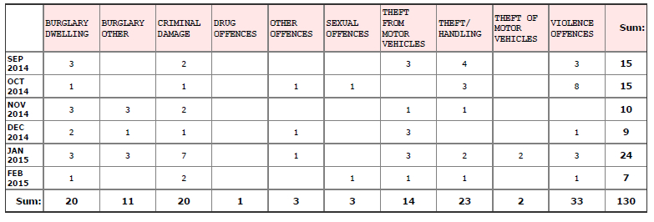
Violence - Domestic Related
Theft/Handling -St Katherines Way, Cash Stolen.
Theft from Motor Vehicle -Arkwright Road, Wing Mirror Stolen.
Sexual Offences -Historic Report
Criminal Damage - Chester House, Electric Fencing Damaged - Vehicle at Irchester Country Park
Burglary Dwelling - Woodlands Road, Jewellery Stolen, no lines of enquiry.

Little Irchester Knuston
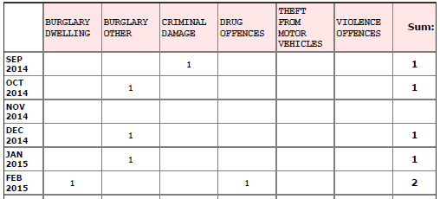
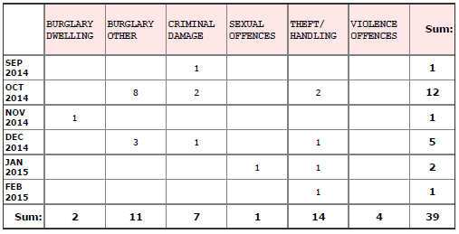

Theft/Handling - Claudius Way, DHL, Theft of Pedal Cycle Drug Offences - Possession of Cannabis
Burglary Dwelling - Station Road, known offender, dealt with by community resolution, item returned.

Public –

At the February JAG meeting the police asked that the public be aware of rural crimes. These included crimes on isolated farms etc so if anything unusual is seen please report it to the police.

Chair thanked the public for their comments.

14/111 Actions/Matters from previous minutes
Agenda | Task | By | Completed/comments
90/101/13 | Quotes re land registry | Clerk | Ongoing
8797//13 | Dog Fouling | Cllrs | Monitor
106/13 | Sign fly posting | Cllrs | To monitor
14/94 | Report manhole on A509 roundabout | Clerk | Reported – no action NCC
14/100 | Order fencing for skate park to include wire | Clerk | Ordered
 | Reseed slope at Austin Close | Clerk | Ordered
 | Equipment on rec check warranty | Clerk | Received
14/101 | St Kat’s light reported again | Clerk | Repaired
 | Quote to replace light at St Kat’s | Clerk | Requested
 | TL5 response | Clerk | Sent
14/104 | Consultation response for NNJPCS/WBC Local Plan | Clerk | Sent
14/105 | Cemetery meet re graves/cremated remains | Advisory | Agenda item

- Warranty on equipment was for 12 months
- NCC stated the manhole cover did not need further repair
- TL5 footpath NCC ignored the pc request so the closure will go ahead. The pc wish to appeal and it was suggested to inform the ramblers association also

14/112 Financial Matters

- Approval of Payments – Resolved: That the payments £10,175.05 for March 2015 be approved
- Date Paid | Payee Name | Cheque Ref | Amount Paid Authorized Ref | Transaction Detail
25/03/2015 | HM Revenue | 300267 | 246.96 | Tax & NI March
25/03/2015 | Irchester Youth Club | 300268 | 600.00 | Grant
25/03/2015 | Irchester Village Hall | 300269 | 600.00 | Grant
25/03/2015 | S May | 300270 | 65.00 | Village Voice Editor Exp
25/03/2015 | D Carr | 300271 | 500.00 | interim 2nd Stage NHP consult
25/03/2015 | JP Carr | 300272 | 891.00 | Hall hire. stationary,travel
25/03/2015 | NCALC | 300273 | 34.00 | Training
25/03/2015 | Eurooffice | 300274 | 37.01 | Ink and paper
25/03/2015 | Wellingborough Council | 300275 | 108.00 | Cemetery rates
25/03/2015 | A & R Print Solutions | 300276 | 992.00 | Print Village Voice
25/03/2015 | Adam Redman | 300277 | 60.00 | NHP domain name
25/03/2015 | N Daft | BACS0301 | 250.00 | NHP work
25/03/2015 | N Greenhalf | BACS0302 | 240.00 | LItter picking February
25/03/2015 | N Daft | BACS0304 | 1,231.58 | Mar salary and exp
25/03/2015 | M Wright | BACS0305 | 69.50 | Salary & Exp
25/03/2015 | Mowerman | BACS0306 | 4,020.00 | Fence Austin Close
25/03/2015 | Green Garden Craft | BACS0307 | 230.00 | Cem/War Memorial Garden
Total Payments 10,175.05

b) The bank statement of £90,765.81 was noted as being available after current payments made.
c) RESOLVED that Cllr P Armstrong and L Brown authorise the bacs payments for March
d) The council were informed of Automatic Enrolment into a Pension Scheme. This is mandatory for the Clerk and the 33 tasks involved will take approximately 9 to 12 months to complete. The council were informed of an organisation that could help with the process at a cost of £79.00 set up fee and then £29.00 per month until the tasks had been completed. It was agreed that the new finance advisory group look at in the new council.
e) EON had increased their rates by 50% and other suppliers were being contacted for costs.

14/113 Recreation Grounds

- Inspection report had been received. The copings for the skate park had not yet been repaired and the manufacturer had been reminded. It was agreed that the Recreation Advisory Group from the new elected council carry out an audit of all the current equipment.
- A quotation of £ 875.00 had been received to clear the rubble and weed area near to the slope at Austin Close. After discussion regarding the wild flower area, it was agreed to accept the quote and plant the wildflowers opposite the skate park near the hedge. The pc could spend up to £200.00 for seeds.

14/114 Highways –

- The Highway Warden report was noted. CP was thanked for all his efforts with the reports as it was stated that this would be his last council meeting as he was moving from the area.
- A quotation had not been received regarding the upgrading of the light in St Katherine’s Way. The contractor to be contacted to determine if there was a problem.
- Speedwatch programme – no progress
- DPPO – the order was reviewed and it was agreed that the order was successful and should remain in place.

14/115 Little Irchester/Knuston

- There was no updated Highway Warden report as there were currently various problems regarding the highways and their contractors therefore a meeting had been asked with NCC

14/116 Planning - The following had been received:

- Neighbourhood Plan update had been circulated to councillors SO suspended in order for the Chair of the NHP Group to answer councillors questions. Question re Heritage Assessment cost. It was stated the group were awaiting costs and if any grants were available to support this. Question regarding the effect this would have on the time table. Stated unsure on the time scale and how it will affect the plan at the moment. Request that an updated timetable be added to the website. SO resumed
- WP/15/00156/FUL – Single storey extension 19 Beech Crescent – no objections

14/117 Emergency Plan

- A meeting had been held with NCC regarding the producing of an Emergency Plan. The NCC would be donating some equipment that would be stored at the village hall for use in an emergency. Volunteers were now required to attend training, write the plan and be included in the plan. These included people with skills ie first aiders, nurses etc and also people with 4 x 4 vehicles, tractors and chain saws etc. It was agreed to place a notice in the village voice asking for volunteers.

14/118 Cemetery

- The cemetery advisory group had met to look at the query regarding the cremated remains row. SO suspended for the registrar to make comment. Amendments had been made to the rules and regulations and it was agreed to accept the changes with the size of the cremated remains plots added and also diagrams regarding the positioning of the tablet. SO resumed.
- Bins – not being emptied because the bins were contaminated. Could use black bins and brown bins and leave them by the gate.

14/119 Correspondence

- The chair had arranged the Annual Parish Meeting for residents for Wednesday 15th April at the Village Hall for 7.00pm

Meeting closed at 9.05 pm Chair

