
The Parish Council of Irchester
Clerk  Nikki Daft MILCM  45 Park Road  Irthlingborough  Northants  NN9 5PW |  | Telephone 01933384180  Parishclerk123@gmail.com

Dear Councillor 20th November 2017

You are hereby summoned to attend the Ordinary meeting of Irchester Parish Council to be held in the Village Hall, School Road Irchester on Wednesday 29th November 2017 at 7.15p.m.

Yours faithfully
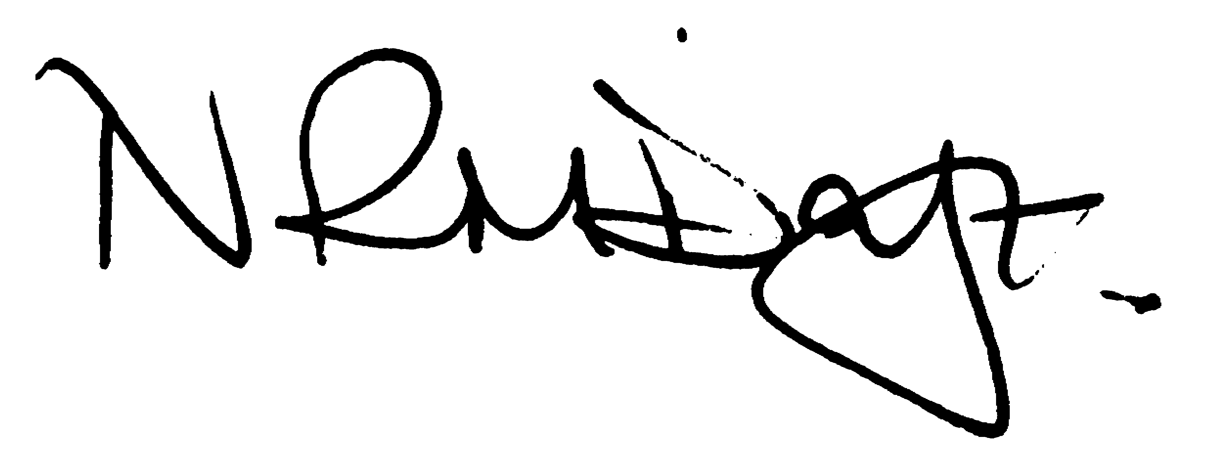

Nikki Daft – Parish Clerk

AGENDA

APOLOGIES AND ACCEPTANCE OF APOLOGIES

17/81 NOTIFICATION OF ANY DISCLOSABLE PECUNIARY INTERESTS OR OTHER INTERESTS
Only in respect of matters which are to be considered by members below. (Disclosures previously declared and registered need not be repeated).

17/82 PUBLIC QUESTIONS, POLICE REPORT AND NCC UPDATE

Public participation may continue until for 15 minutes after which the public must not take part at any other time during the meeting. Request should be made to the Chair if any member of the public wishes to make a recording of any part of the meeting. All audible sounds to be switched to silent unless otherwise agreed at the start of the meeting. A report only can also be given by the Police and NCC representatives

17/83 MINUTES - To approve the minutes of the meetings held on 25th October 2017 as a true record.

17/84 RESOLUTIONS AND ACTIONS - MATTERS FROM PREVIOUS MINUTES

- Speed boards ordered
- Co-op letter – response received
- F Webber re tree war memorial – response
- Dates for training

17/85 FINANCIAL/POLICIES

- To Approve Payments for November 2017 (Clerk)
- To receive information regarding the current financial statement (Clerk)
- To agree the authorisation of the bacs payments

17/86 RECREATION GROUNDS

- To receive and agree the reports/repairs/damage to the recreation grounds (JD)
- To receive information and agree dates for Pindar Circus to use the recreation ground

17/87 HIGHWAYS

- To agree any items that need to be added to the next agenda
- To agree the grass mowing contract for 2018 with NCC
- To receive information regarding the VAS signs

17/88 LITTLE IRCHESTER/KNUSTON - To agree the Highway Warden report, previously circulated. Matters arising will be added to the next agenda

17/89 PLANNING - To discuss any planning issues

- WP/17/00676/FUL – Conversion of Tithe Barn to 2 dwellings and garage– 75A High Street
- WP17/00677/LBC – Conversion of Tithe Barn to 2 dwellings and garage – 75A High Street

17/90 NEIGHBOURHOOD PLAN - To receive an update on the progress of the NHP

17/91 CEMETERY/WAR MEMORIAL

- To receive the Registrars report and decide if details should be added to the next agenda
- To discuss the problems with the headstones and what course of action the council wishes to take

17/92 COMMUNITY ISSUES

- To discuss the damaged fence to the allotment and if the pc can support the association in funding the repairs
- To discuss organising a working party in order to organise events to commemorate World War One 100 years.
- To complete the 6 month review of the Business Plan

17/93 CONSULTATIONS

- To discuss the consultation regarding the Boundary Commission
- To discuss the budget cut proposals from Northants County Council

17/94 CORRESPONDENCE To consider information received from incoming correspondence and decide on agenda items for the next meeting.

17/95 EXCLUSIVE TO PUBLIC AND PRESS

17/96 COMPLAINTS

- To receive information regarding complaints

17/97 COMMUNITY ASSETS

- To discuss how the council should proceed in securing Community Assets

