IRCHESTER PARISH COUNCIL

Minutes of the Meeting of the Parish Council held on Wednesday 29th October 2014 at Village Hall, School Road Irchester at 7.15p.m.

Members Present:
P Armstrong – In the Chair

Councillors
I French P Smith J Dunkley K Clements I Nunney
D May Miss L Brown Mrs A May C Painter D Scholl

The meeting started at 7.15pm. There were 6 members of the public present.

Julie Rankin, Director, Lark Energy, Rachel Wood, Project Officer, Lark Energy and Mike Lee, Land Consultant, Lark Energy attended the parish council meeting and gave a short presentation regarding the proposed solar farm development at Little Irchester. They stated that the proposal was in the very early stages and that public consultations would take place in order to seek public opinion and answer questions.

The Chair thanked Lark Energy for attending

Apologies - Resolved to receive and accept apologies from Cllr J Gibson, T Maguire & M May

14/58 DPI's

None Declared

14/59 Minutes

RESOLVED that the minutes of the meeting held on 24th September 2014 were agreed as a true record.

14/60 Public participation, police reports and NCC updates

Public comments – Concern was raised regarding the trees in Farndish Road during the summer months as they had produced sap and maggots that had fallen on to residents cars. It was agreed to ask NCC to look into the problem. Concern was also raised regarding the lighting in that area. It was agreed to look at the area once the new lights had been installed. To be raised as an Agenda item.

Chair thanked the public for their comments.

Police: PCSO R Head from the police attended the meeting. Chair thanked R Head for her comments regarding the stats.

Irchester

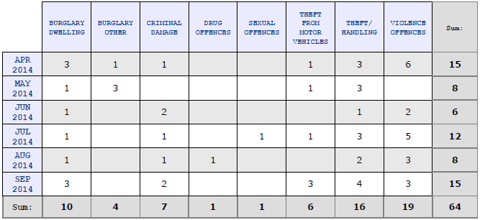

Assault with injury – Friend related.
Assault without injury – Kids fight.
Assault with injury – Dog bite.

Knuston Little Irchester

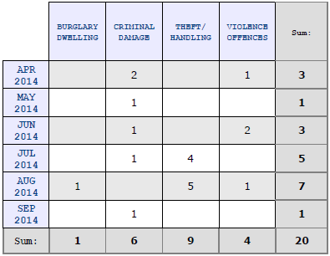
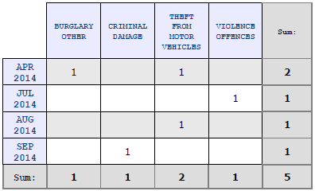

14/61 Actions/Matters from previous minutes

Agenda | Task | By | Completed/comments
90/101/13 | Quotes re land registry | Clerk | Ongoing
8797//13 | Dog Fouling | Cllrs | Monitor
106/13 | Sign fly posting | Cllrs | To monitor
14/12 | CIL/S106 projects | Cllrs | Meeting 2015
14/50 | Lighting changes for Chester Road | Clerk | Completed
14/53 | Letter sent re Bowls club underlease | Clerk | Sent
14/49 | Gate Austin Close ordered | Clerk | Completed
 | Bollards Recreation Ground | Clerk | Ordered
14/57 | Letter re claim | Clerk | Sent

- Lighting changes to Chester Road had been completed.
- Letter regarding the underlease for the Bowls Club to Emotion had been sent
- Gate at Austin Close had been locked
- Letter regarding damages claim had been sent

14/62 Financial Matters

- Approval of Payments – Resolved: That the payments £12,064.98 for October 2014 be approved

Date Payee Cheque Amount Detail
22/10/2014 Mowerman 300168 1,105.00 grass, flail, lock grass cutting, austin flail
22/10/2014 HM Revenue 300169 208.40 Tax & NI
22/10/2014 Playground Supplies 300170 180.00 repair wetpore rec
22/10/2014 Glasdon Ltd 300171 826.17 Larbreck seat (donation)
22/10/2014 Eon Maintenance 300172 321.18 Unmetered supply
22/10/2014 Croyland Motors 300173 27.00 fuel cemetery
22/10/2014 Wellingborough Norse 300174 1,874.40 Maintenance
22/10/2014 RBS Software Solutions 300175 130.80 accounts maintenance
22/10/2014 Outdoor Lighting Solutions 300176 5,335.20 Chester Road lights
22/10/2014 N Daft BACS1001 222.00 NHP admin
22/10/2014 R Annies BACS1002 470.00 Salary
22/10/2014 N Daft BACS1003 1,079.33 Salary & Expenses
22/10/2014 M Wright BACS1004 69.50 Salary & expenses
22/10/2014 D Carr BACS1005 216.00 Salary & Expenses

Total Payments 12,064.98

b) The bank statement of £142,482.05 was noted as being available after current payments made.
c) RESOLVED that Cllr I French and P Armstrong authorise the bacs payments for October.
d) Finance meeting to be arranged before organising the budget meeting

14/63 Recreation Grounds

- Inspection report had been received. No problems with the Circus. It was stated that the drain cover housing had been damaged and needed to be repaired. It was agreed to have this work completed asap. The hedge at the back of the fence in the toddler play area was overgrown. It was agreed to obtain a quotation to have this cut back. The wooden surround to some wet pore in the recreation ground was rotting and nails were protruding. These had been removed. To monitor the situation. Some scratch damage had been made to the equipment in Little Irchester.
- Skatepark - the concrete elements had been installed and it was anticipated to be completed by beginning of November. Discussion took place regarding the launch date which was agreed to be held on Saturday 15th November 2014 at 12 noon. It was agreed to invite all councillors, the sponsors and those making donations to the park. RESOLVED to spend up to £250.00 on refreshments for the guests.
- Request was made to the council to sell a section of land from Austin Close. It was agreed not to proceed with discussion until the exact ownership of the parcels of land was established.

14/64 Highways –

a) The Highway Warden report was noted placed on the council’s website. The white lines for the zebra crossing outside Co-op had been repainted. Highways responding very positively to the reports that the Highway Wardens were sending through. Latest information: There will be repair work to the carriageway around the Woodlands Road build-out within the next 5 days, repair work in Farndish Road within 4 months and pavement damage in Arkwright will be repaired within 2 months.

14/65 Little Irchester/Knuston

a) The Highway Warden report was noted and placed on the council’s website. It was stated that the alleyway in Little Irchester belonged to the residents therefore it was their responsibility to clear them. It was stated that the gutters were no longer the responsibility of NCC or Wellingborough Norse but that the pc are responsible for clearing them. This had been queried with the Borough Councillors.

14/66 Planning - The following applications had been received:

- Neighbourhood Plan update had been received. It was suggested that ‘energy’ may be included in the project topics.
- WP/14/00666/FUL – Access junction improvement A45 – Chester Farm – improvements but restricted traffic access for service vehicles and disabled
- WP/14/00661/LBC – Repoint front elevation of house and replace windows – 25 High Street – No comments1
- WP/14/00672/FUL – Demolish rear kitchen and construct new single storey – 197 Wollaston Road – No comments
- WP/14/00710/ADV Sign ATM in Irchester 8 High Street – no comments

14/67 Community Assets

There had been no further progress regarding land registration.

14/68 Remembrance Day

Committee members were organising the event as in the previous year. Wreaths had been ordered for the parish council and were ready for collection. £300 has been allocated for the order of service printing. RESOLVED to allocate Little Irchester a donation of £25.00 for bugler. CP stated that he would be away and unable to attend the service.

14/69 Correspondence

- Letter from resident asking if an electric car charger point could be installed in the village hall car park – Agenda item
- WBC letter received regarding village boundaries
- Refuse collection details

Meeting closed at 9.00pm Chair

