
The Parish Council of Irchester
Clerk  Nikki Daft PSLCC  45 Park Road  Irthlingborough  Northants  NN9 5PW |  | Telephone 07525909528  irchesterpc@gmail.com  www.hugofox.com/community/irchester-parish-council-13388/about-us

Dear Councillor May 2022

You are hereby summoned to attend the Annual meeting of Irchester Parish Council followed by the ordinary meeting of the Parish Council to be held at Village Hall, School Lane, Irchester on Wednesday 25th May 2022 at 7.15p.m.

Yours faithfully
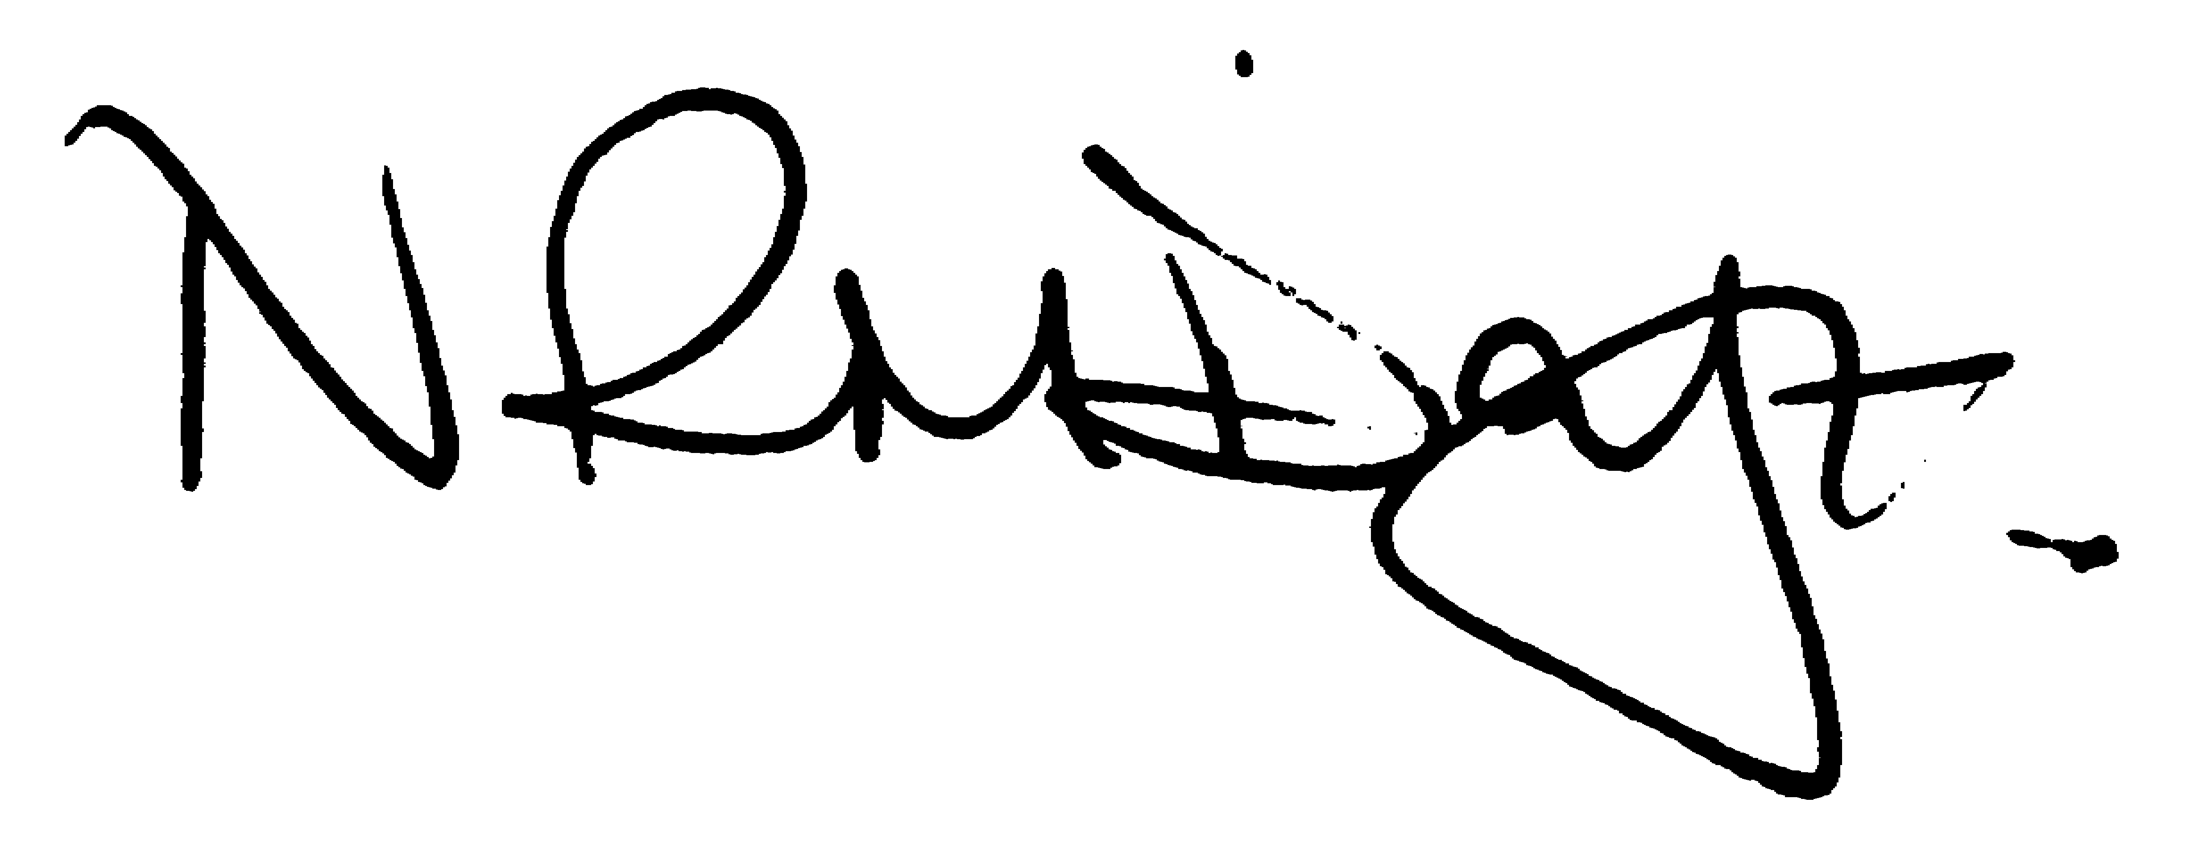

Nikki Daft – Parish Clerk

AGENDA

APOLOGIES AND ACCEPTANCE OF APOLOGIES

22/1 CHAIRMAN ELECTION AND ACCEPTANCE OF OFFICE

- To receive nominations and elect a Chair for the Parish Council for the ensuing year. Declaration of acceptance of office to be completed.

22/2 NOTIFICATION OF ANY DISCLOSABLE PECUNIARY INTERESTS OR OTHER INTERESTS
Only in respect of matters which are to be considered by members below. (Disclosures previously declared and registered need not be repeated).

- To receive declarations of interest
- Councillors to declare any personal interest in any items on the agenda
- Councillors to declare any personal and/or prejudicial interest in any items on the agenda and to inform the Chairman if they wish to speak on the matter during public participation

22/3 CO-OPTION OF COUNCILLORS

To co-opt councillors

22/4 APPOINTMENTS OF MEMBERS to the following specific areas of interest:

a) Vice Chair b) Internal Accounts Controller
c) Footpaths d) Highway Wardens for Irchester, Little Irchester and Knuston
e) H & S Representative

22/5 APPOINTMENT OF ADVISORY GROUPS/WORKING PARTIES

- Finance
- Recreation
- Cemetery
- Highways & Lighting
- Planning
- Staff
- Orchard & Wild Flower areas
- Village Voice
- Emergency planning/flooding
- Community Projects
- Events

22/6 APPOINTMENT OF REPRESENTATIVES ON OUTSIDE BODIES

To appoint representatives on Outside Bodies for the following:

a) Irchester Sports Association (2) b) Village Hall Committee
c) Youth Centre Management Committee d) Allotment Association
e) Bowling Club Committee f) Library

22/7 DATES OF COUNCIL MEETINGS 2022//23

To approve the dates for meetings throughout 2022/23

29th June 2022 25th January 2023
31st August 2022 22nd February 2023
28th September 2022 29th March 2023
26th October 2022 26th April 2023
30th November 2022 31st May 2023

To commence the Ordinary Meeting of Irchester Parish Council

22/8 PUBLIC QUESTIONS, POLICE REPORT AND NCC UPDATE

Public participation may continue until for 15 minutes after which the public must not take part at any other time during the meeting. Request should be made to the Chair if any member of the public wishes to make a recording of any part of the meeting. All audible sounds to be switched to silent unless otherwise agreed at the start of the meeting. A report only can also be given by the Police and NCC representatives

22/9 MINUTES

a) To approve the minutes of the meeting held on 27th April 2022 as a true record

22/10 FINANCIAL/POLICIES

- To Approve Payments for May 2022 (Clerk)
- To receive information regarding the current financial statement (Clerk)
- To agree the authorisation of the bacs payments
- To discuss the energy costs for unmetered supply

22/11 RECREATION GROUNDS

- To receive and agree the reports/repairs/damage to the recreation grounds
- To receive a request from Romans Youth FC to use the Recreation Ground on Sunday 26th June for parking

22/12 HIGHWAYS

- To determine highways issues to be added to the next agenda
- To discuss the quotation for the reduction of the tree on the bank at Station Road Corner
- To discuss the replacement of the litter bin at the corner of Bradshaw Way

22/13 PLANNING

NW/22/00272/FUL - The construction of 2 x 2 bed detached bungalows, one detached garage to serve each dwelling, hardstanding, vehicular accessess, new boundary treatments and landscaping and brick curved boundary wall and 1.8 metre high close boarded fencing adjacent to 88 Farndish Road, Irchester Location: Land Adjacent 34 34 Coulon Close Irchester

NW/22/00268/FUL - Demolish existing UPVC conservatory and replace with a single storey rear extension constructed in brick. The demolition of an existing UPVC sun room extension to the rear of the kitchen. Existing lounge to conservatory doorway to be bricked up to create a third bedroom. Internal alterations including the open plan kitchen-diner space to be created by knocking through wall from kitchen to new room. Location: 88 Farndish Road Irchester

NW/22/00286/FUL - Proposed conversion to part of dwelling to form 1 no. holiday let unit (retrospective) Location: 14 School Hill Irchester

NW/22/00229/FUL - Redevelopment and extension of the bungalow at the ground floor and addition of a first floor. Location: 18 Gipsy Lane Irchester

NW/22/00316/FUL - Proposed single storey rear extension with roof lantern Location: 35 Bradshaw Way Irchester

22/14 CEMETERY/WAR MEMORIAL

- To receive information regarding the cemetery
- To discuss the damaged Tommy in Little Irchester
- To receive a request from the WI to plant a Weeping Cherry Tree on the War Memorial with added plaque to commemorate the Queens Platinum Jubilee

22/15 COMMUNITY

- To receive an update on the orchard
- To receive an update on the library
- To receive an update of the Big Lunch

22/16 CORRESPONDENCE

To consider information received from incoming correspondence and decide on agenda items for the next meeting.

