
The Parish Council of Irchester
Clerk  Nikki Daft PSLCC  45 Park Road  Irthlingborough  Northants  NN9 5PW |  | Telephone 07525909528  irchesterpc@gmail.com  www.hugofox.com/community/irchester-parish-council-13388/about-us

Dear Councillor 10th May 2021

You are hereby summoned to attend the Annual meeting of Irchester Parish Council followed by the ordinary meeting of the Parish Council to be held at Village Hall, School Lane, Irchester on Wednesday 19th May 2021 at 7.15p.m.

Yours faithfully
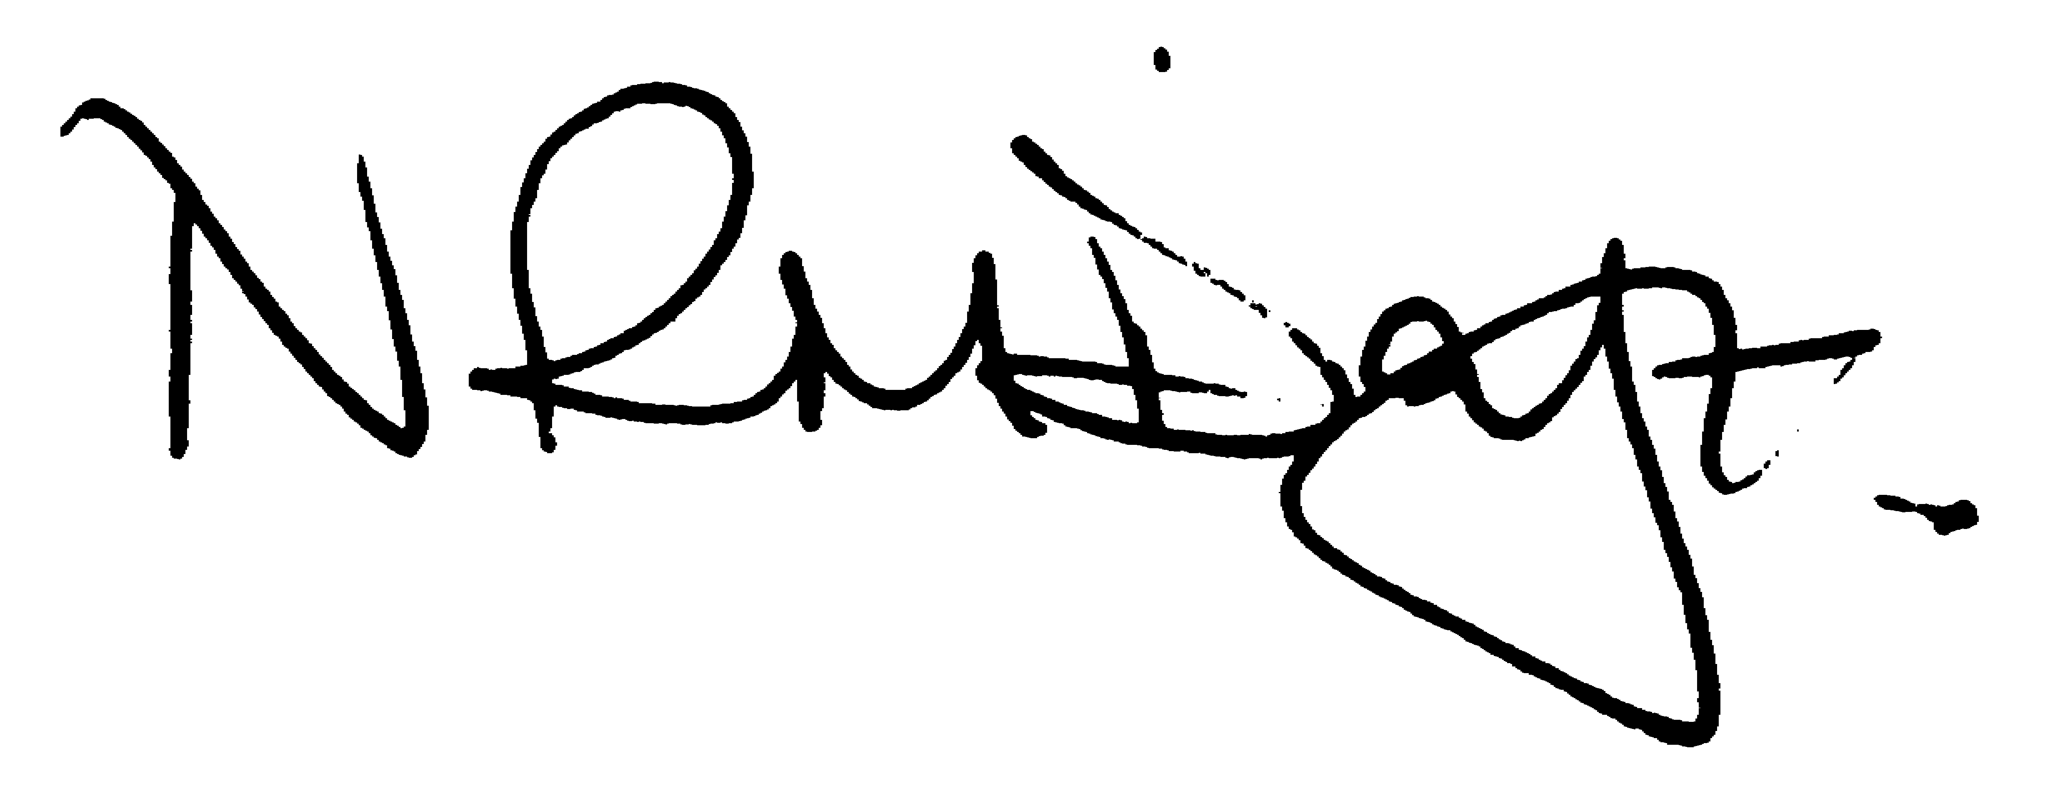

Nikki Daft – Parish Clerk

AGENDA

APOLOGIES AND ACCEPTANCE OF APOLOGIES

21/1 CHAIRMAN ELECTION AND ACCEPTANCE OF OFFICE

- To receive nominations and elect a Chair for the Parish Council for the ensuing year. Declaration of acceptance of office to be completed.
- All Councillors to complete acceptance of Office forms

22/2 NOTIFICATION OF ANY DISCLOSABLE PECUNIARY INTERESTS OR OTHER INTERESTS
Only in respect of matters which are to be considered by members below. (Disclosures previously declared and registered need not be repeated).

- To receive declarations of interest
- Councillors to declare any personal interest in any items on the agenda
- Councillors to declare any personal and/or prejudicial interest in any items on the agenda and to inform the Chairman if they wish to speak on the matter during public participation

22/3 APPOINTMENTS OF MEMBERS to the following specific areas of interest:

a) Vice Chair b) Internal Accounts Controller
c) Footpaths d) Highway Wardens for Irchester, Little Irchester and Knuston
e) H & S Representative

22/4 APPOINTMENT OF ADVISORY GROUPS

- Finance
- Recreation
- Cemetery
- Highways & Lighting
- Planning
- Orchard & Wild Flower areas
- Village Voice
- Emergency planning/flooding
- Community Projects

22/5 APPOINTMENT OF REPRESENTATIVES ON OUTSIDE BODIES

To appoint representatives on Outside Bodies for the following:

a) Irchester Sports Association (2) b) Village Hall Committee
c) Youth Centre Management Committee d) Allotment Association
e) Bowling Club Committee f) Library

22/6 DATES OF COUNCIL MEETINGS 2021/22

To approve the dates and venues for meetings throughout 2021/22

30th June 2021 26th January 2022
25th August 2021 23rd February 2022
29th September 2021 30th March 2022
27th October 2021 27th April 2022
24th November 2021 25th May 2022

To commence the Ordinary Meeting of Irchester Parish Council

22/7 PUBLIC QUESTIONS, POLICE REPORT AND NCC UPDATE

Public participation may continue until for 15 minutes after which the public must not take part at any other time during the meeting. Request should be made to the Chair if any member of the public wishes to make a recording of any part of the meeting. All audible sounds to be switched to silent unless otherwise agreed at the start of the meeting. A report only can also be given by the Police and NCC representatives

22/8 MINUTES

a) To approve the minutes of the meeting held on 28th April 2021 as a true record

22/9 FINANCIAL/POLICIES

- To Approve Payments for May 2021 (Clerk)
- To receive information regarding the current financial statement (Clerk)
- To agree the authorisation of the bacs payments

22/10 RECREATION GROUNDS

- To receive and agree the reports/repairs/damage to the recreation grounds
- To discuss the quotations for the seesaw for Little Irchester
- To discuss the quotation for cutting the Recreation Ground and childrens area

22/11 HIGHWAYS

- To determine highways issues to be added to the next agenda

22/12 PLANNING

NW/21/00354/FUL – Conversion of integral garage to habitable room – 36 Arkwright Road

22/13 CEMETERY/WAR MEMORIAL

- To receive information regarding the cemetery

22/14 CORRESPONDENCE

To consider information received from incoming correspondence and decide on agenda items for the next meeting.

Details received from Crime Wave

22/15 EXCLUSIVE TO PUBLIC AND PRESS

22/16 PARSONS HALL LEASE – To discuss the request from the YCT to modernise the lease

22/17 LAND AT AUSTIN CLOSE – To discuss a Promotion Agreement between landowners

