
The Parish Council of Irchester
Clerk  Nikki Daft PSLCC  45 Park Road  Irthlingborough  Northants  NN9 5PW |  | Telephone 07525 909528  irchesterpc@gmail.com

Dear Councillor 18th March 2019

You are hereby summoned to attend the Ordinary meeting of Irchester Parish Council to be held in the Village Hall, School Road Irchester on Wednesday 27th March 2019 at 7.15p.m.

Yours faithfully
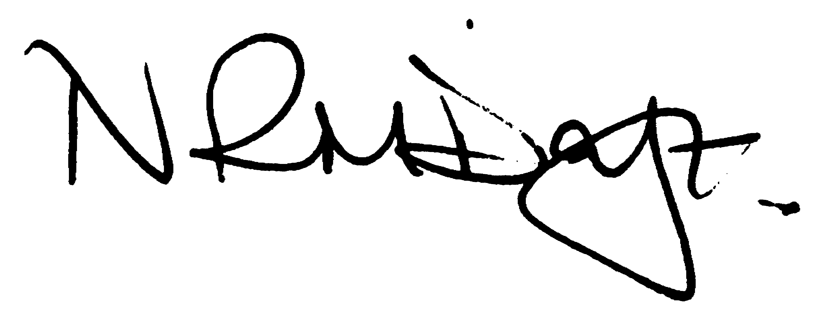

Nikki Daft – Parish Clerk

AGENDA

APOLOGIES AND ACCEPTANCE OF APOLOGIES

18/116 PUBLIC QUESTIONS AND/COMMENTS

Public participation may continue until for 15 minutes after which the public must not take part at any other time during the meeting. Any member of the public can make a recording of any part of the meeting. All audible sounds to be switched to silent unless otherwise agreed at the start of the meeting.

POLICE REPORT AND NCC UPDATE

To receive a verbal report from the Police and NCC representative if in attendance

18/117 NOTIFICATION OF ANY DISCLOSABLE PECUNIARY INTERESTS OR OTHER INTERESTS
Only in respect of matters which are to be considered by members below. (Disclosures previously declared and registered need not be repeated).

- To receive declarations of interest
- Councillors to declare any personal interest in any items on the agenda
- Councillors to declare any personal and/or prejudicial interest in any items on the agenda and to inform the Chairman if they wish to speak on the matter during public participation

18/118 MINUTES - To approve the minutes of the meetings held on 27th February 2019 as a true record.

18/119 Co-option – To consider the co-option of a councillor for the Little Irchester Ward

18/120 RESOLUTIONS AND ACTIONS - MATTERS FROM PREVIOUS MINUTES

Quotes for cemetery work
Cemetery course – booked
Cremated remains letter sent and work completed
Play area repairs ordered
Letter NCC re cherry trees

18/121 FINANCIAL/POLICIES

- To Approve Payments for March 2019 details sent to councillors via email (Clerk)
- To receive information regarding the current financial statement – reconciliation statement sent to councillors via email (Clerk)
- To agree the authorisation of the bacs payments
- To discuss the quotations received regarding the unmetered supply for the street lights and to determine if the council wish to enter into a fixed term contract

18/122 RECREATION GROUNDS

- To receive and agree the reports/repairs/damage to the recreation grounds (JD)
- To discuss the making of a byelaw for the open spaces in Irchester

18/123 HIGHWAYS

- To agree any items that need to be added to the next agenda

18/124 LITTLE IRCHESTER/KNUSTON - To agree the Highway Warden report. Matters arising will be added to the next agenda.

18/125 CEMETERY/WAR MEMORIAL/GARDENS

- To note the report from the Cemetery Working Party and decide if any item needs to be added to the next agenda
- To discuss the quotations received for the levelling of the graves and memorial testing of the headstones

18/126 PLANNING

Application No. WP/19/00131/FUL Proposal: Single storey rear extension Location: 1A London Road, Little Irchester, Wellingborough, Northamptonshire, NN8 2EA

18/127 COMMUNITY/CONSULTATIONS EVENTS

- To receive a report from the Village Voice Working Party and decide if any item needs to be added to the next agenda
- To decide if the pc wish to express an interest regarding the disposal of Irchester Library.
- To receive information regarding the response to the pc leaflet for help with managing the library
- To discuss the property and documentation checks for Parsons Hall and when the AGM will be taking place.

18/128 CORRESPONDENCE To consider information received from incoming correspondence and decide on agenda items for the next meeting.

