IRCHESTER PARISH COUNCIL

Minutes of the Annual and Ordinary Meeting of the Parish Council held on Wednesday 26th October 2022 at the Village Hall, School Road at 7.15p.m.

Members Present:
P Armstrong – In the Chair

Councillors
P Smith K Watts L Brown JP Carr
S Bridge C Ashford D Shroll K Clarke S East

The meeting started at 7.15pm. There was 1 member of the public present.

Apologies - Agreed and Accepted from Cllrs J Dunkley.

Apologises were received from M May.

The Chair thanked everyone who attended the training on 20th October held by NCALC and feedback forms to be completed and returned.

22/56 Public Questions, Police Report and NNC Update

Public – Query regarding the street light replacement on Station Road which was damaged by an accident. Clerk to investigate.

NNC Update – An email had been received from NNC regarding Knuston Hall closure and the sale of the property. Councillors requested the marketing particulars for the property once available. The cost of garden waste collections were due to be discussed further at the scrutiny meeting. Grants were being made available for vulnerable & low income households in support of the cost-of-living crisis over the winter months.

22/57 Notification of Any Interests

None declared.

22/58 Minutes

The minutes from 28th September 2022 were agreed as a true record to be signed by the Chair.

22/59 Financial Matters

- Payments – RESOLVED: That the payments for October £9,926.60 were approved.
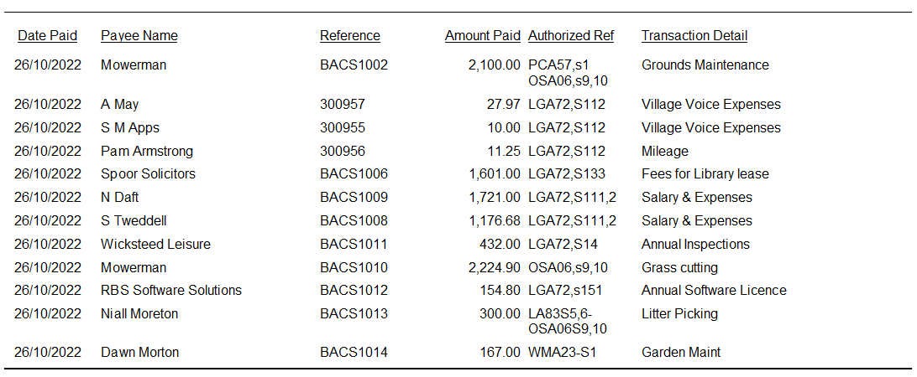
- The Current financial statement after the October payments being £240,833.95.
- RESOLVED that Cllrs Brown and JP Carr to authorise the bacs payments for October 2022.
- Discussion took place regarding training courses requested by the Clerk totalling £240. RESOLVED courses approved and to be booked with relevant providers.

22/60 Cemetery/War Memorial

- There have been issues regarding plastic edging around graves. It was agreed to write to relevant owners about removal.
- The Lime tree on the war memorial is due to be cut back before the Remembrance Day service.

22/61 Highways

- Vegetation on Gypsy Lane had been reported to Fixmystreet however it was advised that this was not a safety issue so no further action will take place.
- Discussion took place regarding a replacement English oak tree for Station Road corner however it was advised that an alternative type of tree chould be planted in that area.

22/62 Play Areas
- The annual play area inspections were discussed regarding the safety aspects and repairs.
- A quotation had been received regarding the repairs of the equipment for the play areas. RESOLVED to accept the quotation for repairs of equipment for both areas except the wetpore on the Recreation Ground as this order has had already been placed.
- A quotation had been received to remove a dead tree and raise the canopies on trees on the Recreation Ground that were affecting a neighbouring property. RESOLVED to accept the quotation.

22/63 Community Projects

- Received the update for the community orchard and quotation for trees. RESOLVED to accept the quotation for 2 packs of trees.
- Received an update from the library of which it was stated that approx. 100 people attended the ‘soft opening’. There were still some repairs outstanding which are being looked in to. BBC Northampton Radio breakfast show will visit the library on 3rd November.
- Remembrance Day Services, road closures have been arranged and the programme of service for Irchester is being prepared. The services will start in Irchester from 10.50am and Little Irchester from 2.20pm.

22/64 Planning

The following planning applications were discussed:
- NW/22/00696/FUL – (1 Manton Spinney Knuston) – Front porch and canopy. No comment.
- NW/22/00718/FUL – (Irchester Grange Farm, Farndish Road) – Conversion of agricultural buildings into five dwellings (2 x 3 bed, 2 x 4 bed and 1 x 5 bed) together with the formation of a new access, hardstanding for the parking and manoeuvring of vehicles, boundary treatment and landscaping. The demolition of an existing detached barn. Irchester Parish Council express concerns about the application and therefore object to it for the following reasons

1. Irchester Grange Farm is a unique Model Farm in the local area dating from the 1850s. It was
part of the Overstone Estate that covered large tracts of Northamptonshire in the 1800s
and early 1900s. It is unique in the immediate area to Irchester and is part of the agricultural
development history of the parish. The Parish Council express concerns of the lack of detail
in the planning application to make a sound judgement of the conversion of these historic
buildings.

2. There is little detail in the applications to how the conversion of the agricultural buildings
will enhance these buildings. For example:
a. There are no current photographs or plans of the current buildings (interior or
exterior) as they currently exist for compassion to the intended conversion plans
and drawings. This would help in seeing how the buildings were being converted.
b. There is no detail within the Design and Access Statement (or any further reports
with the planning application) about the aesthetics of the proposed conversion of
the buildings. For example, with the insertions of doors/windows there is no real
details of what materials these are made of, what the roof will be made of etc.
c. The conversion drawings also appear that buildings will be rendered when they are
currently made of stone which will be a great loss of heritage. There are no details of
any interior heritage features that may be preserved.
d. There is no heritage impact assessment for this building or as yet any archaeological
assessment.
e. There are no details about any materials propose for the roadway, hardstanding,
landscaping of gardens etc and the visual impact this may have.
f. There are no drawings which show the buildings conversions in the landscape
particularly in relationship to the separate adjoining Grange Farm House, its cottage
and associated building, or the model (former) farm labourers’ cottages located next
to the farm.

3. The development will be car dependant as there is no footpath to the site from the village of
Irchester.

4. The Parish Council is puzzled about the addition of another access road into the site when
there is already a very wide farm roadway into the site.
5. There is no detailed design for this intended access road

6. This proposed new access road could impact on the historic setting of the buildings and their
historical background as a Model Farm

7. Whilst the Parish Council realise the idea of conversion of the farm buildings, which are no
longer fit for modern farming purposes, will help preserve the for the future they feel that
the application is lacking in detail to form a sound judgment – hence the objection.

8. The Parish Council believes that the development, also because of this lack of information,
goes against the Joint Core Strategy for North Northamptonshire and the following Policies
apply:
a. Policy 2 – Historic Environment (All points)
b. Policy 3 – Landscape Character (Points A-E)
c. Policy 8 – Place setting principles (All points)
d. Policy 9 – Sustainable Buildings (All points)
- NW/22/00729/HSC – (60 London Road, Little Irchester) – Hazardous Substances Consent for the storage of up to 30 tonnes of liquefied petroleum gas (LPG) and 88 tonnes of liquefied natural gas. Resending objections from last meeting. Irchester Parish Council currently object to the planning application due to a lack of detail. In particular their concerns are as follows:

1. Lack of details on Highways issues - this has also been highlighted by the Highways Authority who are requesting more details. We welcome an opportunity to comment once Highways have commented.

2. Lack of details on Security issues - this has also been highlighted by Northamptonshire Police. We welcome the Police's views.

3. The impact on the development on the Environment - in particular the projected noise and planned floodlight of the site and its positioning within the Nene Valley and the SPA/SSSI.

4.There is little detail in the application about visual impact, in particular the view from the Nene Valley and its public footpaths which run alongside the River Nene.

There is also concern about the Safety aspect of the site not only with the movement of vehicles into/out of the site, but also within it. In addition, the impact it may have from a safety perspective to the nearby village of Little Irchester, its residents and amenities. It is right next door to a substation and next to a main sewer pipe for the community.
- NW/22/00742/FUL – (134 Wollaston Road) Single Storey rear extension and side extension. Demolition of wraparound side and rear single storey conservatory. No comment.

Village Voice working party arranged to meet again after the budget meeting on 4th November.

Meeting closed at 8.47 pm

Chair

