IRCHESTER PARISH COUNCIL

Minutes of the Ordinary Meeting of the Parish Council held on Wednesday 27th March 2024 at the Village Hall, School Road at 7.15p.m.

Members Present:
P Armstrong – In the Chair

Councillors
L Brown A Hurley J Dunkley K Watts M May
P Smith B Leeson D Schroll

The meeting started at 7.15pm. There were 4 members of the public present

Apologies - Received by the Clerk which were Agreed and Accepted from Cllrs S East and JP Carr. NNC Cllr T Partridge Underwood gave his apologies

Cllr K Clark did not attend the meeting or give apologies

23/96 Public Questions, Police Report and NNC Update

Public – No questions received

Police – report sent to councillors. Concern was raised regarding the number of assaults and where they had taken place.

NNC Update – Leaders report sent to councillors

23/97 Notification of Any Interests

23/108 & 9 Cllrs P Armstrong & L Brown Village Hall Trust
23/109 Cllr Leeson Youth centre

23/98 Minutes

RESOLVED - The minutes from 28th February 2024 meeting were agreed as a true record and signed by the Chair.

23/99 Financial Matters

- Payments – RESOLVED: That the payments for £10,003.64 for March 2024 were approved. Directs Debit payments pending NNC,HMRC and N Power
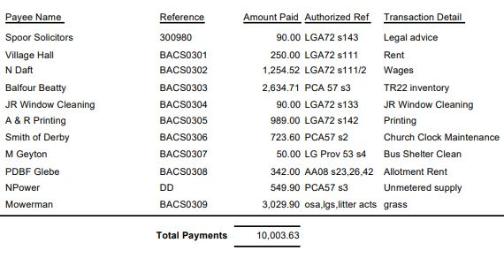

- The Current financial statement after the payments being £181,946.60
- RESOLVED that Cllrs P Armstrong & L Brown to authorise the bacs payments for March 2024.

23/100 Cemetery/War Memorial

There were no issues with the cemetery. Grass cutting season had now started.
A request had been received to place a tablet on a childs grave that was owned by the council. RESOLVED to accept the request as long as the tablet was installed by an approved memorial mason.

23/101 Highways

- It was noted that no new issues had been reported
- RESOLVED to accept the s136 details and grant from NNC for the grass cutting for 2024/25.

23/102 Play Areas

- The repairs to the recreation ground had now been carried out successfully however the skate park repairs have not yet taken place due to the continued wet weather.

23/103 Planning
NW/22/00640/FUL Full Planning Permission: Proposed Liquefied Natural Gas (LNG) road tanker storage and Liquefied Petroleum Gas (LPG) retail centre. The western half of the site will comprise: 3x6 cylinder stack storage area, forklift manoeuvre area x2, LPG cylinder unloading bay, forklift storage area, overnight parking areas for up to 4 LNG road tankers and 4x lighting columns. The eastern half of site will comprise: 2 storey office/reception building, customer/staff parking bays, 4 additional parking bays, 7m hinged gate entrance / exit, 3x lighting columns, provision for incoming services and septic tank, pedestrian gates (internal and emergency), 2 x 5m traffic barriers and concrete safety wall. Location: Land Rear 60 London Road Little Irchester – objections as the application does not comply to the following policies:

a) Ircheser, Knuston and Little Ircheser Neigbourhood Plan – Policy 1 – Settlement Boundary Policy – The proposed development is outside the Little Irchester Settlement Boundary Map
b) North Northamptonshire Joint Core Strategy – Policy 3 (Landscape Character), Policy 4 (Biodiversty and Geodiversity), Policy 5 (Water Environment, Resources and Flood Risk Management), Policy 8 (North Northamptonshire Place Shaping Principles), Policy 9 (Sustainable Buildings), Policy 20 (The River Nene and Ise Valley)
Cllr Leeson declare prejudicial interest in the following application and made no comment or vote.

NW/24/00062/FUL Full Planning Permission: Installation of air conditioning unit within side passageway adjacent to 8 Gipsy lane. Location: 8 Gipsy Lane Irchester – no objections

Appeal details received regarding the application NW/23/00665/FUL 2 Warren Close New one bed bungalow

23/104 Correspondence

A complaint had been received from a resident in Farndish Road regarding the parking issues on a Sunday and concern that emergency vehicles would not be able to access the road

April agenda items requested were:
Update on the Orchard
Update on the dog bin in Woodlands Road

23/105 Exclusive to Public and Press

RESOLVED: That pursuant to the Public Bodies (Admission to Meetings) Act 1960, the public and press is excluded from the meeting for the item of business on the grounds that publicity would be prejudicial to the public interest by reason of the confidential nature of the business to be discussed.

23/106 Promotion Agreement Austin Close

The Council agreed recommendations for the promotion agreement which were sent to the promoters agent. Although the 33% split was not agreed other details were accepted. Further suggestion was made that a land receipt be put in place.

23/107 Job Vacancy

There had been 10 applications for the position. 4 were invited for interview however only 3 attended. 2 candidates were invited to attend the pc meeting in order to observe council.

23/108 Village Hall Grant Request

Cllrs P Armstrong and Cllr L Brown left the meeting

Vice Chair Cllr Watts took the Chair

A meeting was held with the council working party and village hall committee members in order to understand the current situation. Papers presented were incomplete and further information is required by council.

23/109 Community Buildings Update

Cllr Leeson left the meeting

Discussion took place regarding the.leases for the Parish Council owned buildings and it was agreed, on legal advice, to write to the lessees regarding their contractual terms.

Meeting closed at 8.50 pm

Chair

These minutes are draft until agreed at the next full council meeting

