IRCHESTER PARISH COUNCIL

Minutes of the Ordinary Meeting of the Parish Council held on Wednesday 26th January 2022 at the Village Hall, School Road at 7.15p.m.

Members Present:
P Armstrong – In the Chair

Councillors

P Smith K Watts N Gibbons V Wilkinson L Brown

The meeting started at 7.15pm. there were 2 members of the public present.

Apologies - Agreed and Accepted from Cllr T Maguire, J Dunkley, M May, JP Carr (late arrival) & D Shroll

21/72 Public participation/Police Report/North Northants Council

Concern was raised regarding the poor lighting in Wollaston Road and the state of the trees – referred to NNC

Meeting was held with the 3 NNC councillors and the parishes that they are responsible for to discuss several issues that affect the parishes. Meetings were open to the Clerk and 2 councillors and will be held approximately every three months.

Query was raised regarding issuing draft minutes earlier however these are published according to SO’s.

21/73 Declaration of Interest

Cllrs P Armstrong & L Brown declared an interest in agenda item 21/79

21/74 Minutes

- The minutes from 24th November 2021 were agreed as a true record to be signed by the Chair.

21/75 Financial Matters

- Payments – Resolved: That the payments of £14,683.76 for December 2021 and January 2022 be approved
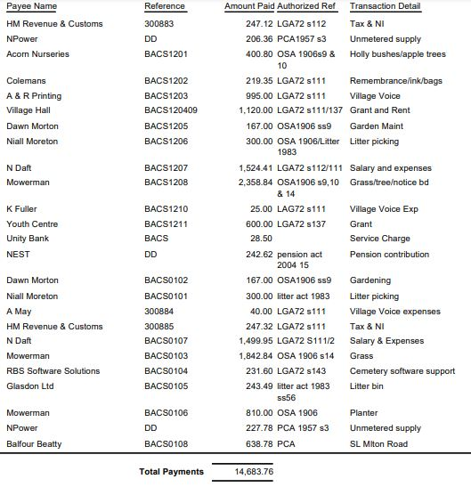

- The Current financial statement after the payments is £193,051.64
- RESOLVED that Cllrs L Brown & P Armstrong to authorise the bacs payments for January 2022
- RESOLVED to accept the grant from NNC regarding the cutting of the grass verges
- RESOLVED to purchase 2 sets of defibrillator batteries for £155.99 each

21/76 Cemetery/War Memorial
- There had been a few interments in the cemetery, holly bushes planted and growing nicely

21/77 Highways

Cllr Carr attended the meeting

- Repairs/resurfacing of Gypsy Lane is scheduled to take place in February 2022. Highways should also fill in some potholes and add the white lines.
- Asset Management Project – it was agreed that a working party be set up consisting of Cllrs KW/LB/JPC/PA/Clerk. A zoom meeting regarding the project from NCALC pending.

.21/78 Play Areas

- There had been some issues with the play area in Little Irchester having mud on the surface and equipment. This had been cleaned however continued to occur
- Discussion took place regarding purchasing table tennis tables. It was agreed to place one the other side of the childrens play area in the Recreation Ground and also in Little Irchester play area. Costs to be looked at again before ordering due to time scale with decisions.

21/79 Community Projects

- 13 Trees had been planted, 10 apple, 2 plum and 1 crab apple and were starting to show signs of growth. Cllrs were invited to see the orchard and speak to experts on 12th February.
- Library – NNC had issued Works orders for trees, electrics and roof repairs etc. Concern was raised that they continue to ask the pc for access however no keys are held by the council
- Seed balls had been received and needed to be collated into bags and distributed

Cllrs P Armstrong and L Brown left the meeting – Cllr JP Carr took the Chair

- Discussion took place regarding the grant request from the Village Hall committee for the resurfacing of the car park. Decision deferred until further information regarding exact costs etc were received.

Cllrs P Armstrong and L Brown returned to the meeting. Cllr Armstrong re took the chair

21/62 Planning

NW/21/01105/FUL – First floor side extension – 61 Arkwright Road – no objection
NW/21/01117/FUL – Two storey side extension – 19 Knuston Road – no objection
NW/21/01120/FUL – First floor side extension – 76 Woodlands Road – no objection
NW/22/00017/FUL - Planning permission to build a new agricultural building to the east of the holding next to the railway line and remove some of the hardstanding that has been installed by Network Rail. Location: Land Adjacent Railway Station Road Irchester – See details below
- Irchester Parish Council has grave concerns about this application for an agricultural building on land adjoining the Midland Main line opposite to the former Irchester Railway Good Shed.
- The hard core standing and surrounding earth bunds that has been put in place on sites adjoining Station Road and adjoining the railway line opposite to the former Irchester Railways Station Good Shed were implement by Network Rail for there Electrification Project as compound sites. The electrification work was now been completed. These sites never received any form of planning permission for and the Parish Council believe it should be returned to its original use that of open countryside and farmland.
- An agreement surely must have been established between the land owner/applicant and Network Rail for permissions and for it return to its original use as farmland/open countryside and the removal of the hard core and earths bunds as part of any agreement.
- The landowner/applicant has tried several times to place an agricultural building in different locations near to this site. However, the landowner/applicant does have a farmyard just one field away at Lower Farm in the High Street and the Parish Council wonder why such a building cannot be erected adjoining this farmyard. The applicant has unfortunately turned many of his agricultural buildings over to Non-Farming use including offices and industrial units over the years
- The information provided does not show clearly how the agricultural barn will fit into the landscape and what colour it would be. Nor does it provide evidence if a fence will be erected for security purposes and what that fence would look like. There is little evidence with the application of its setting within the landscape.
- This surrounding landscape has been noted several times by planning inspectors for the setting of the Grade I Listed Church of St Katharine’s and also for purposes of the Irchester, Knuston and Little Irchester Neighbourhood Plan.
- The applications also does not show the landscape views show what passengers passing by on the Midland Main Line will see of the countryside and the setting of that Grade I Listed Church.
- The Parish Council believe that the erection of the agricultural buildings conflicts with the following policies
  - North Northamptonshire Joint Core Strategy
    - Policy 2 – Historic Environment – in particular the visual setting of the building in the landscape and the vistas of a significant Grade I Listed Church.
    - Policy 3 – Landscape Character – the building is being erected opposite a significant historic unique1880s Midland Railway Good Shed that can be significantly viewed from the village of Irchester and its surrounding footpaths in the landscape. There is little in the application to reflect design that makes the agricultural buildings fit into the landscape. In addition the applicants does not explain about fencing, colour or materials being used.
  - Irchester, Knuston and Little Irchester Neighbourhood Plan 2011-2031
    - Policy 2 - Heritage Policy – the application conflicts with aspects of this policy in regards to the protections, enhancement of designated heritage assets like the Parish Church. Also key views and vistas out of and into the village of the Parish Church.
- The Parish Council therefore strongly objects to the application and would welcome a site viewing.

NW/22/00042FUL – Single storey rear extension - 27 School Road – no objection

Meeting closed at 8.35pm

Chair

