
The Parish Council of Irchester
Clerk  Nikki Daft PSLCC  45 Park Road  Irthlingborough  Northants  NN9 5PW |  | Telephone 01933 384180  irchesterpc@gmail.com

Dear Councillor 16th April 2018

You are hereby summoned to attend the Ordinary meeting of Irchester Parish Council to be held in the Village Hall, School Road Irchester on Wednesday 25th April 2018 at 7.15p.m.

Yours faithfully
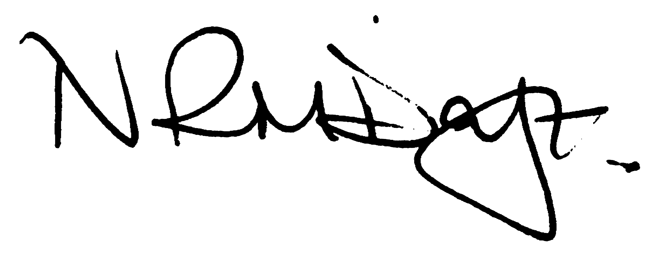

Nikki Daft – Parish Clerk

AGENDA

APOLOGIES AND ACCEPTANCE OF APOLOGIES

17/146 NOTIFICATION OF ANY DISCLOSABLE PECUNIARY INTERESTS OR OTHER INTERESTS
Only in respect of matters which are to be considered by members below. (Disclosures previously declared and registered need not be repeated).

- To receive declarations of interest
- Councillors to declare any personal interest in any items on the agenda
- Councillors to declare any personal and/or prejudicial interest in any items on the agenda and to inform the Chairman if they wish to speak on the matter during public participation

17/147 PUBLIC QUESTIONS, POLICE REPORT AND NCC UPDATE

Public participation may continue until for 15 minutes after which the public must not take part at any other time during the meeting. Request should be made to the Chair if any member of the public wishes to make a recording of any part of the meeting. All audible sounds to be switched to silent unless otherwise agreed at the start of the meeting. A report only can also be given by the Police and NCC representatives

17/148 MINUTES - To approve the minutes of the meetings held on 28th March 2018 as a true record.

17/149 RESOLUTIONS AND ACTIONS - MATTERS FROM PREVIOUS MINUTES

- Order Flags – Holocaust Day and Armed Forces Day
- Letters to NHW and Cogenhoe
- GDPR information for councillors evening

17/150 FINANCIAL/POLICIES

- To Approve Payments for April 2018 details sent to councillors via email (Clerk)
- To receive information regarding the current financial statement – reconciliation statement sent to councillors via email (Clerk)
- To agree the authorisation of the bacs payments
- "Best value -That the parish council should monitor hours based contracts (Garden, Lengthsman and others?) by asking the contractors/clerk submitting a monthly report on the jobs and activities charged for in the previous month. This could be a sheet with the day and task , where it was and the hours spent.(how long it took)(RE)
- Transparency- The finance working party be asked to review the financial regulations on small contracts ( under £60K ) in may/June as agreed. We need to increase the transparency of the process to adequately cover the items, the work to be done, the outputs or time and the quality and how it is advertised. Also when a contract has been agreed we need clarity on the arrangements for its monitoring, review and its extension/renewal or termination. This is In line with the new internal audit requirements."(RE)

17/151 RECREATION GROUNDS

- To receive and agree the reports/repairs/damage to the recreation grounds (JD)
- To discuss the boundary fence at the recreation ground in Wollaston Road and determine if damage has been caused by the council trees to a property in Baker Crescent

17/152 HIGHWAYS

- To agree any items that need to be added to the next agenda

17/153 LITTLE IRCHESTER/KNUSTON - To agree the Highway Warden report, previously circulated. Matters arising will be added to the next agenda. To discuss the following problems that have arisen in the village:

17/154 PLANNING - To discuss any planning issues

WP/18/00172/ADV – Retrospective application to display signage – Hedgerow Removal Notice

17/155 NEIGHBOURHOOD PLAN - To receive an update on the progress of the NHP

17/156 CEMETERY/WAR MEMORIAL/GARDENS

- To receive the Cemetery report and decide if details should be added to the next agenda
- To discuss the purchasing of a further 10 plants for the Irchester Sign hedging on Station Road corner
- To receive an update regarding the events planned to commemorate WW1
- To receive the cemetery report with recommendations as requested by full council

17/157 COUNTY COUNCIL

To receive an update on County Council aspects(RE)

17/158 CORRESPONDENCE To consider information received from incoming correspondence and decide on agenda items for the next meeting.

- Highways England – A6 Chowns Mill improvement scheme

17/159 EXCLUSIVE TO PUBLIC AND PRESS

17/160 COMMUNITY ASSETS

- To discuss how the council should proceed in securing Community Assets

