
The Parish Council of Irchester
Clerk  Nikki Daft PSLCC  45 Park Road  Irthlingborough  Northants  NN9 5PW |  | Telephone 01933 384180  irchesterpc@gmail.com  www.hugofox.com/community/irchester-parish-council-13388/about-us

Dear Councillor 21st June 2021

You are hereby summoned to attend the ordinary meeting of Irchester Parish on Wednesday 30th 2021 at 7.15p.m.at the Village Hall, School Road, Irchester

Yours faithfully
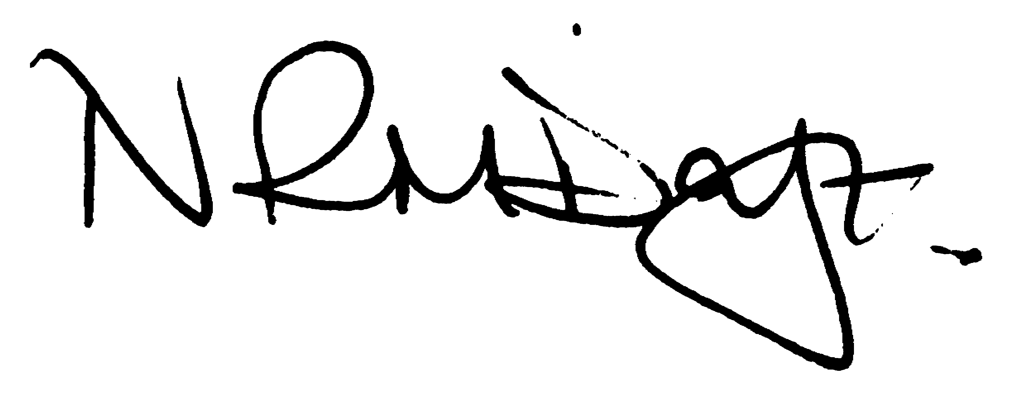

Nikki Daft – Parish Clerk

AGENDA

APOLOGIES AND ACCEPTANCE OF APOLOGIES

21/17 PUBLIC QUESTIONS, POLICE REPORT AND NNU UPDATE

Public to send questions to council prior to the meeting due to time constraints

21/18 NOTIFICATION OF ANY DISCLOSABLE PECUNIARY INTERESTS OR OTHER INTERESTS
Only in respect of matters which are to be considered by members below. (Disclosures previously declared and registered need not be repeated).

- To receive declarations of interest
- Councillors to declare any personal interest in any items on the agenda
- Councillors to declare any personal and/or prejudicial interest in any items on the agenda and to inform the Chairman if they wish to speak on the matter during public participation

21/19 MINUTES

a) To approve the minutes of the meeting held on 19th May 2021 as a true record.

21/20 FINANCIAL/POLICIES

- To Approve Payments for June 2021 (Clerk)
- To receive information regarding the current financial statement (Clerk)
- To agree the authorisation of the bacs payments
- To agree the changes to the bank mandate in order to take off councillors no longer members

21/21 CEMETERY/WAR MEMORIAL

- To receive an update on cemetery matters – to discuss the flowers that have been planted within the gravel in the cremated remains section
- Cemetery Working party request - To discuss and receive a quotation for the removal of the spoil in the corner of the baby section
- Cemetery Working party request - To discuss planting trees/bushes near to the baby section

21/22 PLANNING

NW/21/00463/FUL – 135 Arkwright Rd – single storey rear extension
NW/21/00495/FUL – 20 Roman Way – Single storey side extension
NW/21/00476/FUL – 9 Wollaston Road – Change of use to mixed use including existing restaurant, take away and taxi booking office – Hedgerow Removal Notice
NW/21/00527 – 11 Beech Crescent – Rear conservatory and single storey extension
NW/21/00540 - Reserved matters application for the erection of up to 75 dwellings for residential use including details of the appearance, landscaping, layout and scale pursuant to planning permission ref: WP/19/00154/OUT Land Adjacent 79-81 Farndish Road

21/23 HIGHWAYS

To receive information regarding any highways issues

- To discuss the quotation from Morlock for replacement batteries for the VAS signs

21/24 PLAY AREAS

- To receive an update regarding the installation of the new play equipment
- To discuss the engineers report from Wicksteed regarding the spinner in Daniels Road playarea
- To receive a quotation from Proludic for a replacement deck

21/25 COMMUNITY PROJECTS

Working party request – to discuss the organising of the Queens Platinum Jubilee Celebrations for June 2022 and determine if monies are available within the current budget.

21/26 EXCLUSIVE TO PUBLIC AND PRESS

21/27 PARSONS HALL LEASE

To discuss the questions raised via the Youth Centre Committee

21/28 CEMETERY HEADSTONES

To received information regarding an issue with a headstone in the cemetery as requested at the last meeting.

