IRCHESTER PARISH COUNCIL

Minutes of the Ordinary Meeting of the Parish Council held on Wednesday 26th March 2025 at the Village Hall, School Road at 7.15p.m.

Members Present:
K Watts – In the Chair

Councillors
A Hurley J-P Carr P Smith G Brotherston I McDonald
P Armstrong M May B Leeson A Howden

The meeting started at 7.15pm. There was 2 members of the public present.

Apologies - received and noted from Cllr D Shroll.

- Notification of any Interests

None declared.

- Public Questions, Police Report and NNC Update
Public – A query was raised regarding the ongoing lease for the Sport Association, the Clerk advised a second draft has been received from our solicitor and is pending review. A comment was made thanking the councillors who helped to get the dog bin issue resolved in Woodlands Road. An article relating to reporting full bins to NNC will be published in next quarterly village magazine. Speeding issues raised again and clerk to contact the police requesting this to be monitored.

Police – Report received and sent to Cllrs prior to the meeting.

NNC Update – Apologies received from Cllr Tom Partridge-Underwood. Leader’s report sent to councillors.

- Minutes
  - RESOLVED - The minutes from 26th February 2025 meeting was agreed as a true record and signed by the Chair.

- Financial/Policies
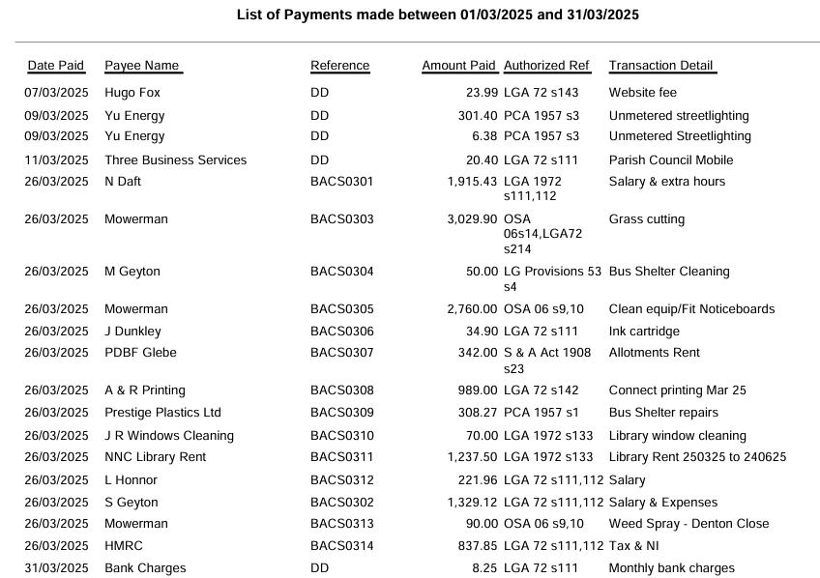
  - Payments – RESOLVED to agree the payments for March 2025 as listed below, totalling £13,576.35.
  - The Current financial statement after the March payments £197,475.79.
  - RESOLVED that Cllrs P Armstrong & B Leeson to authorise the bacs payments for March 2025.
  - RESOLVED to approved cost for Business Broadband Hub for parish office through current mobile provider at £12 per month for a 2-year contract.

- Recreation Grounds
  - No new updates.
  - RESOLVED to approve quotation for the 4 way ‘sunflower’ springer handle. RESOLVED to not replace the litter bin in Austin Close skate park at this time. A replacement dog bin to be ordered in metal for Austin Close at the road entrance. Further quotations to be arranged for the repair of the wet pour around the swings on the recreation ground.

- Highways
  - No issues raised.

- Cemetery/War Memorial
  - Report sent from the Cemetery Officer, further details to be requested. War memorial improvements to be arranged.

- Planning
  - To note the below comments for the following planning applications received by NNC

Application No: NW/25/00060/FUL
Proposal: Demolition of double garage at 191 Wollaston Road and erection of a detached two-storey 4-bedroom dwelling to side of 191 Wollaston Road.
Location: 191 Wollaston Road, Irchester, Wellingborough, NN29 7DG.

Objections from the council are,

- As per the information supplied by NNC Highways - we await further information on this to clarify points in regards to the parking provision of both the current property 191 and the proposed new property adjoining 191.
- Joint Core Strategy, Policy 3, Landscape Character, A, as we feel the building does not fit in with the streetscape, is not of a similar design to the interwar houses in this area, and is not rendered like adjoining buildings, instead being solely of unrendered brick as appears in the design
- Joint Core Strategy, Policy 8, Place Shaping Principles, Bi and Bii, as by the points raised by highways about car parking provision and access, Di and Dii, as the building does not fit in within the character of the streetscape as mentioned above.

Application No: NW/25/00076/PNT
Proposal: Application to determine if prior approval is required for a proposed telecommunications installation: 12 metre streetworks pole fitted with an Arqiva Smart Metering 1no. Omni at 13.45 metres
Location: Land At Irchester Pumping Station, Farndish Road, Irchester, Poddington, NN29 7HL.

No objections from the council.

  - No decisions to note from NNC.

- Correspondence
  - Correspondence received regarding to targeted consultations for Green Hill Solar Farm and an email had been received from Santa Pod advising events are due to start for the season.

- Exclusive to public and press

RESOLVED: That pursuant to the Public Bodies (Admission to Meetings) Act 1960, the public and press is excluded from the meeting for the item of business on the grounds that publicity would be prejudicial to the public interest by reason of the confidential nature of the business to be discussed.

- SA Lease
  - Clerk updated council that a second draft has been received from the solicitors which is pending review by the Clerk.

Meeting closed at 9.08pm Chair 30th April 2025

